**Preliminary Investigation**

**ORGANISATIONAL OVERVIEW:**

Since 1965, The National Zoo has been fascinating patrons with its wild, exotic animals and adventure-seeking events such as Walkathon, Wildlife photography. Animals, reptiles and birds from around the world can be found here.

It is a sprawling green island and a motley collection of animals and birds, all in the middle of the urban Navi Mumbai. The zoo is home to about 1350 animals representing almost 130 species of animals and birds from around the world.

The zoo can be seen on foot or using a battery-operated vehicle which can be rented at the zoo. Visitors are not permitted to bring any food other than drinking water, but there is a canteen in the zoo.

**THE CURRENT SYSTEM:**

The zoo maintains data about available animals and events along with their information and the employees of the zoo manually in the registers.

The zoo employees manage animal food and medicine and also the maintenance of the zoo. They keep track of orders in manually created registers.

After transfer of new animal to the zoo, the zoo employees update the data in the registers manually.

Registrations for the events are done manually in the catalogues.

**DRAWBACKS OF THE CURRENT SYSTEM:**

* Updating the new animal information to the existing data is tedious.
* Maintenance of all the manual records is time consuming and takes a lot of storage.
* There are possibilities of data redundancy.
* There is no certainty of the data, as new animals are to be added.
* Difficult to keep track of orders and their status.
* It is time consuming to register for events using catalogues.

**THE PROPOSED SYSTEM:**

* The proposed system is to be created to develop a website which has information about zoo, animals in the zoo, events and registrations.
* The proposed system will store all the records in a database. The system is computerized, so the access to the data and the modification of the data is easier.
* The system can be used by zoo visitors, admin.
* Admin can be any zoo employee who adds new records to the system modifies the existing record to the system.
* Admin can also add orders for animal food and medicine to keep a track of orders.
* The system has its own feedback section, so it can receive response from the users.

**ADVANTAGES OF PROPOSED SYSTEM:**

* Employees’ work would be reduced to a greater extent as animal information and their updates are added directly to the database.
* Hence manual work and redundancy is reduced.
* Publicity of events and registration is made easier with the system. It also enables to see who and how many have registered for the events.

**FEASIBILITY STUDY:**

**Economic Feasibility:**

The project doesn’t need much money for development. The maintenance of the system is also economically feasible.

**Technical Feasibility:**

The project is technically feasible as there isn’t any difficulty to get required resources. All the technology used is simple.

**Operational Feasibility:**

The system requires minimum knowledge and understanding of the computer. The system can be easily used by the user.

**Environmental Feasibility:**

The system is environmentally feasible as it doesn’t use many natural resources and also promotes conservation of wildlife.

**Cultural Feasibility:**

The system promotes the wildlife conservation, so it’s culturally feasible.

**FACT FINDING USING QUESTIONAIRES:**

1. Currently, how the data is stored?
2. When the data is updated?
3. What kind of data is stored in the system?
4. Who can use the system?
5. How the system works?

**PROJECT REQUIREMENTS**

**Hardware Requirement**

* Minimum 512MB RAM
* Intel 2 GHz Processor
* Atleast 1 GB Secondary Storage

**Software Requirement**

* Operating System:Windows XP or later
* Netbeans IDE 7.3.1 with jdk 1.7
* SQL Server Management Studio Express 2005

**STAKEHOLDERS:**

1. **Admin:**

Admin can be any zoo employee who adds and updates the data in the system.

Admin updates the website, adds new data and checks feedbacks and registrations from the user.

1. **User / Visitor:**

Users are the visitors who visit the zoo.

Users can view the information of the animals.

Users can view the events and register for events.

Users can read the information about the zoo and can fill the feedback form.

**GANTT CHART:**

|  |  |  |  |  |  |  |  |  |  |  |  |  |  |  |  |  |  |  |  |  |
| --- | --- | --- | --- | --- | --- | --- | --- | --- | --- | --- | --- | --- | --- | --- | --- | --- | --- | --- | --- | --- |
|  | | | | | | | | | | | | | | | | | | | | |
| **Phase Title** | **Jun** | | | | **Jul** | | | | **Aug** | | | | | | | **Sept** | | | | |
|  | **1** | **2** | **3** | **4** | **1** | **2** | **3** | **4** | **1** | **2** | | **3** | | **4** | | **1** | | **2** | **3** | **4** |
| **Project Approval** |  |  |  |  |  |  |  |  |  |  | |  | |  | |  | |  |  |  |
| **PRELIMINARY INVESTIGATION** |  |  |  |  |  |  |  |  |  |  | |  | |  | |  | |  |  |  |
| **SYSTEM ANALYSIS PHASE** | | | | | | | | | | | | | | | | | | | | |
| * Event Table |  |  |  |  |  |  |  |  |  |  | |  | |  | |  | |  |  |  |
| * Class Diagram |  |  |  |  |  |  |  |  |  |  | |  | |  | |  | |  |  |  |
| * Use Case Diagrams |  | | | |  |  |  | |  |  | |  | |  | |  | | | | |
| * Scenarios |  | | | |  |  |  |  | |  | |  | |  | | | | |
| * Sequence Diagrams |  | | | |  | | | |  | |  | |  | |  | |  | | | |
| * Collaboration Diagrams |  | | | |  | | | |  |  | |  | |  | |  | | | | |
| * State Chart Diagram |  | | | |  | | | |  |  | |  | |  | |  | | | | |
| * Activity Diagram |  | | | |  | | | |  |  | |  | |  | |  | | | | |
| * **SYSTEM DESIGN PHASE** |  | | | |  | | | |  | | | | | | |  | | | | |
| * Design Class Diagram |  | | | |  | | | |  | | | | | | |  | | | | |
| * Database Designing |  | | | |  | | | |  | | | | | | |  | | | | |
| * Component Diagram & Deployment Diagram |  | | | |  | | | |  | | | | | | |  | |  |  |  |
| * Package Diagram |  | | | |  | | | |  | | | | | | |  | | | | |
| * Designing User Interface |  | | | |  | | | |  | | | | | | |  | |  |  |  |

|  |  |  |  |  |  |  |  |  |  |  |  |  |  |  |  |  |  |  |  |  |
| --- | --- | --- | --- | --- | --- | --- | --- | --- | --- | --- | --- | --- | --- | --- | --- | --- | --- | --- | --- | --- |
| Tasks | Oct | | | | Nov | | | | Dec | | | | Jan | | | | Feb | | | |
|  | **1** | **2** | **3** | **4** | **1** | **2** | **3** | **4** | **1** | **2** | **3** | **4** | **1** | **2** | **3** | **4** | **1** | **2** | **3** | **4** |
| **CODING** |  | | | |  | | | |  | | | |  | | | |  | | | |
| **TESTING** |  | | | |  | | | |  | | | |  | | | |  | | | |
| **IMPLEMENTATION** |  | | | |  | | | |  | | | |  | | | |  | | | |

**Expected Date of Completion**

**Actual completion Date**

**Break**

**SYSTEM ANALYSIS**

**EVENT TABLE: VISITOR**

|  |  |  |  |  |  |  |
| --- | --- | --- | --- | --- | --- | --- |
| **Sr. No.** | **Event** | **Trigger** | **Source** | **Activity** | **Response** | **Destination** |
| 1. | Visitor wants to enquire about zoo. | Zoo enquiry | Visitor | Look up for information | Zoo details | Visitor |
| 2. | Visitor wants to create an account | New account | Visitor | New account | Account details | Visitor |
| 3. | Visitor wants to log in | Request to login | Visitor | Verify authentication | Login | Visitor |
| 4. | Visitor searches for animals | Request for animal information | Visitor | Display animal information | Animal information | Visitor |
| 5. | Visitor wants to check events | Request for event information | Visitor | Display event information | Event information | Visitor |
| 6. | Visitor wants to register for event | Request for registration | Visitor | Register | Registration confirmation | Visitor |
| 7. | Visitor fills feedback form | Request for feedback form | Visitor | Display feedback form | Feedback details | Visitor |

**EVENT TABLE: ADMIN**

|  |  |  |  |  |  |  |
| --- | --- | --- | --- | --- | --- | --- |
| **Sr. No.** | **Event** | **Trigger** | **Source** | **Activity** | **Response** | **Destination** |
| 1. | Admin logs in to account | Request to login | Admin | Verify authentication | Login | Admin |
| 2. | Admin wants to add animal | Request to add animal | Admin | Add animal | Animal details | Admin |
| 3. | Admin wants to delete animal | Request for deletion | Admin | Delete animal | Animal deletion details | Admin |
| 4. | Admin wants to update animal information | Request for update | Admin | Update animal | Animal update details | Admin |
| 5. | Admin wants to add event | Request to add event | Admin | Add event | Event details | Admin |
| 6. | Admin wants to remove event | Request to remove event | Admin | Remove event | Event removal details | Admin |
| 7. | Admin wants to update event | Request to update event | Admin | Update event | Event update details | Admin |
| 8. | Admin wants to add order | Request to add order | Admin | Add order | Order details | Admin |
| 9. | Admin wants to check orders | Request to check orders | Admin | Display orders | Order details | Admin |
| 10. | Admin wants to update order | Request to update order | Admin | Update order | Order update details | Admin |
| 11. | Admin checks registrations | Request to check registrations | Admin | Display registrations | Registrations details | Admin |
| 12. | Admin views feedbacks | Request to display feedbacks | Admin | Display feedbacks | Feedback details | Admin |
| 13. | Admin wants to delete feedback | Request to delete feedback | Admin | Delete feedback | Feedback deletion details | Admin |
| 14. | Admin wants to logout | Request to logout | Admin | Logout | Logout | Admin |

**USE CASE DIAGRAM:**

* **Subsystem-wise:**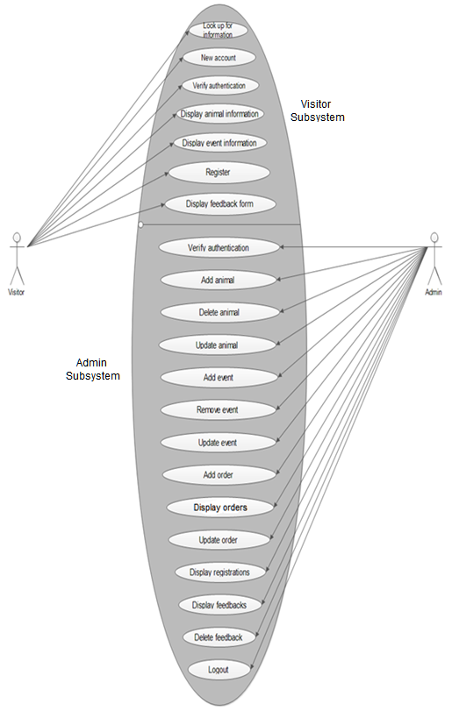
* **Actor-wise:**

**For Visitor –**



**For Admin –**

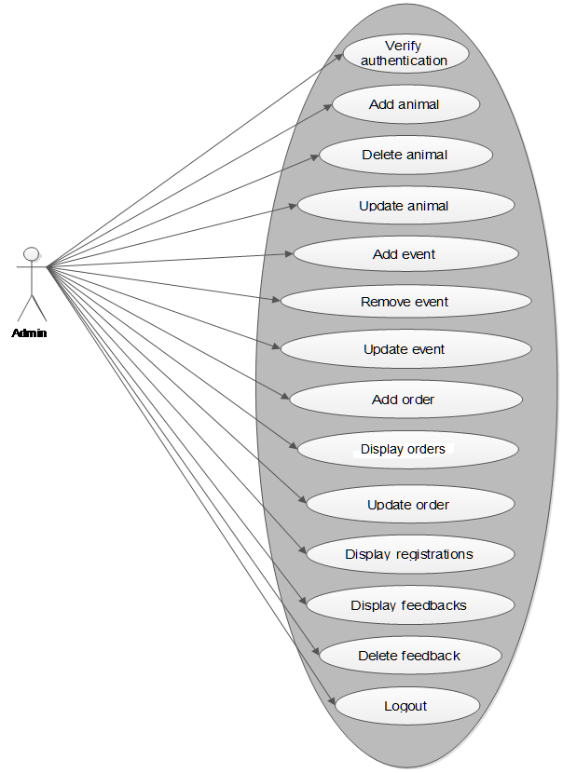

* **Use case includes:**

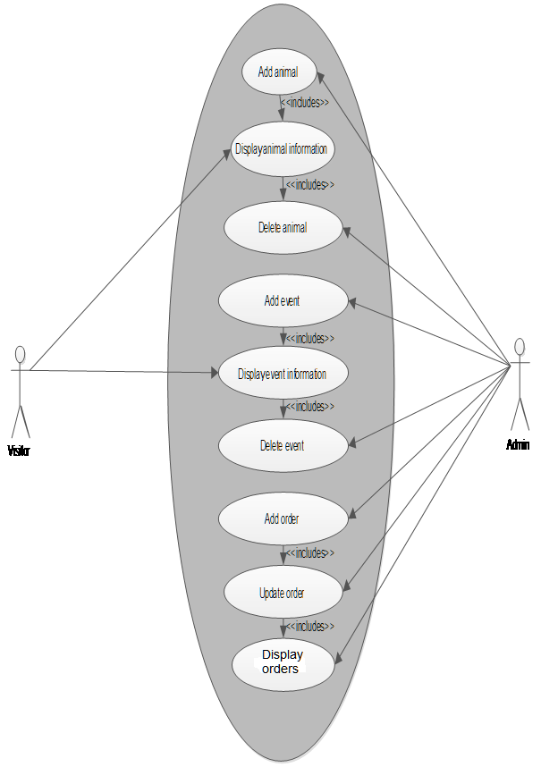

**USE CASE SCENARIO:**

1. **Use case name:** Look up for information

**Scenario:** Visitor wants to look up for zoo information

**Actors:** Visitor

**Triggering event:** Zoo enquiry

**Flow of activities:**

1. Visitor wants to visit zoo.

2. Visitor checks out zoo information

3. Visitor notes zoo details

1. **Use case name:** New account

**Scenario:** Visitor wants to create a new account

**Actors:** Visitor

**Triggering event:** New account

**Flow of activities:**

1. Visitor wants to create a new account.
2. Visitor enters details.
3. **Use case name:** Verify authentication

**Scenario:** Visitor wants to login

**Actors:** Visitor

**Triggering event:** Request to login

**Flow of activities:**

1. Visitor enters credentials.
2. Visitor logs in to system.
3. **Use case name:** Display animal information

**Scenario:** Visitor wants to view animals

**Actors:** Visitor

**Triggering event:** Request for animal information

**Flow of activities:**

1. Visitor searches for animals.
2. Visitor views the animal details
3. **Use case name:** Display event information

**Scenario:** Visitor wants to view events

**Actors:** Visitor

**Triggering event:** Request for event information

**Flow of activities:**

1. Visitor selects an event
2. Visitor views information about selected event
3. **Use case name:** Register

**Scenario:** Visitor wants to register for event

**Actors:** Visitor

**Triggering event:** Request for registration

**Flow of activities:**

1. Visitor selects an event.
2. Visitor registers for the event
3. **Use case name:** Display feedback form

**Scenario:** Visitor wants give feedback

**Actors:** Visitor

**Triggering event:** Request for feedback

**Flow of activities:**

1. Visitor submits feedback form.
2. **Use case name:** Verify authentication

**Scenario:** Admin wants to login to the system

**Actors:** Admin

**Triggering event:** Request to login

**Flow of activities:**

1. Admin enters credentials.
2. Admin logs in to the system
3. **Use case name:** Add animal

**Scenario:** Admin wants to add animal information

**Actors:** Admin

**Triggering event:** Request to add animal

**Flow of activities:**

1. Admin checks animals in the zoo.
2. Admin adds animals to the system.
3. **Use case name:** Delete animal

**Scenario:** Admin wants to delete animal information

**Actors:** Admin

**Triggering event:** Request to delete animal

**Flow of activities:**

1. Admin deletes the animal from the system.
2. **Use case name:** Update animal

**Scenario:** Admin wants to update animal information

**Actors:** Admin

**Triggering event:** Request to update animal

**Flow of activities:**

1. Admin updates animal information in the system.
2. **Use case name:** Add event

**Scenario:** Admin wants to add event information

**Actors:** Admin

**Triggering event:** Request to add event

**Flow of activities:**

1. Admin checks for the events in the zoo.
2. Admin adds a new event to the system.
3. **Use case name:** Remove event

**Scenario:** Admin wants to remove event

**Actors:** Admin

**Triggering event:** Request to remove animal

**Flow of activities:**

1. Admin checks if any event has been done.
2. Admin removes the event
3. **Use case name:** Update event

**Scenario:** Admin wants to update event

**Actors:** Admin

**Triggering event:** Request to update event

**Flow of activities:**

1. Admin checks if there are any changes in the event
2. Admin updates the event
3. **Use case name:** Add order

**Scenario:** Admin wants to add order

**Actors:** Admin

**Triggering event:** Request to add order

**Flow of activities:**

1. Admin checks for the orders.
2. Admin adds orders to the zoo.
3. **Use case name:** Display orders

**Scenario:** Admin wants to check orders

**Actors:** Admin

**Triggering event:** Request to display order

**Flow of activities:**

1. Admin checks for order.
2. System displays all orders
3. **Use case name:** Update order

**Scenario:** Admin wants to update order information

**Actors:** Admin

**Triggering event:** Request to delete animal

**Flow of activities:**

1. Admin selects an order.
2. Admin updates information about order.
3. **Use case name:** Display registrations

**Scenario:** Admin wants to check out registrations.

**Actors:** Admin

**Triggering event:** Request to display registrations

**Flow of activities:**

1. Admin views registrations
2. **Use case name:** Display feedbacks

**Scenario:** Admin wants to check out feedbacks

**Actors:** Admin

**Triggering event:** Request to display feedbacks

**Flow of activities:**

1. Admin views feedbacks.
2. **Use case name:** Delete feedback

**Scenario:** Admin wants to delete feedback

**Actors:** Admin

**Triggering event:** Request to delete feedback

**Flow of activities:**

1. Admin selects feedback.
2. Admin deletes the feedback.

1. **Use case name:** Logout

**Scenario:** Admin wants to logout from the system

**Actors:** Admin

**Triggering event:** Request to logout

**Flow of activities:**

1. Admin logs out from the system.

**ACTIVITY DIAGRAM:**

**Admin activity diagram –**

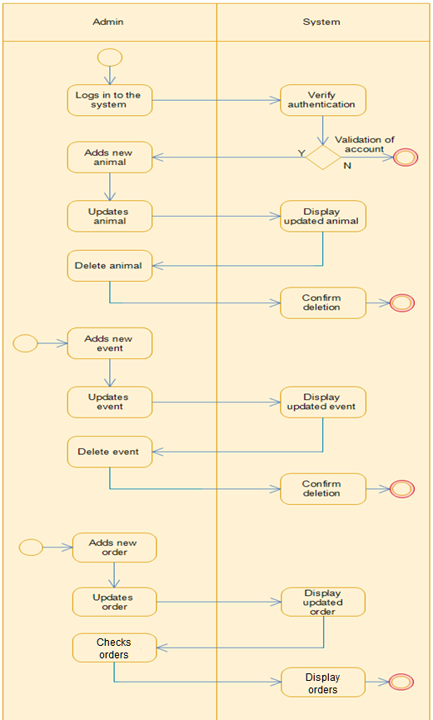

**Visitor activity diagram –**

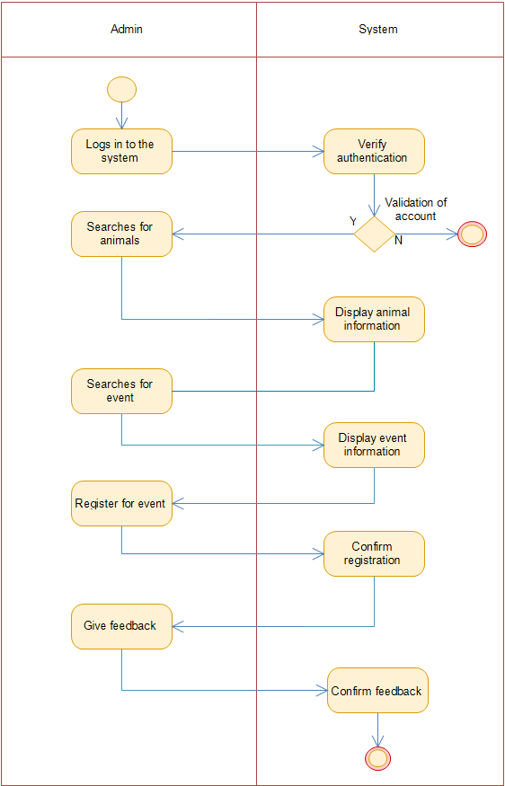

**CLASS DIAGRAM:**

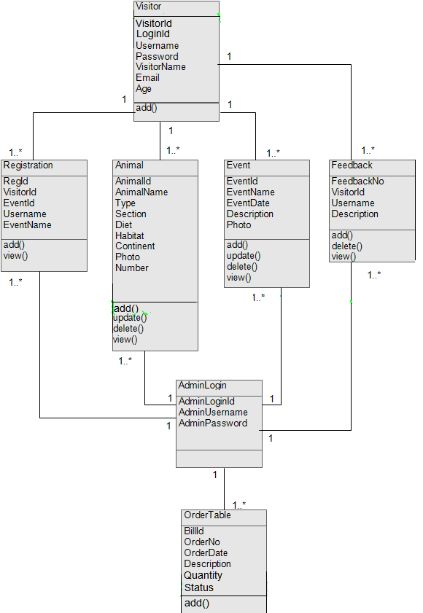

**SEQUENCE DIAGRAM:**

1. New account

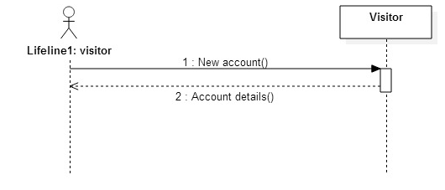

1. Verify authentication

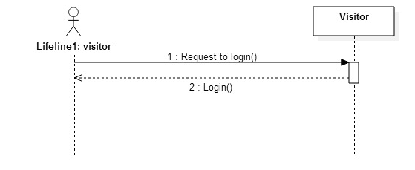

1. Display animal information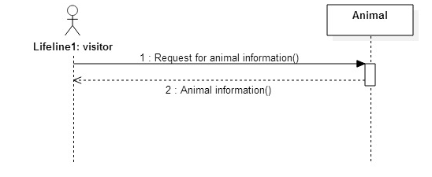
2. Display event information

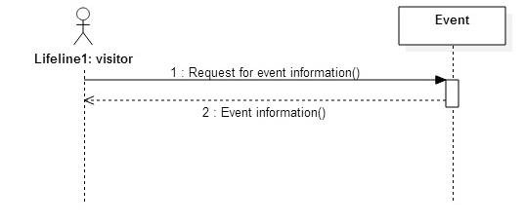

1. Register

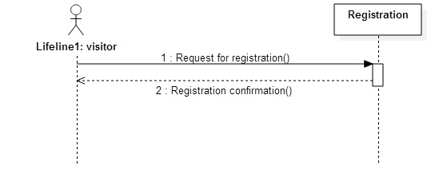

1. Display feedback form

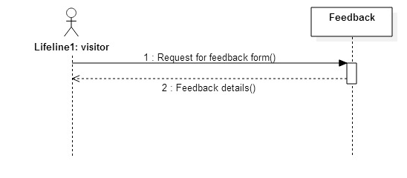

1. Verify authentication

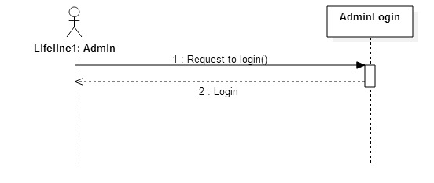

1. Add animal

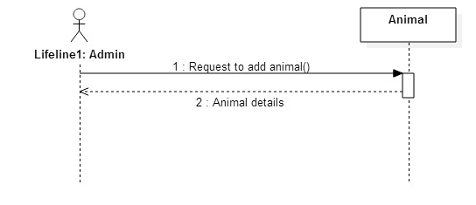

1. Delete animal

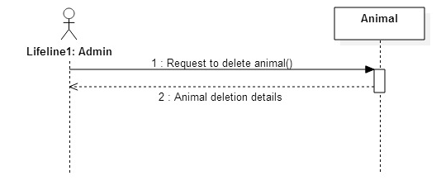

1. Update animal

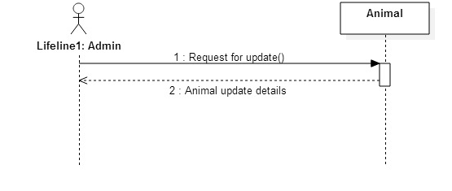

1. Add event

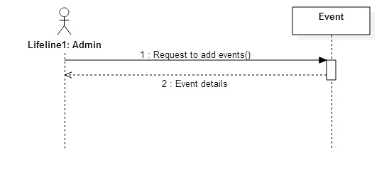

1. Remove event

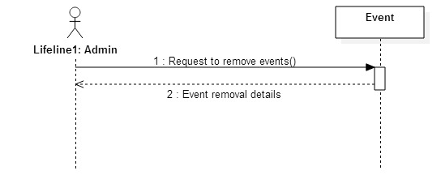

1. Update event

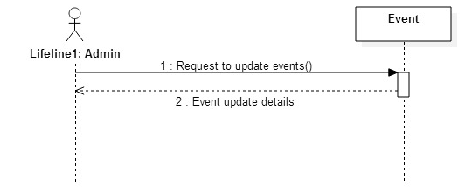

1. Add order

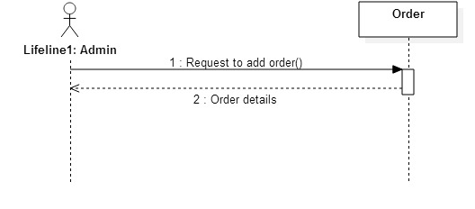

1. Display order

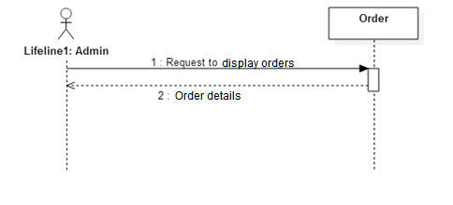

1. Update order

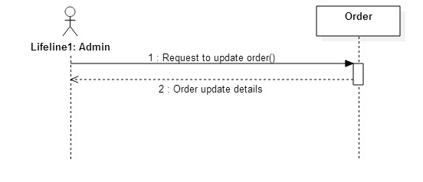

1. Display registrations

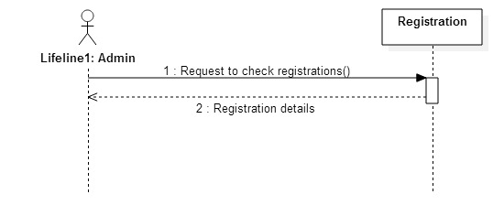

1. Display feedbacks

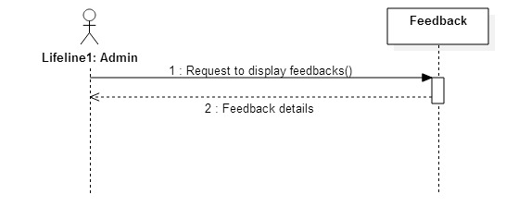

1. Delete feedbacks

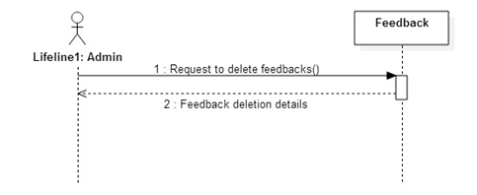

1. Logout

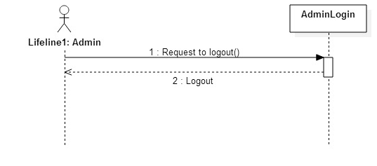

**COLLABORATION DIAGRAMS:**

1. Visitor creates a new account and logs into the system



1. Visitor want to login to the system



1. Visitor searches for animal and the system displays animal information



1. Visitor wants to check out events



1. Visitor wants to register for event



1. Visitor wants to give feedback



1. Admin wants to login



1. Admin wants to add new animals to the system



1. Admin wants to delete animal from the system



1. Admin wants to update animal information



1. Admin wants to add new event to the system



1. Admin wants to remove event from the system



1. Admin wants to update event information



1. Admin wants to add new order



1. Admin wants to check orders

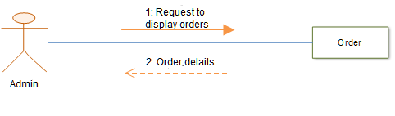

1. Admin wants to update order



1. Admin wants to view registrations for events



1. Admin wants to view feedbacks



1. Admin wants to delete feedback



1. Admin wants to logout

**STATECHART DIAGRAM:**

**For Visitor:**



**For Admin:**



**System design**

**CONVERTING CLASS DIAGRAMS TO TABLES:**

|  |  |  |
| --- | --- | --- |
| **TABLE NAME** | **FIELD NAME** | **DATATYPE** |
| **Visitor** | VisitorId | Varchar |
| LoginId | Varchar |
| Username | Varchar |
| Password | Varchar |
| VisitorName | Varchar |
| Email | Varchar |
| Age | numeric |
| **Registration** | RegId | varchar |
| VisitorId | Varchar |
| EventId | Varchar |
| Username | Varchar |
| EventName | Varchar |
| **Animal** | AnimalId | Varchar |
| AnimalName | Varchar |
| Type | Varchar |
| Section | numeric |
| Diet | Varchar |
| Habitat | Varchar |
| Continent | Varchar |
| Photo | Varchar |
| Number | numeric |
| **Event** | EventId | Varchar |
| EventName | Varchar |
| EventDate | Datetime |
| Description | Varchar |
| Photo | Varchar |
| **Feedback** | FeedbackNo | Varchar |
| VisitorId | Varchar |
| Username | Varchar |
| Description | Varchar |
| **AdminLogin** | AdminLoginId | Varchar |
| AdminUsername | Varchar |
| AdminPassword | Varchar |
| **OrderTable** | BillId | Varchar |
| OrderNo | Varchar |
| OrderDate | datetime |
| Description | Varchar |
| Quantity | numeric |
| Status | Varchar |

**DESIGN CLASS DIAGRAM:**

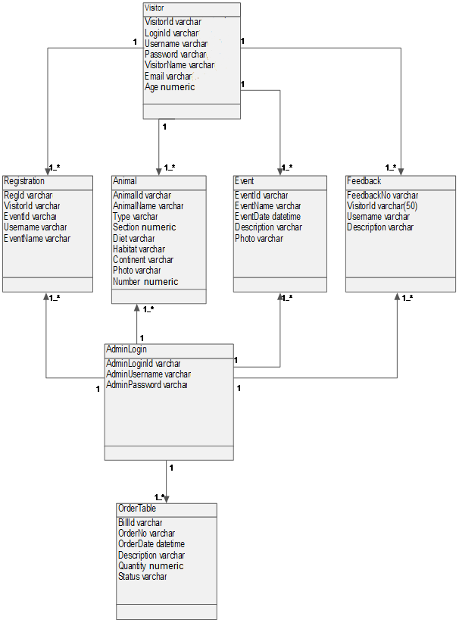

**COMPONENT DIAGRAM:**

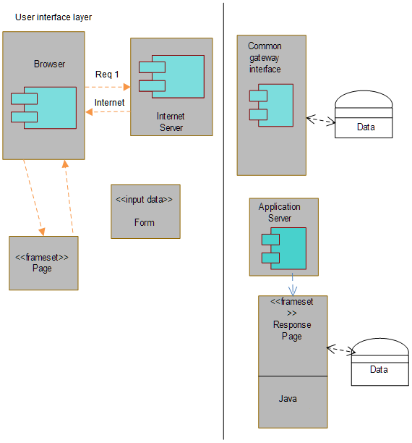

**PACKAGE DIAGRAM:**

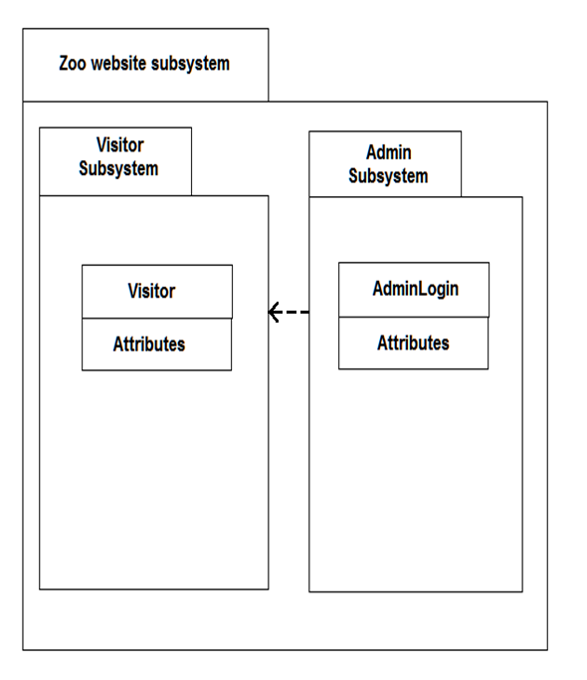

**DEPLOYMENT DIAGRAM:**



System coding

**SITEMAP FOR REGISTERED USERS:**

* **HOME**
* **VISIT THE ZOO**
* **Rates**
* **Timing**
* **Maps**
* **History**
* **ANIMALS**
* **EVENTS**
* **FEEDBACK**
* **CONTACT**
* **LOGOUT**

**SITEMAP FOR UNREGISTERED USERS:**

* **HOME**
* **VISIT THE ZOO**
* **Rates**
* **Timing**
* **Maps**
* **History**
* **CONTACT**
* **ACCOUNT**
* **Create new account**
* **Login**

**SITEMAP FOR ADMIN:**

* **HOME**
* **ANIMALS**
* **EVENTS**
* **ORDERS**
* **REGISTRATIONS**
* **FEEDBACK**
* **LOGOUT**

**LIST OF SYSTEM TABLES AND VALIDATIONS:**

|  |  |  |  |  |
| --- | --- | --- | --- | --- |
| **TABLE NAME** | **FIELD NAME** | **DATATYPE** | **SIZE** | **DESCRIPTION** |
| **Visitor** | VisitorId | Varchar | 10 | Primary key/ not null |
| LoginId | Varchar | 10 | Primary key/not null |
| Username | Varchar | 30 | Not null |
| Password | Varchar | 30 | Not null |
| VisitorName | Varchar | 30 | Not null |
| Email | Varchar | 30 | Not null |
| Age | numeric | 18,0 | Not null |
| **Registration** | RegId | varchar | 10 | Primary key/ Not null |
| VisitorId | Varchar | 10 | Foreign key/ Not null |
| EventId | Varchar | 10 | Foreign key/ Not null |
| Username | Varchar | 30 | Not null |
| EventName | Varchar | 30 | Not null |
| **Animal** | AnimalId | Varchar | 10 | Primary key/ Not null |
| AnimalName | Varchar | 30 | Not null |
| Type | Varchar | 30 | Not null |
| Section | numeric | 18,0 | Not null |
| Diet | Varchar | 50 | Not null |
| Habitat | Varchar | 50 | Not null |
| Continent | Varchar | 50 | Not null |
| Photo | Varchar | 50 | Not null |
| Number | numeric | 18,0 | Not null |
| **Event** | EventId | Varchar | 10 | Primary key/ Not null |
| EventName | Varchar | 30 | Not null |
| EventDate | Datetime | - | Not null |
| Description | Varchar | 100 | Not null |
| Photo | Varchar | 50 | Not null |
| **Feedback** | FeedbackNo | Varchar | 10 | Primary key/ Not null |
| VisitorId | Varchar | 10 | Foreign key/ Not null |
| Username | Varchar | 30 | Not null |
| Description | Varchar | 50 | Not null |
| **AdminLogin** | AdminLoginId | Varchar | 10 | Primary key/ Not null |
| AdminUsername | Varchar | 30 | Not null |
| AdminPassword | Varchar | 30 | Not null |
| **OrderTable** | BillId | Varchar | 10 | Primary key/ Not null |
| OrderNo | Varchar | 10 | Primary key/ Not null |
| OrderDate | datetime | - | Not null |
| Description | Varchar | 50 | Not null |
| Quantity | numeric | 18,0 | Not null |
| Status | Varchar | 30 | Not null |

**DESIGN PATTERNS USED:**

**Two Tier Architecture –**

* In the Two-Tier Model,the three componenets of an application namely,Presentation,Processing and Data are divided among two softwares tiers:Client Application Code and Database Server.
* Presentation is handled exclusively by the client,processing is split bwetween cliet and server,and data is stored on and asccessed via the server.
* In tyhis aplication programming model,the client application directly interacts with the server application without the presence of any intermediate application.
* The Client apllication communicates with the data layer through a database bridge Application Programming Interfacce(API).The database bridge used over here is JDBC commonly known as J Java Database Connectivity.
* The client process sends a request to the server.The server interprets the message and then attempts to fulfill the request.In order to fulfill the request,the server may have to refr to the database ,process data(perform calculations),control a peripheral,or make an additional request of another server.
* A robust client application development language and a versatile mechanism for transmitting client requests to the server are essential for a Two-Tier implementation.And hence the project is developed using Java Server Pages as the programming language and SQL Server as the database server.
* A Two=Tier application is approprite for a small application that does not have a lot of users.

**Advantages –**

* The Two-Tier application progamming model provides you with improved usability,scalability and flexibity of apllications.
* The most compelling advantage of a Two-Tier environment is application development speed.
* Two-Tier architectures work well in relatively homogeneous environments with fairly static business rules.
* It helps you to get the basic functions of an application up and running quickly.

**Disadvantages –**

* If you change the type of database used by your organisation,redeploy and reconfigure each client application.
* This architecture is less suited for dispersed,heterogeneous environments with rapidly changing rules.
* Since the bulk of apllication logic exists on the PC Client .the two-tier architecture faces a number of potential version control and application re-distribution problems.
* A change in business rules would require a change to the client logic in each application in a corporation'sportfolio which is affected by the change.

**PROGRAM DESCRIPTION WITH NAMING CONVENTIONS:**

**PROGRAM DESCRIPTION**

**Login form for Visitor**

Login Form is Login.jsp page of the website. By filling this form people visiting this website can be officially part of this website. Once visitor register to the zoo website they can check out animals, events and register for the event.

**Event Register form for Visitor**

This is Events.jsp form and EventRegister.jsp page to register a Visitor to a specific event. This form confirms the registration of the Visitor.

**Feedback form for Visitor**

Feedback form is Feedback.jsp page and FeedbackCheck.jsp page of the website. The registered users of the system can fill the feedback form. By accepting feedbacks from the users Admin can improve the website services.

|  |  |
| --- | --- |
| **Control Name** | **Naming Convention** |
| TextBox | Txt |
| Button | Btn |
| Image | Img |
| DropDownList | ddl |

**INPUT/OUTPUT SCREEN LAYOUTS & REPORT LAYOUT:**

Homepage

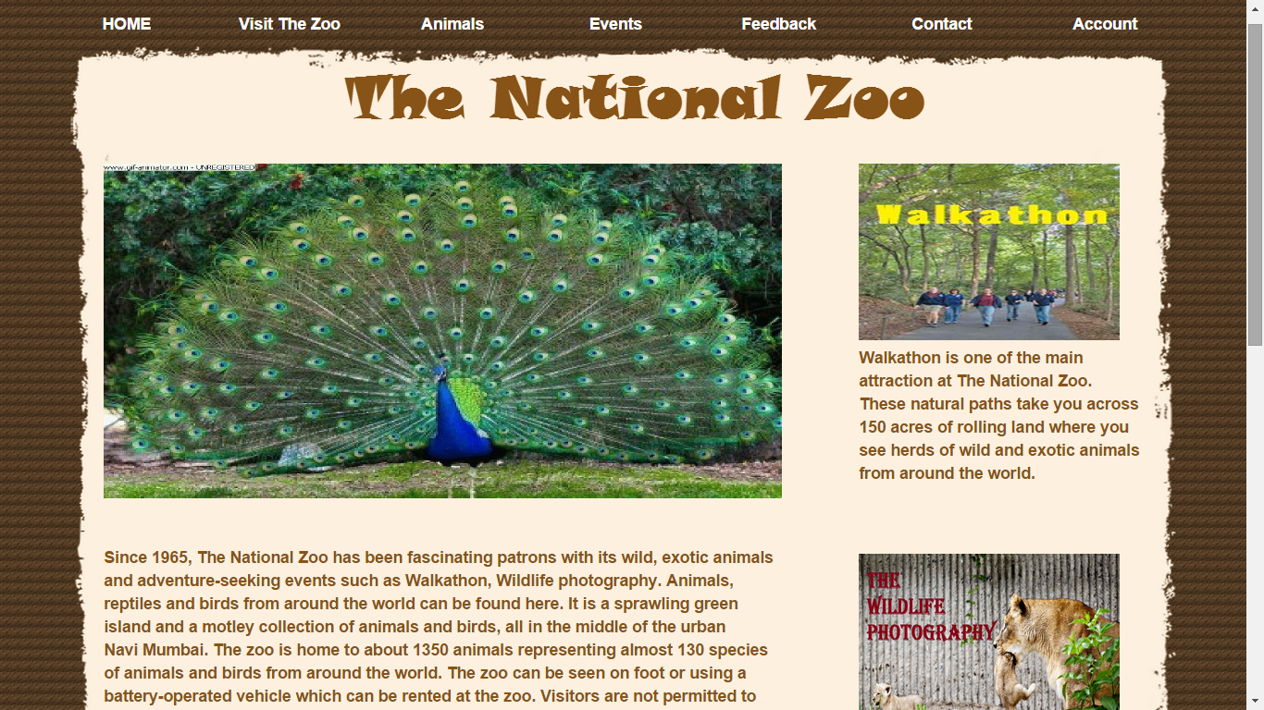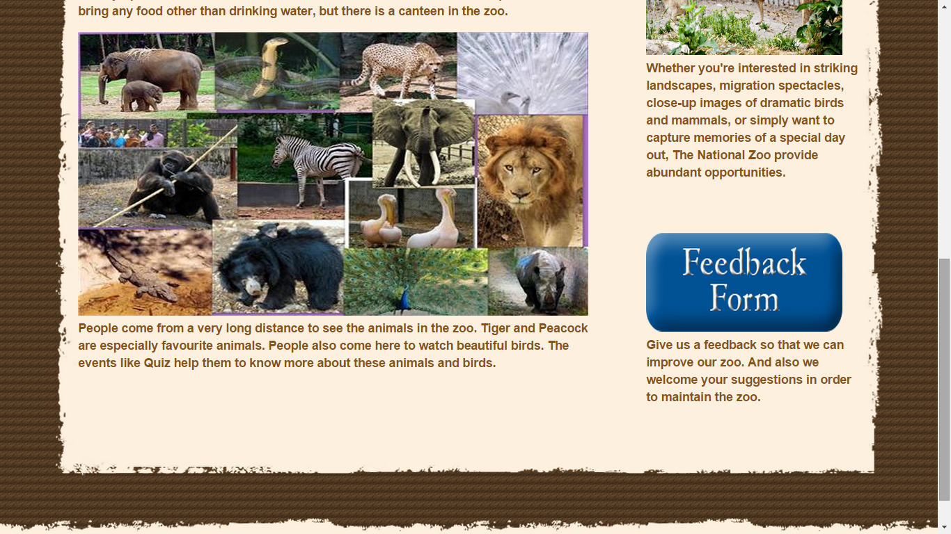

Login page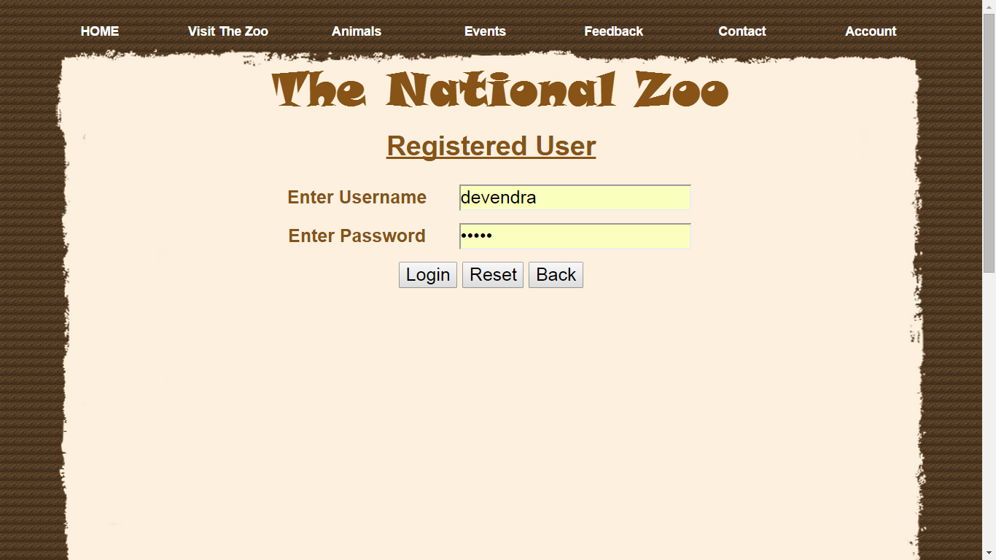

Create new account page

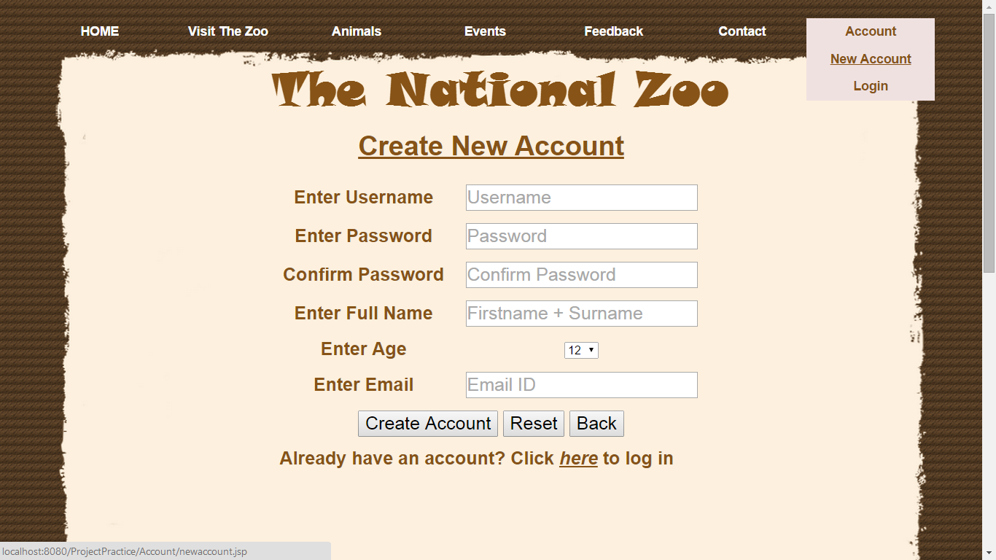

Animals page

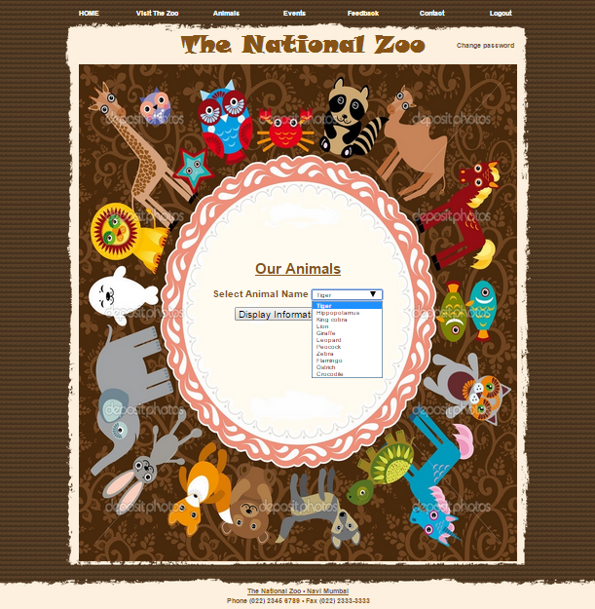

Display animal

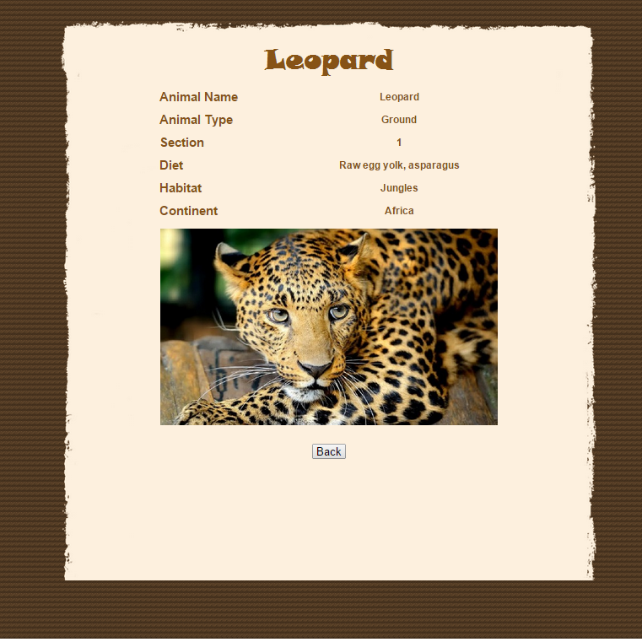

Events page

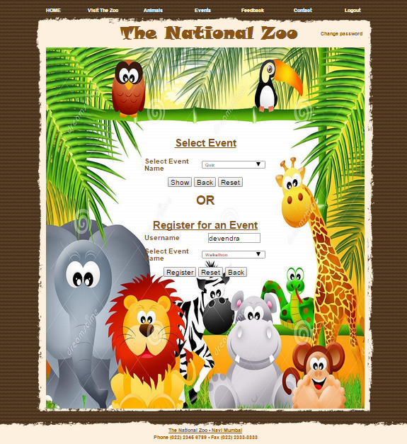

Display event

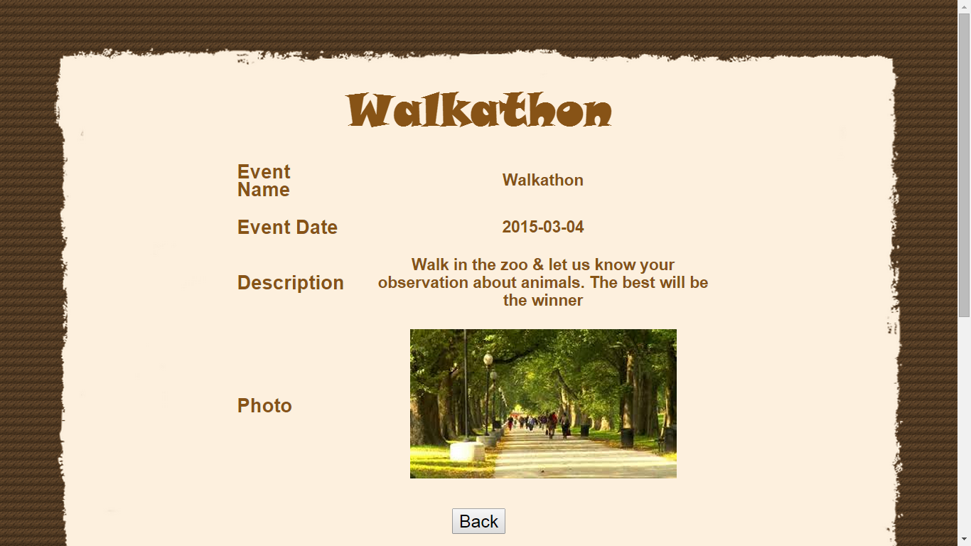

Registered for event

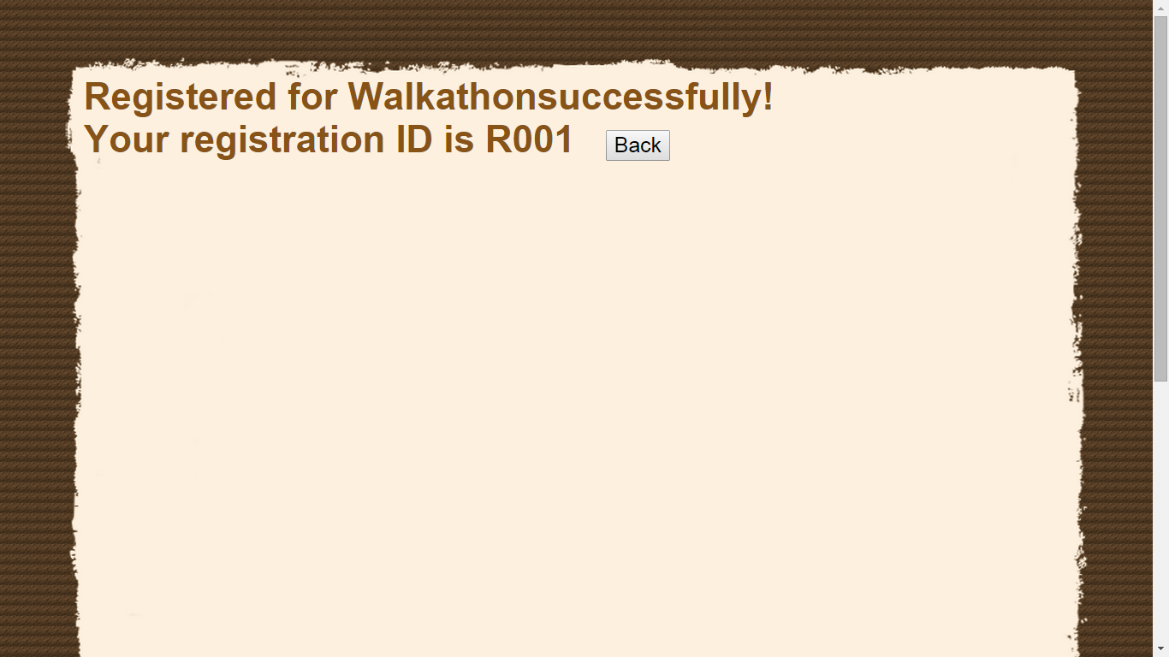

Feedback

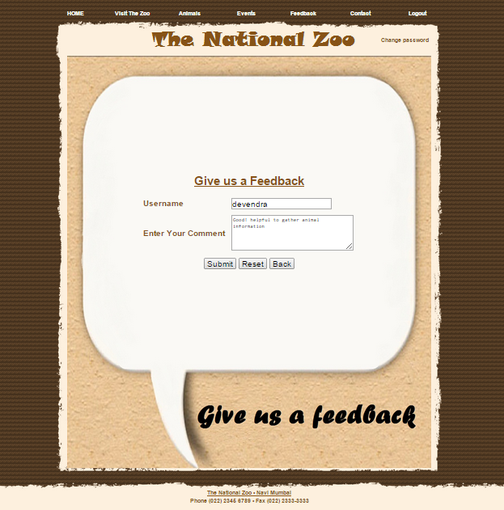

Static page (Map)

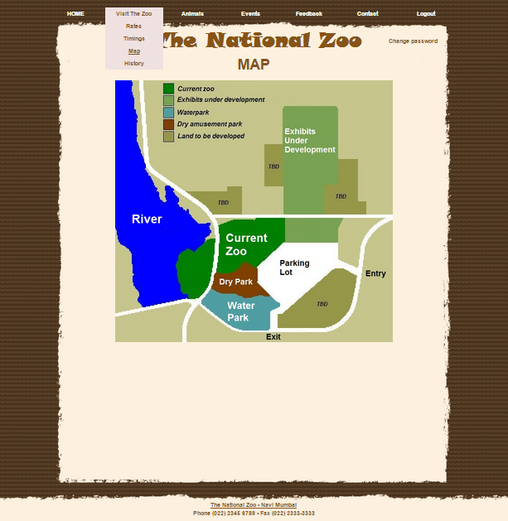

Change password

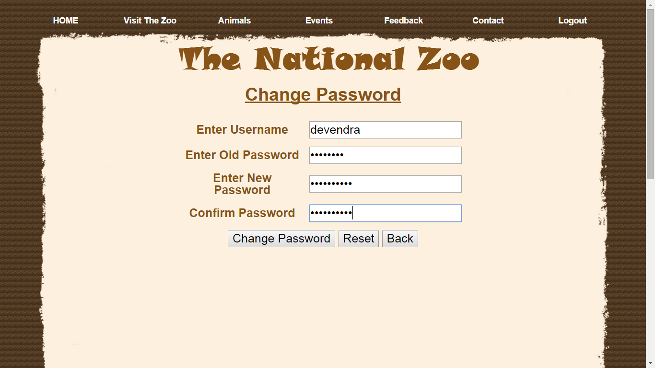

Confirmation

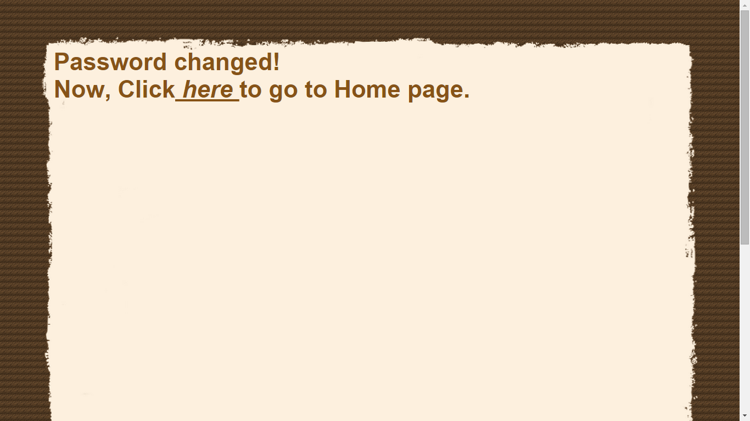Admin login

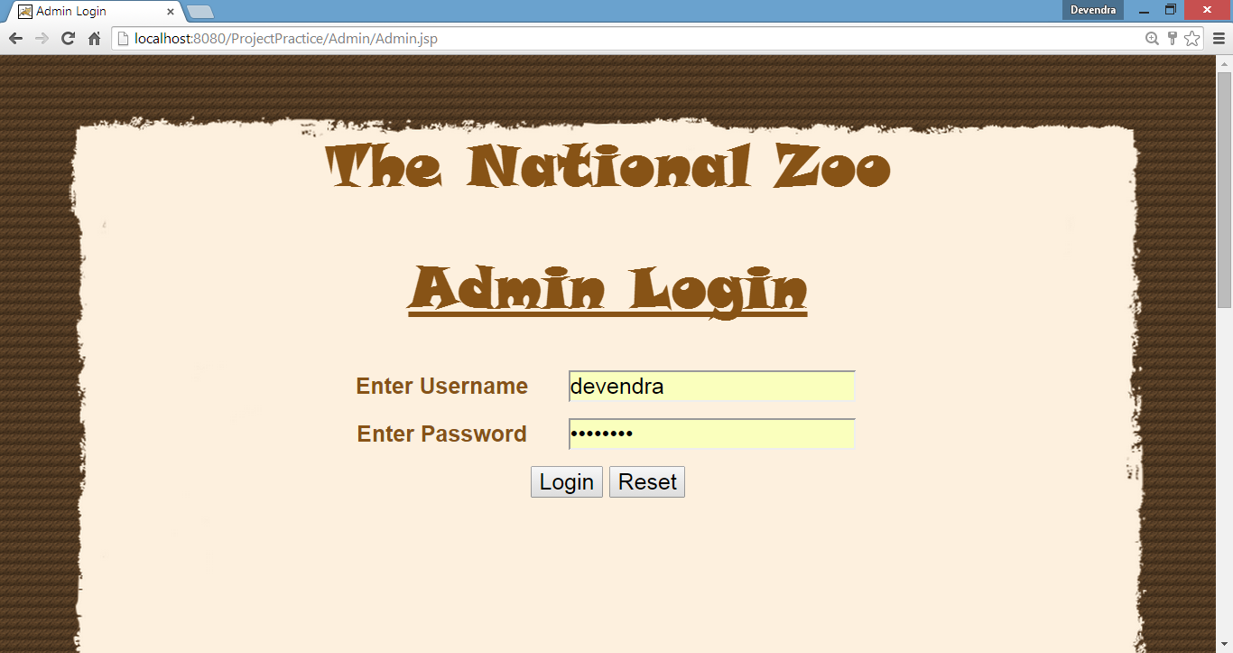

Animal page

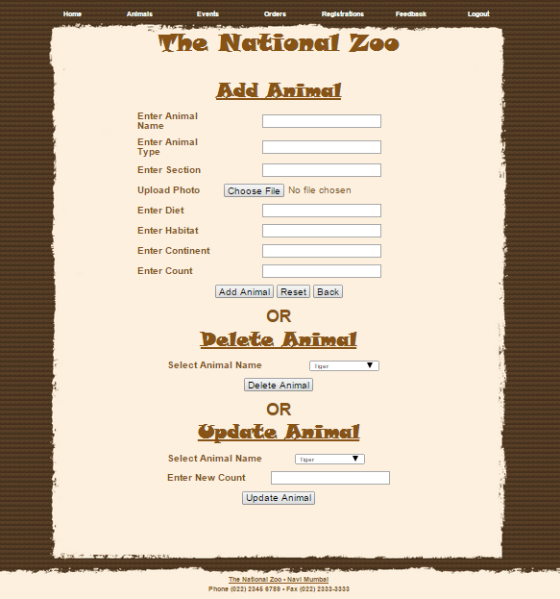

Adding animal

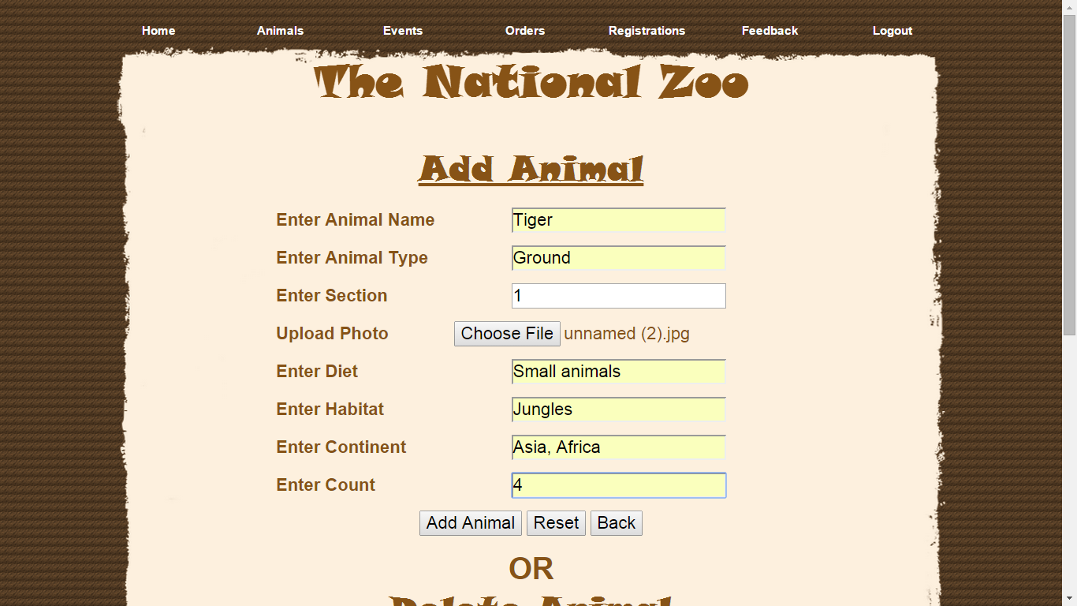

Confirmation

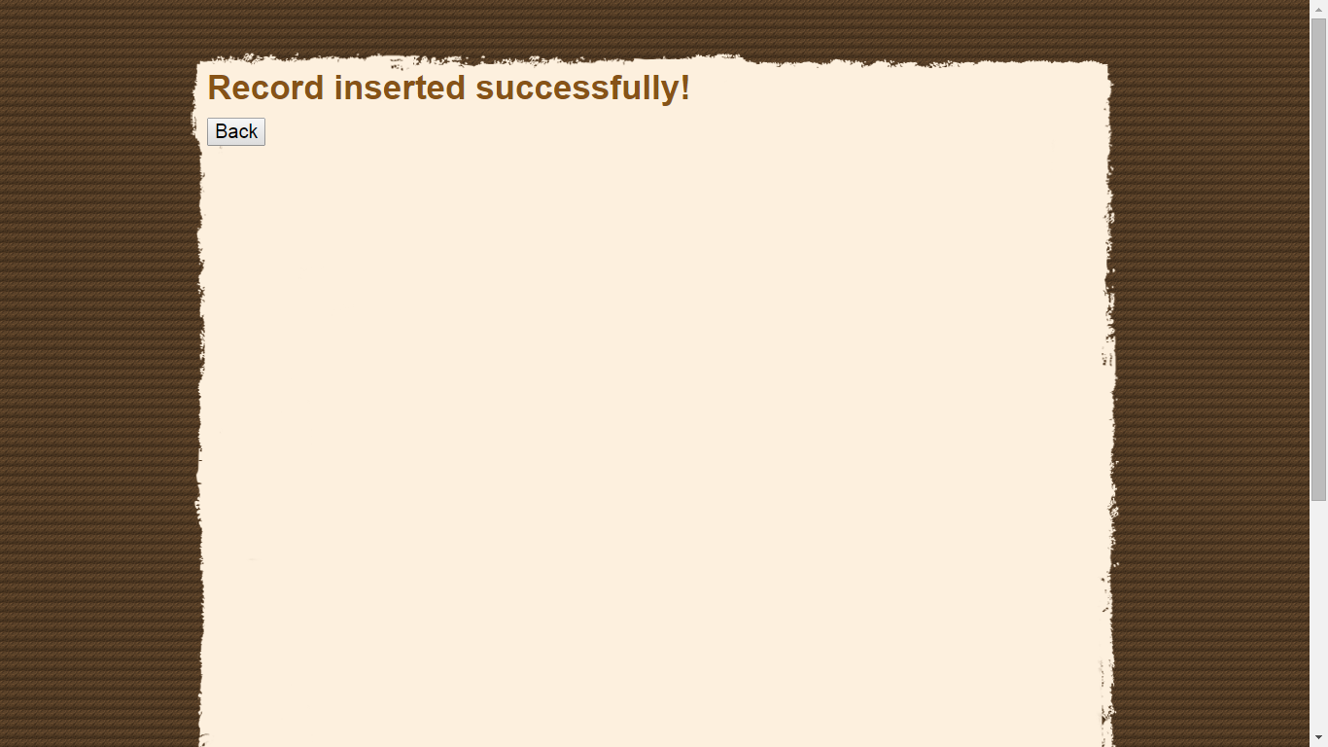

Animal deletion

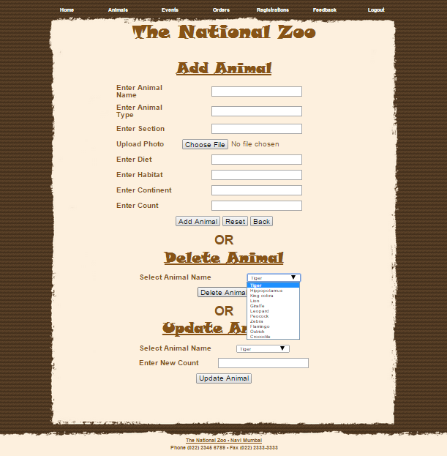

Confirmation

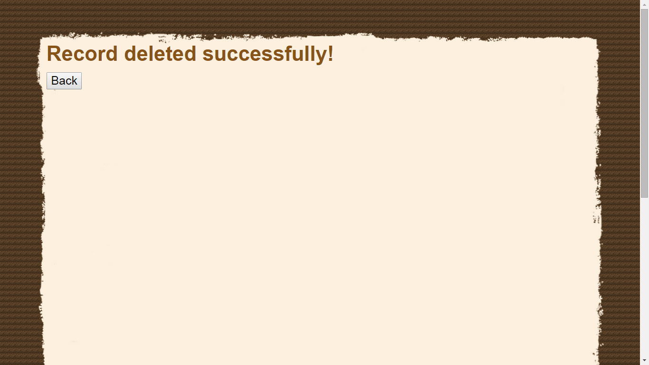

Updating animal count

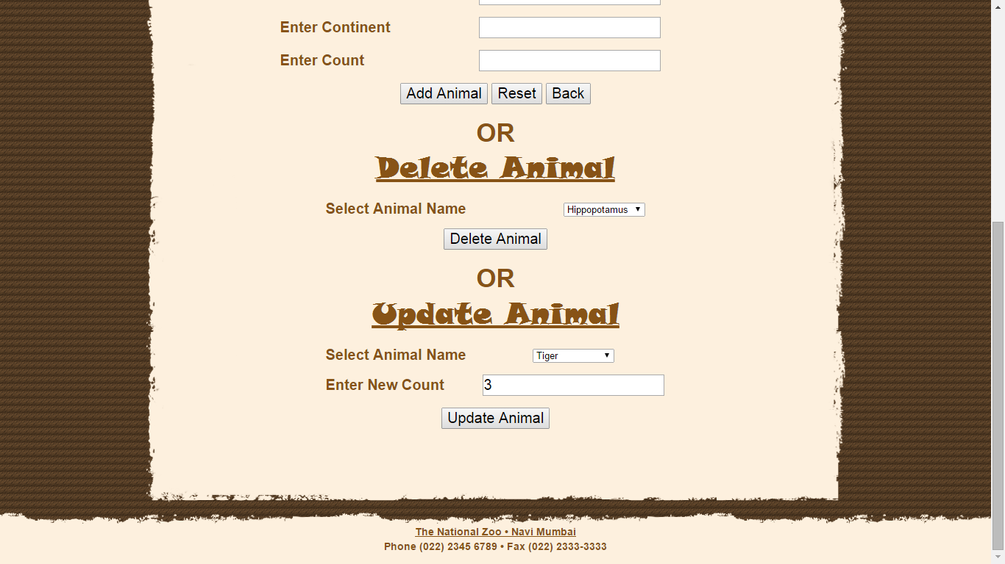

Confirmation

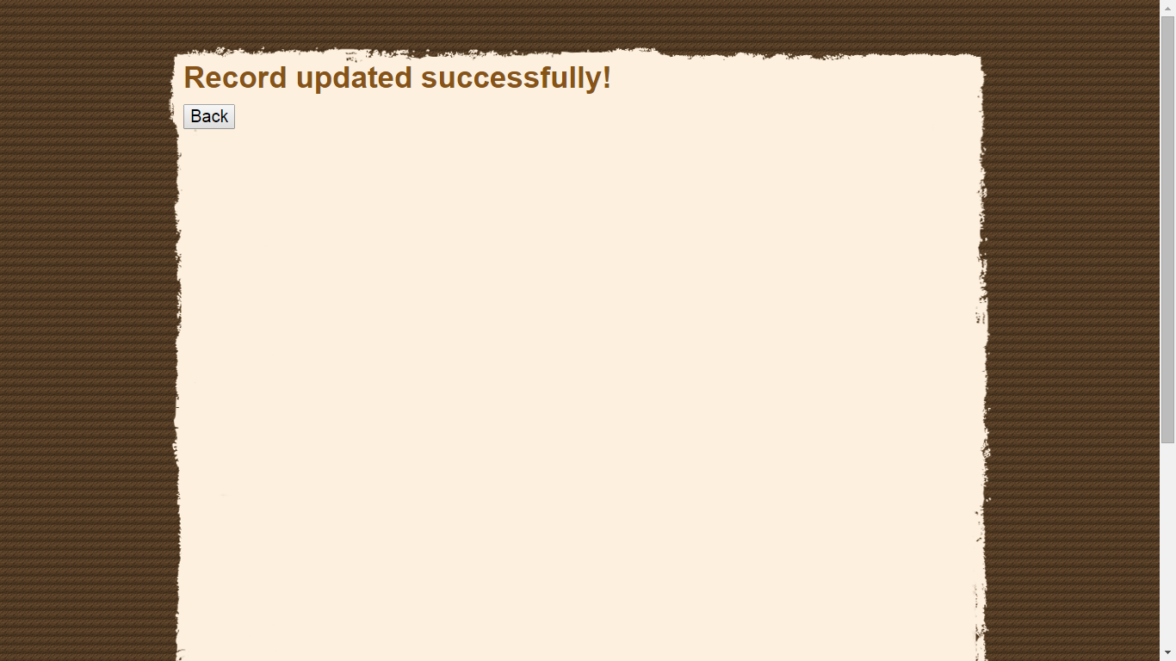

Events page

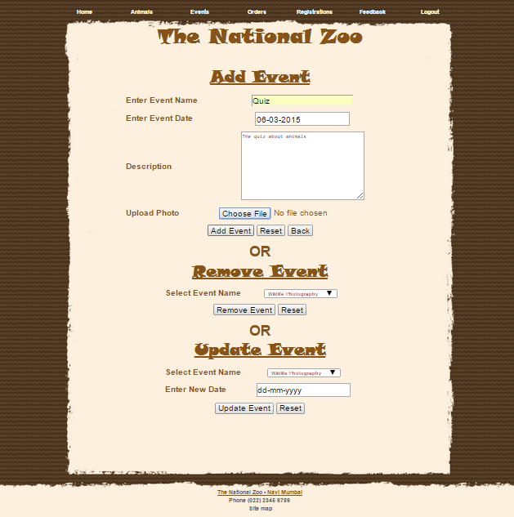

Removing and updating event

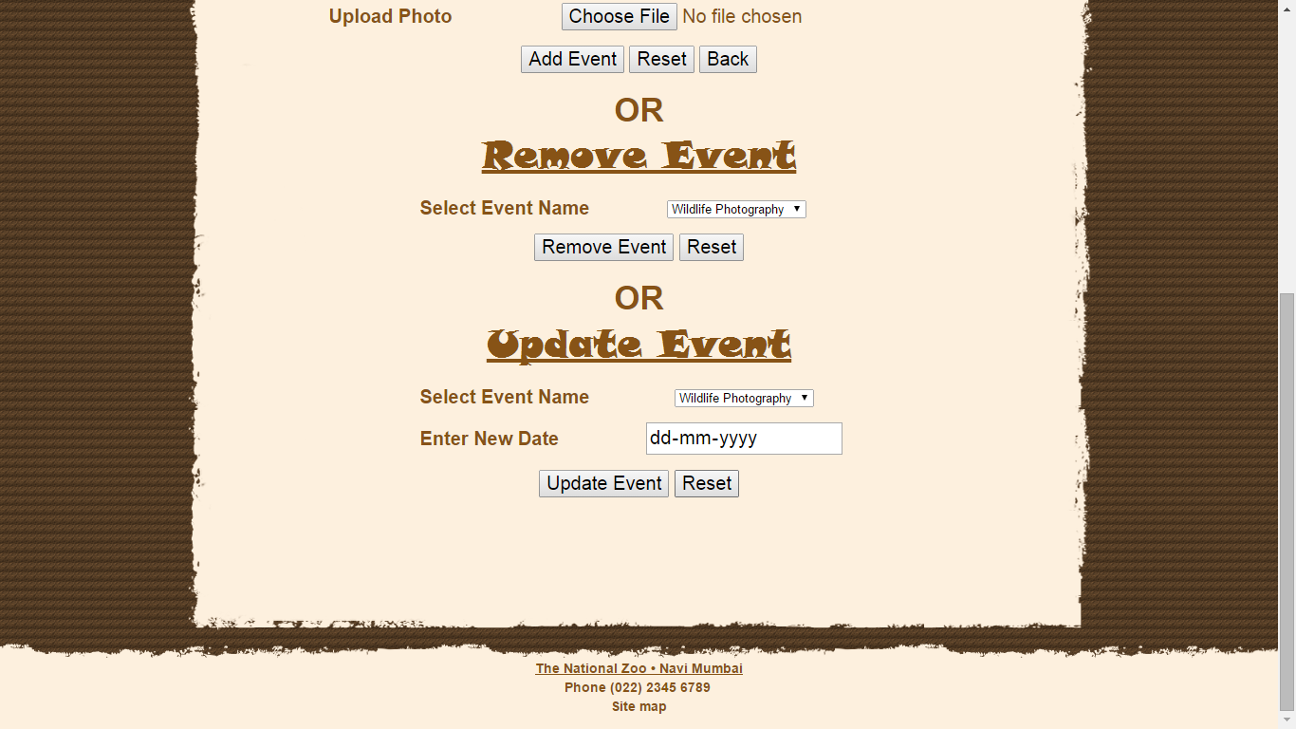

Adding a new order

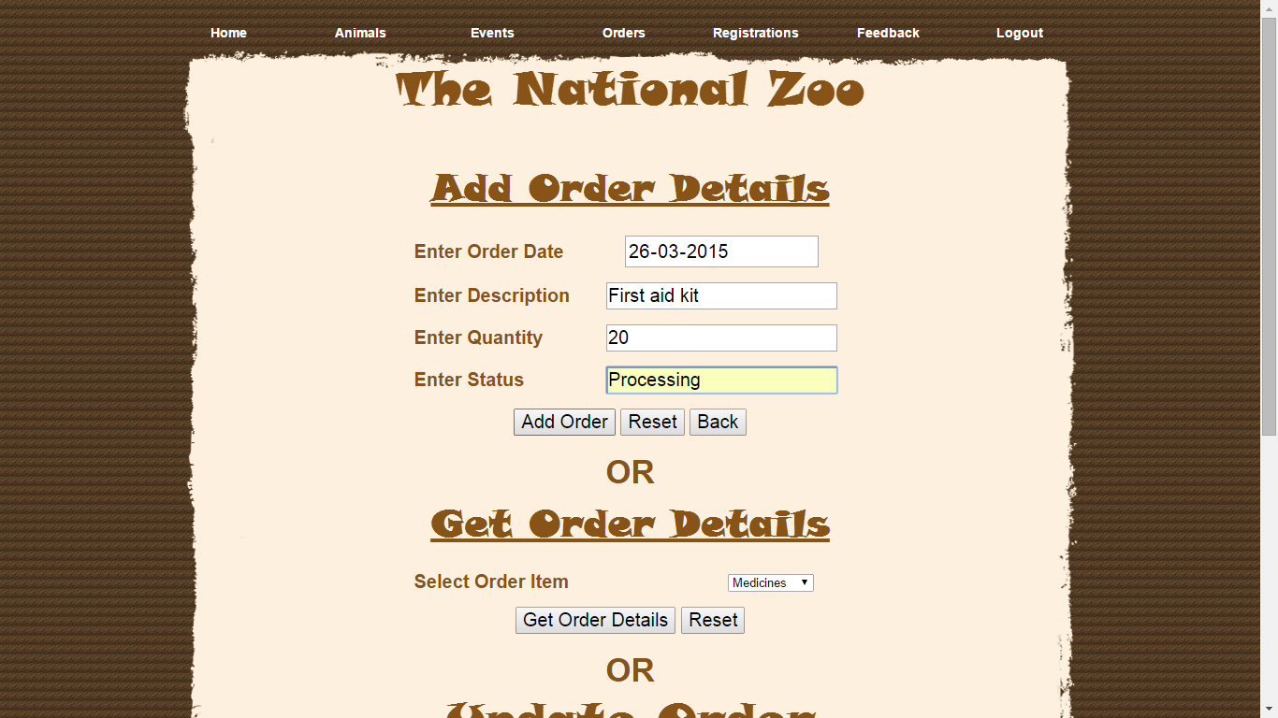

Confirmation



Getting order details

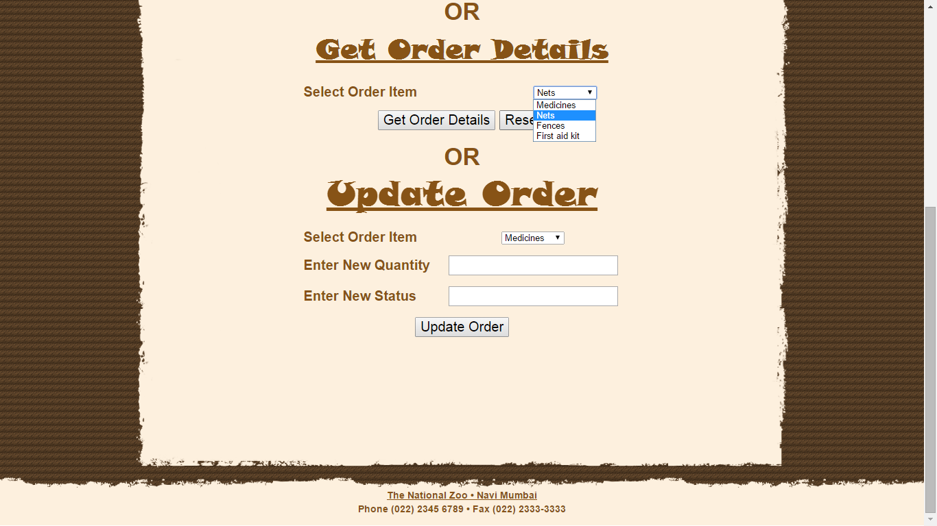

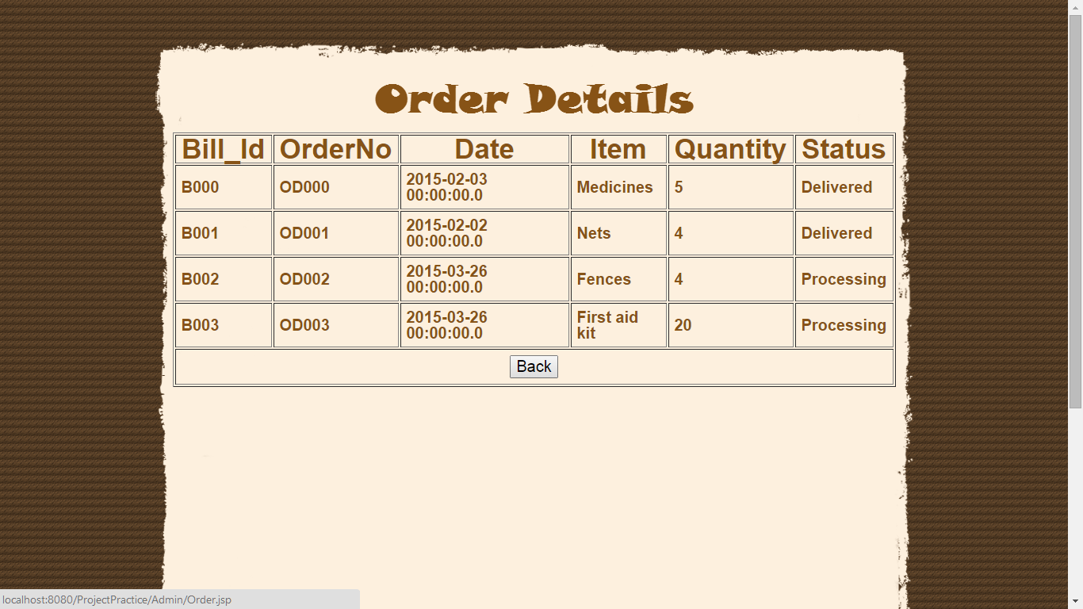

Updating the order

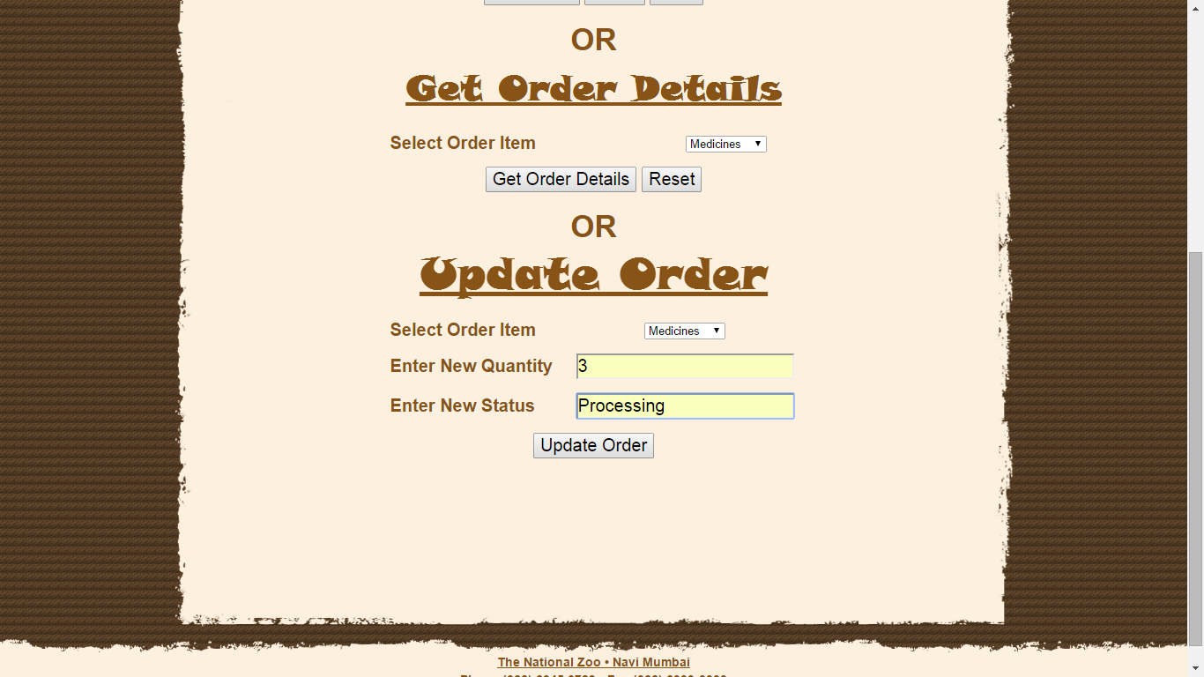

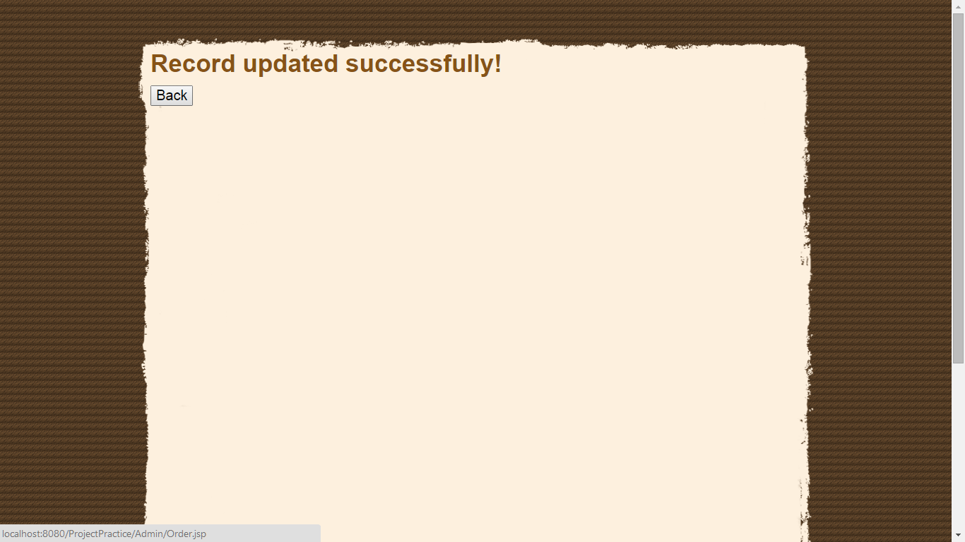

Feedback page

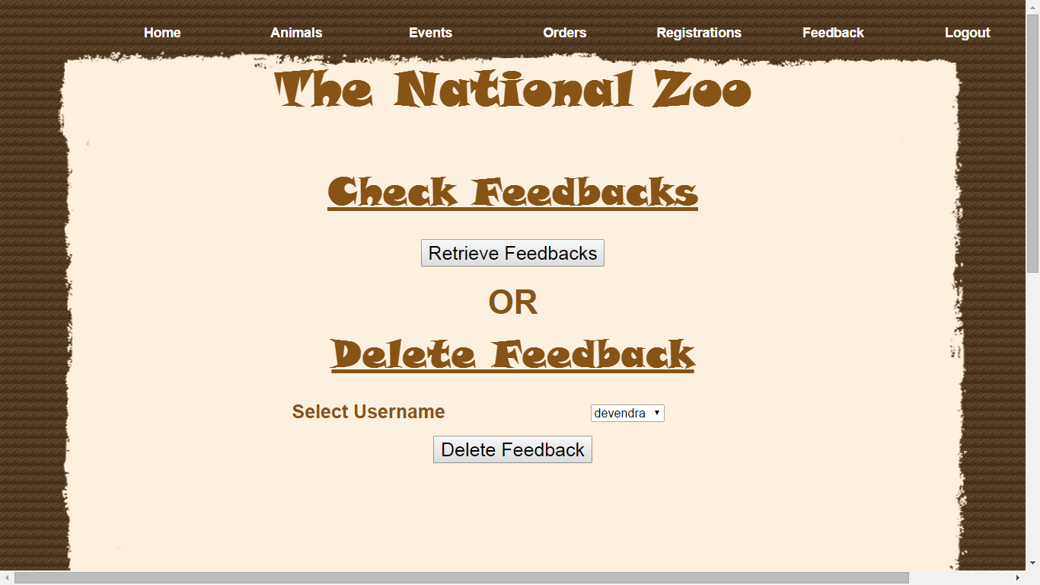

Checking feedbacks

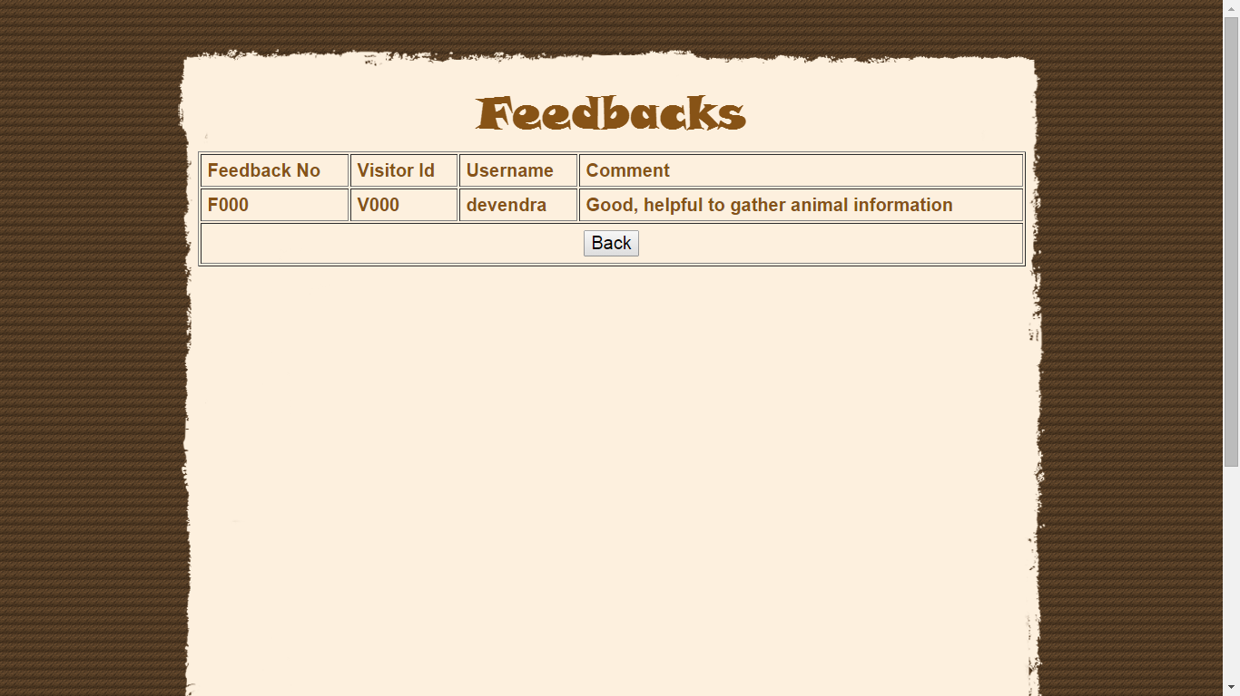

Registrations

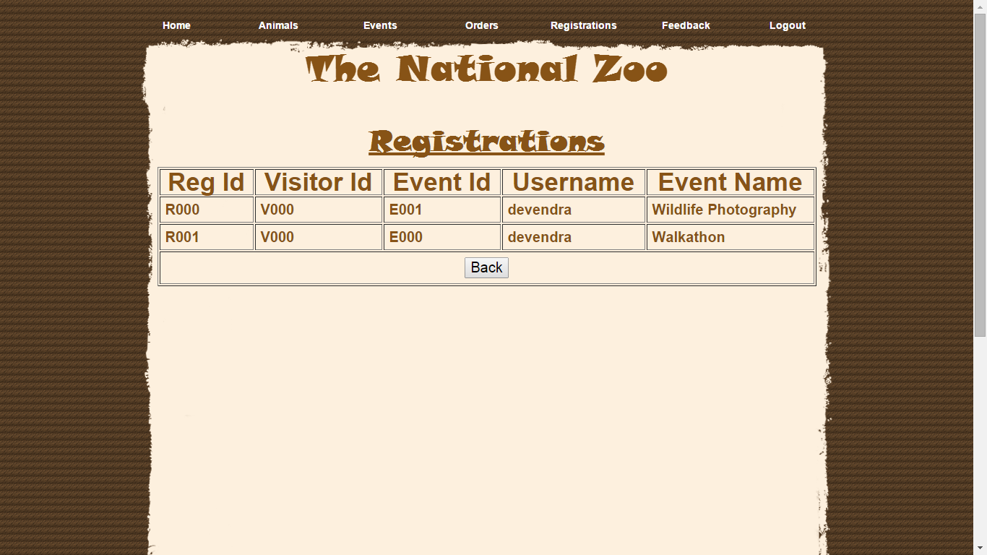

**PROGRAM LIST INDEX AND PROGRAM CODE LISTING:**

**home.css**

@charset "utf-8";

/* CSS Document */

body {background:url(Images/bg-body.gif);

height:auto;

width:auto;

margin:0 auto;}

#bodybg {background:url(Images/bg-page.gif) no-repeat center 0;

height:auto;

width:auto;

margin:0 auto;}

#bodybg-home

{

width: 960px;

margin: 0 auto;

overflow: hidden;

height: auto;

padding-bottom: 30px;}

#rightbar

{

color: #875316;

font-size: 15px;

font-weight: normal;

font-family: arial;

margin: 15px 0;

line-height: 25px;

text-align: justify;

width: 585px;

}

#header {font-family: arial;

width:960px;

margin:0 auto;

position:relative;

top: 0px;

left: 0px;

height: 20px;

}

#change{font-family:Arial, Helvetica, sans-serif; color: #875316; font-size:14px; font-weight:bold; line-height:20px; margin-top : -50px; margin-left: 750px; }

p {font-family:Arial, Helvetica, sans-serif; color: #875316; font-size:14px; font-weight:bold; line-height:20px; }

ul, ol {font-family:Arial, Helvetica, sans-serif; font-size:14px; font-weight:bold; line-height:20px; }

li {font-family:Arial, Helvetica, sans-serif; font-size:14px; line-height:20px; }

h1

{

font-family: 'Snap ITC';

font-size: 50px;

font-weight: bold;

text-transform: capitalize;

color: #875316;

text-align: center;

}

a, a:link, a:visited, a:active

{

color: #FFFFFF;

font-weight: bold;

text-decoration: none;

width: 121px;

}

a:hover

{

color: #875316;

font-weight: bold;

text-decoration: underline;

}

.header {color:#484e23; font-size:18px; font-weight:bold; }

/**** menu ****/

.menu{ font-size:18px; font-weight:bold; line-height:18px; color: #FFFFFF; width:1020px; height:120px;

padding:0px 0px 0px 20px;

}

ul {list-style: none;padding: 0px;margin: 0px;}

ul li {display: block;position: relative;float: left; }

li ul {display: none; }

ul li a

{

display: block;

background: none;

padding: 5px 10px 5px 10px;

text-decoration: none;

white-space: nowrap;

color: #875316;

}

ul li a:hover

{

background: #F0E1E1;

color: #875316;

}

li:hover ul {display: block; position: absolute;}

li:hover li {float: none;}

li:hover a

{

background: #F0E1E1;

color: #875316;

}

li:hover li a:hover

{

}

#drop-nav li ul li {border-top: 0px;}

/**** end menu ****/

#footer {

background: url(Images/bg-footer.gif) repeat-x center top;

padding: 7px 0 0;

overflow: hidden;

}

#footer div p

{

text-align: center;

font-size: 12px;

color: #ad8753;

font-family: arial;

clear: both;

margin: 0 0 47px;

}

**HomeGuest.html**

<!DOCTYPE html>

<html>

<head>

<meta http-equiv="Content-Type" content="text/html; charset=utf-8" />

<title>The National Zoo</title>

<link href="home.css" rel="stylesheet" type="text/css" />

</head>

<body>

<center>

<div id="bodybg">

<div id="header">

</div>

<div class="menu">

<ul id="drop-nav">

<li><a href="HomeVerify.jsp"><font id="hd">HOME</font></a></li>

<li><a href="#">Visit The Zoo</a>

<ul>

<li><a href="VisitZoo/RatesVerify.jsp">Rates</a></li>

<li><a href="VisitZoo/TimingVerify.jsp">Timings</a></li>

<li><a href="VisitZoo/MapsVerify.jsp">Map</a></li>

<li><a href="VisitZoo/HistoryVerify.jsp">History</a></li>

</ul>

</li>

<li><a href="AnimalSearch/AnimalVerify.jsp" >Animals</a></li>

<li><a href="Events/EventVerify.jsp" >Events</a></li>

<li><a href="Feedback/FeedbackVerify.jsp" >Feedback</a></li>

<li><a href="ContactVerify.jsp">Contact</a></li>

<li><a href="#">Account</a>

<ul>

<li><a href="Account/newaccount.jsp">New Account</a></li>

<li><a href="Account/Login.jsp">Login</a></li>

</ul>

</li>

</ul>

<br /><br /><h1>The National Zoo</h1>

</div>

<div id="bodybg-home">

<table width="900" border="0" align="center" cellspacing="0">

<tr>

<td valign="top" width="600">

<p><img src="Images/TheZoo.gif" width="586" height="326" alt="The Zoo" /><br>

<span class="rightbar">Since 1965, The National Zoo has been fascinating patrons with its wild, exotic animals<br /> and adventure-seeking events such as Walkathon, Wildlife photography. Animals, <br />reptiles and birds from around the world can be found here.

It is a sprawling green<br /> island and a motley collection of animals and birds, all in the middle of the urban<br /> Navi Mumbai. The zoo is home to about 1350 animals representing almost 130 species<br /> of animals and birds from around the world.

The zoo can be seen on foot or using a<br /> battery-operated vehicle which can be rented at the zoo. Visitors are not permitted to <br />bring any food other than drinking water, but there is a canteen in the zoo.</span></p>

<p><img src="Images/Collage1.jpg" width="586" height="326" alt="Collage of Animals" /><br>

<span class="rightbar">People come from a very long distance to see the animals in the zoo. Tiger and Peacock<br /> are especially favourite animals. People also come here to watch beautiful birds. The<br /> events like Quiz help them to know more about these animals and birds. </span></p>

</td>

<td valign="top" width="225">

<p><a href="Events/EventVerify.jsp"><img src="Images/Walkathon.jpg" alt="Walkathon" width="225" height="153" border="0" /></a><span class="rightbar">Walkathon is one of the main attraction at The National Zoo. These natural paths take you across 150 acres of rolling land where you see herds of wild and exotic animals from around the world.</span></p><br>

<p><a href="Events/EventVerify.jsp"><img src="Images/Photography.jpg" alt="Photography" width="225" height="194" border="0" /></a>

<span class="rightbar">Whether you're interested in striking landscapes, migration spectacles, close-up images of dramatic birds and mammals, or simply want to capture memories of a special day out, The National Zoo provide abundant opportunities.</span></p><br>

<p><a href="Feedback/FeedbackVerify.jsp"><img src="Images/Feedback button.png" alt="Feedback" width="225" height="114" border="0" /></a>

<span class="rightbar">Give us a feedback so that we can improve our zoo. And also we welcome your suggestions in order to maintain the zoo.</span></p><br>

<p>&nbsp;</p>

</td>

</tr>

</table>

</div>

<div id="footer">

<p><strong><u>The National Zoo &bull; Navi Mumbai</u></strong><br />

<strong>Phone (022) 2345 6789 <br><a href="Sitemap.html" id="here">Site map</a></strong></p>

</div>

</div>

</center>

</body>

</html>

**RatesGuest.html**

<!DOCTYPE html>

<html>

<head>

<meta http-equiv="Content-Type" content="text/html; charset=utf-8" />

<title>Rates</title>

<link href="Rates.css" rel="stylesheet" type="text/css" />

</head>

<body>

<center>

<div id="bodybg">

<div id="header">

</div>

<div class="menu">

<ul id="drop-nav">

<li><a href="../HomeVerify.jsp"><font id="hd">HOME</font></a></li>

<li><a href="#">Visit The Zoo</a>

<ul>

<li><a href="RatesVerify.jsp">Rates</a></li>

<li><a href="TimingVerify.jsp">Timings</a></li>

<li><a href="MapsVerify.jsp">Map</a></li>

<li><a href="HistoryVerify.jsp">History</a></li>

</ul>

</li>

<li><a href="../AnimalSearch/AnimalVerify.jsp">Animals</a></li>

<li><a href="../Events/EventVerify.jsp">Events</a></li>

<li><a href="../Feedback/FeedbackVerify.jsp">Feedback</a></li>

<li><a href="../ContactVerify.jsp">Contact</a></li>

<li><a href="#">Account</a>

<ul>

<li><a href="../Account/newaccount.jsp">New Account</a></li>

<li><a href="../Account/Login.jsp">Login</a></li>

</ul>

</li>

</ul>

<br /><br /><h1>The National Zoo</h1>

</div>

<div id="bodybg-home">

<table border="0" align="center" width="60%" cellpadding="7">

<tr>

<th align="center">ZOO RATES<br><br></th>

</tr>

<tr>

<td>Rates given are for the general public. For groups of 20 or more, see <font>Group Rates and Information.</font> Children under 3 years of age are free for all attractions.<br><br></td>

</tr>

<tr>

<td><span style="font-size: x-large"><span><strong>2014 Season</strong></span></span></td>

</tr>

<tr>

<td><p><b>Admission Fees</b> : ₹200.00 &ndash; all ages 12 years and older</p>

<p>All persons entering the Zoo must pay Parking Charges separately</p>

<p><b>Events Charges</b> : ₹200.00 &ndash; all ages 12 years and older</p>

<p><b>Discounts</b> : Every Day - Includes 25% for Senior citizens, Handicapped and ages between 2-12 years. (ID required)<br>

Children below age 3 are free for all attractions at the park</p><br>

</td>

</tr>

<tr>

<td><span style="font-size: x-large"><span><strong>Group Rates and Information</strong></span></span></td>

</tr>

<tr>

<td><p>The National Zoo welcomes groups to a world of animals and an adventurous education.

Many schools, recreational clubs and businesses have discovered the value of our zoo as a destination for class trips, club outings and company picnics.

May, September and October are ideal months to schedule group trips. We accept groups everyday the park is open and also Thursdays and Fridays in September and October.

The hours of operation for groups will vary so please refer to the Group Schedule listed below.</p>

<p>To receive group rates, you must have a minimum of 20 people (ages 12 years and older) AND pre-schedule your trip.

Advance reservations are required for groups and must be made at least two weeks in advance of schedule date.

For our handicapped and elderly visitors, please note that the park has gravel walkways.</p>

<p>To schedule a group visit to our park , call the park number <br>(022) 2345 6789 on Monday through Friday from 10 a.m. to 5 p.m.</p>

</td>

</tr>

<tr>

<td><span style="font-size: x-large"><span><strong>The special group rates per person for 2014 Season are as follow:</strong></span></span></td>

</tr>

<tr>

<td><p><b>Group Park Admission</b> : ₹150.00 &ndash; all ages 12 years and older</p>

<p><b>Events Charges</b> : ₹150.00 &ndash; all ages 12 years and older <br>(Includes the Events Walkathon, Photography and Quiz)</p>

</td>

</tr>

</table>

</div>

<div id="footer">

<p><strong><u>The National Zoo &bull; Navi Mumbai</u></strong><br />

<strong>Phone (022) 2345 6789 <br><a href="Sitemap.html" id="here">Site map</a></strong></p>

</div>

</div>

</center>

</body>

</html>

**TimingGuest.html**

<!DOCTYPE html>

<html>

<head>

<meta http-equiv="Content-Type" content="text/html; charset=utf-8" />

<title>Timing</title>

<link href="Timing.css" rel="stylesheet" type="text/css" />

</head>

<body>

<center>

<div id="bodybg">

<div id="header">

</div>

<div class="menu">

<ul id="drop-nav">

<li><a href="../HomeVerify.jsp"><font id="hd">HOME</font></a></li>

<li><a href="#">Visit The Zoo</a>

<ul>

<li><a href="RatesVerify.jsp">Rates</a></li>

<li><a href="TimingVerify.jsp">Timings</a></li>

<li><a href="MapsVerify.jsp">Map</a></li>

<li><a href="HistoryVerify.jsp">History</a></li>

</ul>

</li>

<li><a href="../AnimalSearch/AnimalVerify.jsp">Animals</a></li>

<li><a href="../Events/EventVerify.jsp">Events</a></li>

<li><a href="../Feedback/FeedbackVerify.jsp">Feedback</a></li>

<li><a href="../ContactVerify.jsp">Contact</a></li>

<li><a href="#">Account</a>

<ul>

<li><a href="../Account/newaccount.jsp">New Account</a></li>

<li><a href="../Account/Login.jsp">Login</a></li>

</ul>

</li>

</ul>

<br /><br /><h1>The National Zoo</h1>

</div>

<div id="bodybg-home">

<table border="0" align="center" width="50%" cellpadding="7">

<tr>

<th align="center">ZOO TIMINGS<br><br></th>

</tr>

<tr>

<td><span style="font-size: x-large"><span><strong>2014 Season</strong></span></span></td>

</tr>

<tr>

<td><p><b>March to May</b><br>

Monday to Friday : 10 a.m. - 6 p.m.<br>

Saturday & Sunday : 9 a.m. - 7 p.m.</p>

</td>

</tr>

<tr>

<td><p><b>June to September</b><br>

Monday to Friday : 12 p.m. - 5 p.m.<br>

Saturday & Sunday : 11 a.m. - 6 p.m.</p>

</td>

</tr>

<tr>

<td><p><b>October to February</b><br>

Monday to Friday : 11 a.m. - 5 p.m.<br>

Saturday & Sunday : 10 a.m. - 6 p.m.</p>

</td>

</tr>

</table>

</div>

<div id="footer">

<p><strong><u>The National Zoo &bull; Navi Mumbai</u></strong><br />

<strong>Phone (022) 2345 6789 <br><a href="Sitemap.html" id="here">Site map</a></strong></p>

</div>

</div>

</center>

</body>

</html>

**MapsGuest.html**

<!DOCTYPE html>

<html>

<head>

<meta http-equiv="Content-Type" content="text/html; charset=utf-8" />

<title>Maps</title>

<link href="Maps.css" rel="stylesheet" type="text/css" />

</head>

<body>

<center>

<div id="bodybg">

<div id="header">

</div>

<div class="menu">

<ul id="drop-nav">

<li><a href="../HomeVerify.jsp"><font id="hd">HOME</font></a></li>

<li><a href="#">Visit The Zoo</a>

<ul>

<li><a href="../VisitZoo/RatesVerify.jsp">Rates</a></li>

<li><a href="../VisitZoo/TimingVerify.jsp">Timings</a></li>

<li><a href="MapsVerify.jsp">Map</a></li>

<li><a href="../VisitZoo/HistoryVerify.jsp">History</a></li>

</ul>

</li>

<li><a href="../AnimalSearch/AnimalVerify.jsp">Animals</a></li>

<li><a href="../Events/EventVerify.jsp">Events</a></li>

<li><a href="../Feedback/FeedbackVerify.jsp">Feedback</a></li>

<li><a href="../ContactVerify.jsp">Contact</a></li>

<li><a href="#">Account</a>

<ul>

<li><a href="../Account/newaccount.jsp">New Account</a></li>

<li><a href="../Account/Login.jsp">Login</a></li>

</ul>

</li>

</ul>

<br /><br /><h1>The National Zoo</h1>

</div>

<div id="bodybg-home">

<table border="0" align="center" width="60%" cellpadding="7">

<tr>

<th align="center">MAP<br><br></th>

</tr>

</table>

<img src ="../Images/ZooMap.JPG" alt="Zoo Map">

</div>

<div id="footer">

<p><strong><u>The National Zoo &bull; Navi Mumbai</u></strong><br />

<strong>Phone (022) 2345 6789 <br><a href="Sitemap.html" id="here">Site map</a></strong></p>

</div>

</div>

</center>

</body>

</html>

**HistoryGuest.html**

<!DOCTYPE html>

<html>

<head>

<meta http-equiv="Content-Type" content="text/html; charset=utf-8" />

<title>History</title>

<link href="History.css" rel="stylesheet" type="text/css" />

</head>

<body>

<center>

<div id="bodybg">

<div id="header">

</div>

<div class="menu">

<ul id="drop-nav">

<li><a href="../HomeVerify.jsp"><font id="hd">HOME</font></a></li>

<li><a href="#">Visit The Zoo</a>

<ul>

<li><a href="RatesVerify.jsp">Rates</a></li>

<li><a href="TimingVerify.jsp">Timings</a></li>

<li><a href="MapsVerify.jsp">Map</a></li>

<li><a href="HistoryVerify.jsp">History</a></li>

</ul>

</li>

<li><a href="../AnimalSearch/AnimalVerify.jsp">Animals</a></li>

<li><a href="../Events/EventVerify.jsp">Events</a></li>

<li><a href="../Feedback/FeedbackVerify.jsp">Feedback</a></li>

<li><a href="../ContactVerify.jsp">Contact</a></li>

<li><a href="#">Account</a>

<ul>

<li><a href="../Account/newaccount.jsp">New Account</a></li>

<li><a href="../Account/Login.jsp">Login</a></li>

</ul>

</li>

</ul>

<br /><br /><h1>The National Zoo</h1>

</div>

<div id="bodybg-home">

<table width="60%">

<tr><th>History<br><br></th></tr>

<tr>

<td>Since 1965, The National Zoo has been fascinating patrons with its wild, exotic animals and adventure-seeking events such as Walkathon, Wildlife photography. Animals, reptiles and birds from around the world can be found here.

It is a sprawling green island and a motley collection of animals and birds, all in the middle of the urban Navi Mumbai. The zoo is home to about 1350 animals representing almost 130 species of animals and birds from around the world.

The zoo can be seen on foot or using a battery-operated vehicle which can be rented at the zoo. Visitors are not permitted to bring any food other than drinking water, but there is a canteen in the zoo.</td>

</tr>

</table>

</div>

<div id="footer">

<p><strong><u>The National Zoo &bull; Navi Mumbai</u></strong><br />

<strong>Phone (022) 2345 6789 <br><a href="Sitemap.html" id="here">Site map</a></strong></p>

</div>

</div>

</center>

</body>

</html>

**ContactGuest.html**

<!DOCTYPE html>

<html>

<head>

<meta http-equiv="Content-Type" content="text/html; charset=utf-8" />

<title>The National Zoo | Contact</title>

<link href="Contact.css" rel="stylesheet" type="text/css" />

</head>

<body>

<center>

<div id="bodybg">

<div id="header">

</div>

<div class="menu">

<ul id="drop-nav">

<li><a href="HomeVerify.jsp"><font id="hd">HOME</font></a></li>

<li><a href="#">Visit The Zoo</a>

<ul>

<li><a href="VisitZoo/RatesVerify.jsp">Rates</a></li>

<li><a href="VisitZoo/TimingVerify.jsp">Timings</a></li>

<li><a href="VisitZoo/MapsVerify.jsp">Map</a></li>

<li><a href="VisitZoo/HistoryVerify.jsp">History</a></li>

</ul>

</li>

<li><a href="AnimalSearch/AnimalVerify.jsp">Animals</a></li>

<li><a href="Events/EventVerify.jsp">Events</a></li>

<li><a href="Feedback/FeedbackVerify.jsp">Feedback</a></li>

<li><a href="ContactVerify.jsp">Contact</a></li>

<li><a href="#">Account</a>

<ul>

<li><a href="Account/newaccount.jsp">New Account</a></li>

<li><a href="Account/Login.jsp">Login</a></li>

</ul>

</li>

</ul>

<br /><br /><h1>The National Zoo</h1>

</div>

<div id="bodybg-home">

<table border="0" align="center" width="50%" cellpadding="7">

<tr>

<th align="center"><font size="5"><u>Directory</u></font><br><br></th>

</tr>

<tr>

<td><span style="font-size: x-large"><span><strong>Mailing Address : </strong></span></span></td>

</tr>

<tr>

<td><p>450, Kharghar,<br>Navi Mumbai - 400999.</p>

<p>Phone number : 022-2345 6789</p>

<p>Fax Number : 022-2333 3333</p>

<p>Email : thenationalzoonm@gmail.com</p>

</td>

</tr>

</table>

</div>

<div id="footer">

<p><strong><u>The National Zoo &bull; Navi Mumbai</u></strong><br />

<strong>Phone (022) 2345 6789 <br><a href="Sitemap.html" id="here">Site map</a></strong></p>

</div>

</div>

</center>

</body>

</html>

**Newaccount.jsp**

<%@page contentType="text/html" pageEncoding="UTF-8"%>

<!DOCTYPE html>

<html>

<head>

<meta http-equiv="Content-Type" content="text/html; charset=utf-8" />

<title>New Account</title>

<link href="Newaccount.css" rel="stylesheet" type="text/css" />

</head>

<body>

<center>

<div id="bodybg">

<div id="header">

</div>

<div class="menu">

<ul id="drop-nav">

<li><a href="../HomeVerify.jsp"><font id="hd">HOME</font></a></li>

<li><a href="#">Visit The Zoo</a>

<ul>

<li><a href="../VisitZoo/RatesVerify.jsp">Rates</a></li>

<li><a href="../VisitZoo/TimingVerify.jsp">Timings</a></li>

<li><a href="../VisitZoo/MapsVerify.jsp">Map</a></li>

<li><a href="../VisitZoo/HistoryVerify.jsp">History</a></li>

</ul>

</li>

<li><a href="../AnimalSearch/AnimalVerify.jsp">Animals</a></li>

<li><a href="../Events/EventVerify.jsp">Events</a></li>

<li><a href="../Feedback/FeedbackVerify.jsp">Feedback</a></li>

<li><a href="../ContactVerify.jsp">Contact</a></li>

<li><a href="#">Account</a>

<ul>

<li><a href="newaccount.jsp">New Account</a></li>

<li><a href="Login.jsp">Login</a></li>

</ul>

</li>

</ul>

<br /><br /><h1>The National Zoo</h1>

</div>

<div id="bodybg-home">

<form name="newAc" action="NewaccountCheck.jsp">

<table border="0" align="center" width="50%" cellpadding="7">

<tr>

<th colspan="2"><font size="5"><u>Create New Account</u><br><br></font></th>

</tr>

<tr>

<td align="center">Enter Username</td>

<td align="center"><input type="text" name="txtUser" placeholder="Username" autofocus required pattern="[a-zA-Z]{5,}" title="Please enter more than 5 letters"></td>

</tr>

<tr>

<td align="center">Enter Password</td>

<td align="center"><input type="password" name="txtpwd" placeholder="Password" required><span id="pwd" hidden>Please match both passwords</span></td>

</tr>

<tr>

<td align="center">Confirm Password</td>

<td align="center"><input type="password" name="confirmPwd" placeholder="Confirm Password" required></td>

</tr>

<tr>

<td align="center">Enter Full Name</td>

<td align="center"><input type="text" name="txtName" autofocus placeholder="Firstname + Surname" required title="Firstname + Surname"></td>

</tr>

<tr>

<td align="center">Enter Age</td>

<td align="center"><select name="txtAge">

<% for (int i=12; i<91; i++)

{

out.println("<option>"+i+"</option>");

} %>

</select></td>

</tr>

<tr>

<td align="center">Enter Email</td>

<td align="center"><input type="email" name="txtEmail" placeholder="Email ID" required title="Please enter a valid Email ID"></td>

</tr>

<tr>

<td colspan="2" align="center"><input type="submit" value="Create Account">

<input type="reset" value="Reset"> <a href="../Home.jsp"><input type="button" value="Back"></a><br>

</td>

</tr>

<tr>

<td colspan="2">Already have an account? Click <a href="../Account/Login.jsp" id="here"><u><i>here</i></u></a> to log in</td>

</tr>

</table>

</FORM>

</div>

<div id="footer">

<p><strong><u>The National Zoo &bull; Navi Mumbai</u></strong><br />

<strong>Phone (022) 2345 6789 <br><a href="Sitemap.html" id="here">Site map</a></strong></p>

</div>

</div>

</center>

</body>

</html>

**NewAccountCheck.jsp**

<%@page import="java.sql.*"%>

<%@page contentType="text/html" pageEncoding="UTF-8"%>

<!DOCTYPE html>

<html>

<head>

<meta http-equiv="Content-Type" content="text/html; charset=UTF-8">

<title>Validate user</title>

<link href="Css.css" rel="stylesheet" type="text/css" />

</head>

<body>

<div id="bodybg">

<%!

Connection con;

Statement stmt;

ResultSet rs;

public void jspInit()

{

try{

Class.forName("sun.jdbc.odbc.JdbcOdbcDriver");

con = DriverManager.getConnection("jdbc:odbc:ZooDSN");

stmt = con.createStatement(ResultSet.TYPE_SCROLL_INSENSITIVE, ResultSet.CONCUR_READ_ONLY);

}

catch(SQLException e)

{

e.printStackTrace();

}

catch(Exception e)

{

e.printStackTrace();

}

}

%>

<%

String s1 = request.getParameter("txtUser");

String s2 = request.getParameter("txtpwd");

String s3 = request.getParameter("confirmpwd");

String s4 = request.getParameter("txtName");

String s5 = request.getParameter("txtEmail");

String s6 = request.getParameter("txtAge");

try

{

rs = stmt.executeQuery("select * from Visitor");

int r = 0;

String a1, a2;

while(rs.next())

{

boolean b = rs.last();

a1 = rs.getString("VisitorId");

a2 = a1.substring(3);

r = Integer.parseInt(a2);

r++;

}

String query1 = "insert into Visitor values ('V00" +r+ "','L00" +r+ "','" +s1+ "','" +s2+ "','" +s4+ "','" +s5+ "'," +s6+ ")" ;

int i = stmt.executeUpdate(query1);

%>

<div id="bodybg-home">

<br><br><br><br>

&nbsp; Account created!<br><br>

&nbsp; Now, Click<a href="Login.jsp" id ="here"><u><i> here </i></u></a>to go to Login page

</div>

<% }

catch(SQLException e)

{

e.printStackTrace();

}

catch(Exception e)

{

e.printStackTrace();

}

%>

</div>

</body>

</html>

**Login.jsp**

<!DOCTYPE html>

<html>

<head>

<meta http-equiv="Content-Type" content="text/html; charset=utf-8" />

<title>Login</title>

<link href="Login.css" rel="stylesheet" type="text/css" />

</head>

<body>

<center>

<div id="bodybg">

<div id="header">

</div>

<div class="menu">

<ul id="drop-nav">

<li><a href="../HomeVerify.jsp"><font id="hd">HOME</font></a></li>

<li><a href="#">Visit The Zoo</a>

<ul>

<li><a href="../VisitZoo/RatesVerify.jsp">Rates</a></li>

<li><a href="../VisitZoo/TimingVerify.jsp">Timings</a></li>

<li><a href="../VisitZoo/MapsVerify.jsp">Map</a></li>

<li><a href="../VisitZoo/HistoryVerify.jsp">History</a></li>

</ul>

</li>

<li><a href="../AnimalSearch/AnimalVerify.jsp">Animals</a></li>

<li><a href="../Events/EventVerify.jsp">Events</a></li>

<li><a href="../Feedback/FeedbackVerify.jsp">Feedback</a></li>

<li><a href="../ContactVerify.jsp">Contact</a></li>

<li><a href="#">Account</a>

<ul>

<li><a href="newaccount.jsp">New Account</a></li>

<li><a href="Login.jsp">Login</a></li>

</ul>

</li>

</ul>

<br /><br /><h1>The National Zoo</h1>

</div>

<div id="bodybg-home">

<form action="LoginCheck.jsp">

<table border="0" align="center" width="50%" cellpadding="7">

<tr>

<th colspan="2"><font size="5"><u>Registered User</u><br><br></font></th>

</tr>

<tr>

<td align="center">Enter Username</td>

<td align="center"><input type="text" name="txtUser" placeholder="Username" autofocus required pattern="[a-zA-Z]{5,}" title="Please enter a valid username"></td>

</tr>

<tr>

<td align="center">Enter Password</td>

<td align="center"><input type="password" name="txtpwd" required placeholder="Password"></td>

</tr>

<tr>

<td colspan="2" align="center"><input type="submit" value="Login">

<input type="reset" value="Reset"> <a href="../Home.jsp"><input type="button" value="Back"></a>

</td>

</tr>

</table>

</form>

</div>

<div id="footer">

<p><strong><u>The National Zoo &bull; Navi Mumbai</u></strong><br />

<strong>Phone (022) 2345 6789 &bull; Fax (022) 2333-3333</strong></p>

</div>

</div>

</center>

</body>

</html>

**LoginCheck.jsp**

<%@page import="java.sql.*"%>

<%@page contentType="text/html" pageEncoding="UTF-8"%>

<!DOCTYPE html>

<html>

<head>

<meta http-equiv="Content-Type" content="text/html; charset=UTF-8">

<title>Login</title>

<link href="Css.css" rel="stylesheet" type="text/css" />

</head>

<body>

<%!

Connection con;

Statement stmt;

ResultSet rs;

public void jspInit()

{

try{

Class.forName("sun.jdbc.odbc.JdbcOdbcDriver");

con = DriverManager.getConnection("jdbc:odbc:ZooDSN");

stmt = con.createStatement();

}

catch(SQLException e)

{

e.printStackTrace();

}

catch(Exception e)

{

e.printStackTrace();

}

}

%>

<%

String s1 = request.getParameter("txtUser");

String s2 = request.getParameter("txtpwd");

String query = "select * from Visitor where Username = '" +s1+ "' and Password = '" +s2+ "'";

rs = stmt.executeQuery(query);

try

{

if(rs.next())

{

session.setAttribute("username",s1);

response.sendRedirect("../Home.html");

}

else

{

response.sendRedirect("Login.jsp");

}

}

catch(SQLException e)

{

e.printStackTrace();

}

catch(Exception e)

{

e.printStackTrace();

}

%>

</body>

</html>

**ChangePass.jsp**

<%@page contentType="text/html" pageEncoding="UTF-8"%>

<html>

<head>

<meta http-equiv="Content-Type" content="text/html; charset=utf-8" />

<title>Login</title>

<link href="Login.css" rel="stylesheet" type="text/css" />

</head>

<body>

<center>

<div id="bodybg">

<div id="header">

</div>

<div class="menu">

<ul id="drop-nav">

<li><a href="../HomeVerify.jsp"><font id="hd">HOME</font></a></li>

<li><a href="#">Visit The Zoo</a>

<ul>

<li><a href="../VisitZoo/RatesVerify.jsp">Rates</a></li>

<li><a href="../VisitZoo/TimingVerify.jsp">Timings</a></li>

<li><a href="../VisitZoo/MapsVerify.jsp">Map</a></li>

<li><a href="../VisitZoo/HistoryVerify.jsp">History</a></li>

</ul>

</li>

<li><a href="../AnimalSearch/AnimalVerify.jsp">Animals</a></li>

<li><a href="../Events/EventVerify.jsp">Events</a></li>

<li><a href="../Feedback/FeedbackVerify.jsp">Feedback</a></li>

<li><a href="../ContactVerify.jsp">Contact</a></li>

<li><a href="Logout.jsp">Logout</a></li>

</ul>

<br /><br /><h1>The National Zoo</h1>

</div>

<div id="bodybg-home">

<form action="ChangePassCheck.jsp">

<%

String str = (String)session.getAttribute("username");

%>

<table border="0" align="center" width="50%" cellpadding="7">

<tr>

<th colspan="2"><font size="5"><u>Change Password</u><br><br></font></th>

</tr>

<tr>

<td align="center">Enter Username</td>

<td align="center"><input type="text" name="txtUser" value="<%= str %>" readonly="readonly"></td>

</tr>

<tr>

<td align="center">Enter Old Password</td>

<td align="center"><input type="password" name="txtOldPwd" required placeholder="Old Password"></td>

</tr>

<tr>

<td align="center">Enter New Password</td>

<td align="center"><input type="password" name="txtNewPwd" required placeholder="New Password"></td>

</tr>

<tr>

<td align="center">Confirm Password</td>

<td align="center"><input type="password" name="confirmPwd" required placeholder="Confirm Password"></td>

</tr>

<tr>

<td colspan="2" align="center"><input type="submit" value="Change Password">

<input type="reset" value="Reset"> <a href="../Home.jsp"><input type="button" value="Back"></a>

</td>

</tr>

</table>

</form>

</div>

<div id="footer">

<p><strong><u>The National Zoo &bull; Navi Mumbai</u></strong><br />

<strong>Phone (022) 2345 6789 &bull; Fax (022) 2333-3333</strong></p>

</div>

</div>

</center>

</body>

</html>

**ChangePassCheck.jsp**

<%@page import="java.sql.*"%>

<%@page contentType="text/html" pageEncoding="UTF-8"%>

<!DOCTYPE html>

<html>

<head>

<meta http-equiv="Content-Type" content="text/html; charset=UTF-8">

<title>Validate user</title>

<link href="Css.css" rel="stylesheet" type="text/css" />

</head>

<body>

<div id="bodybg">

<%!

Connection con;

Statement stmt;

ResultSet rs;

public void jspInit()

{

try{

Class.forName("sun.jdbc.odbc.JdbcOdbcDriver");

con = DriverManager.getConnection("jdbc:odbc:ZooDSN");

stmt = con.createStatement(ResultSet.TYPE_SCROLL_INSENSITIVE, ResultSet.CONCUR_READ_ONLY);

}

catch(SQLException e)

{

e.printStackTrace();

}

catch(Exception e)

{

e.printStackTrace();

}

}

%>

<%

String s1 = request.getParameter("txtUser");

String s2 = request.getParameter("txtOldPwd");

String s3 = request.getParameter("txtNewPwd");

String s4 = request.getParameter("confirmPwd");

try

{

String str = (String)session.getAttribute("username");

String query1 = "update Visitor set Password = '"+s3+ "' where Username = '" +str+ "'";

int i = stmt.executeUpdate(query1);

out.println("<div id='bodybg-home'><br><br><br><br>");

out.println("&nbsp; Password changed!<br><br>");

out.println("&nbsp; Now, Click<a href='../Home.html' id ='here'><u><i> here </i></u></a>to go to Home page.</div>");

}

catch(SQLException e)

{

e.printStackTrace();

}

catch(Exception e)

{

e.printStackTrace();

}

%>

</div>

</body>

</html>

**After successful login:**

**HomeVerify.jsp**

<%@page contentType="text/html" pageEncoding="UTF-8"%>

<!DOCTYPE html>

<html>

<head>

<meta http-equiv="Content-Type" content="text/html; charset=UTF-8">

<title>JSP Page</title>

<link href="Css.css" rel="stylesheet" type="text/css" />

</head>

<body>

<div id="bodybg">

<div id="bodybg-home">

<br><br><br><br>

<%

String str = (String)session.getAttribute("username");

if(str==null)

{

response.sendRedirect("HomeGuest.html");

}

else

{

response.sendRedirect("Home.html");

}

%>

</div>

</div>

</body>

</html>

**Home.html**

<!DOCTYPE html>

<html>

<head>

<meta http-equiv="Content-Type" content="text/html; charset=utf-8" />

<title>The National Zoo</title>

<link href="home.css" rel="stylesheet" type="text/css" />

<script type="text/javascript">

</script>

</head>

<body>

<center>

<div id="bodybg">

<div id="header">

</div>

<div class="menu">

<ul id="drop-nav">

<li><a href="HomeVerify.jsp"><font id="hd">HOME</font></a></li>

<li><a href="#">Visit The Zoo</a>

<ul>

<li><a href="VisitZoo/RatesVerify.jsp">Rates</a></li>

<li><a href="VisitZoo/TimingVerify.jsp">Timings</a></li>

<li><a href="VisitZoo/MapsVerify.jsp">Map</a></li>

<li><a href="VisitZoo/HistoryVerify.jsp">History</a></li>

</ul>

</li>

<li><a href="AnimalSearch/AnimalVerify.jsp" >Animals</a></li>

<li><a href="Events/EventVerify.jsp" >Events</a></li>

<li><a href="Feedback/FeedbackVerify.jsp" >Feedback</a></li>

<li><a href="ContactVerify.jsp">Contact</a></li>

<li><a href="Account/Logout.jsp">Logout</a></li>

</ul>

<br /><br /><h1>The National Zoo</h1><a href="Account/ChangePass.jsp"><p id="change">Change password</p></a>

</div>

<div id="bodybg-home">

<table width="900" border="0" align="center" cellspacing="0">

<tr>

<td valign="top" width="600">

<p><img src="Images/TheZoo.gif" width="586" height="326" alt="The Zoo" /><br>

<span class="rightbar">Since 1965, The National Zoo has been fascinating patrons with its wild, exotic animals<br /> and adventure-seeking events such as Walkathon, Wildlife photography. Animals, <br />reptiles and birds from around the world can be found here.

It is a sprawling green<br /> island and a motley collection of animals and birds, all in the middle of the urban<br /> Navi Mumbai. The zoo is home to about 1350 animals representing almost 130 species<br /> of animals and birds from around the world.

The zoo can be seen on foot or using a<br /> battery-operated vehicle which can be rented at the zoo. Visitors are not permitted to <br />bring any food other than drinking water, but there is a canteen in the zoo.</span></p>

<p><img src="Images/Collage1.jpg" width="586" height="326" alt="Collage of Animals" /><br>

<span class="rightbar">People come from a very long distance to see the animals in the zoo. Tiger and Peacock<br /> are especially favourite animals. People also come here to watch beautiful birds. The<br /> events like Quiz help them to know more about these animals and birds. </span></p>

</td>

<td valign="top" width="225">

<p><a href="Events/EventVerify.jsp"><img src="Images/Walkathon.jpg" alt="Walkathon" width="225" height="153" border="0" /></a><span class="rightbar">Walkathon is one of the main attraction at The National Zoo. These natural paths take you across 150 acres of rolling land where you see herds of wild and exotic animals from around the world.</span></p><br>

<p><a href="Events/EventVerify.jsp"><img src="Images/Photography.jpg" alt="Photography" width="225" height="194" border="0" /></a>

<span class="rightbar">Whether you're interested in striking landscapes, migration spectacles, close-up images of dramatic birds and mammals, or simply want to capture memories of a special day out, The National Zoo provide abundant opportunities.</span></p><br>

<p><a href="Feedback/FeedbackVerify.jsp"><img src="Images/Feedback button.png" alt="Feedback" width="225" height="114" border="0" /></a>

<span class="rightbar">Give us a feedback so that we can improve our zoo. And also we welcome your suggestions in order to maintain the zoo.</span></p><br>

<p>&nbsp;</p>

</td>

</tr>

</table>

</div>

<div id="footer">

<p><strong><u>The National Zoo &bull; Navi Mumbai</u></strong><br />

<strong>Phone (022) 2345 6789 <br><a href="Sitemap.html" id="here">Site map</a></strong></p>

</div>

</div>

</center>

</body>

</html>

**RatesVerify.jsp**

<%@page contentType="text/html" pageEncoding="UTF-8"%>

<!DOCTYPE html>

<html>

<head>

<meta http-equiv="Content-Type" content="text/html; charset=UTF-8">

<title>JSP Page</title>

<link href="Css.css" rel="stylesheet" type="text/css" />

</head>

<body>

<div id="bodybg">

<div id="bodybg-home">

<br><br><br><br>

<%

String str = (String)session.getAttribute("username");

if(str==null)

{

response.sendRedirect("RatesGuest.html");

}

else

{

response.sendRedirect("Rates.html");

}

%>

</div>

</div>

</body>

</html>

**Rates.html**

<!DOCTYPE html>

<html>

<head>

<meta http-equiv="Content-Type" content="text/html; charset=utf-8" />

<title>Rates</title>

<link href="Rates.css" rel="stylesheet" type="text/css" />

</head>

<body>

<center>

<div id="bodybg">

<div id="header">

</div>

<div class="menu">

<ul id="drop-nav">

<li><a href="../HomeVerify.jsp"><font id="hd">HOME</font></a></li>

<li><a href="#">Visit The Zoo</a>

<ul>

<li><a href="RatesVerify.jsp">Rates</a></li>

<li><a href="TimingVerify.jsp">Timings</a></li>

<li><a href="MapsVerify.jsp">Map</a></li>

<li><a href="HistoryVerify.jsp">History</a></li>

</ul>

</li>

<li><a href="../AnimalSearch/AnimalVerify.jsp">Animals</a></li>

<li><a href="../Events/EventVerify.jsp">Events</a></li>

<li><a href="../Feedback/FeedbackVerify.jsp">Feedback</a></li>

<li><a href="../ContactVerify.jsp">Contact</a></li>

<li><a href="../Account/Logout.jsp">Logout</a></li>

</ul>

<br /><br /><h1>The National Zoo</h1><a href="../Account/ChangePass.jsp"><p id="change">Change password</p></a>

</div>

<div id="bodybg-home">

<table border="0" align="center" width="60%" cellpadding="7">

<tr>

<th align="center">ZOO RATES<br><br></th>

</tr>

<tr>

<td>Rates given are for the general public. For groups of 20 or more, see <font>Group Rates and Information.</font> Children under 3 years of age are free for all attractions.<br><br></td>

</tr>

<tr>

<td><span style="font-size: x-large"><span><strong>2014 Season</strong></span></span></td>

</tr>

<tr>

<td><p><b>Admission Fees</b> : ₹200.00 &ndash; all ages 12 years and older</p>

<p>All persons entering the Zoo must pay Parking Charges separately</p>

<p><b>Events Charges</b> : ₹200.00 &ndash; all ages 12 years and older</p>

<p><b>Discounts</b> : Every Day - Includes 25% for Senior citizens, Handicapped and ages between 2-12 years. (ID required)<br>

Children below age 3 are free for all attractions at the park</p><br>

</td>

</tr>

<tr>

<td><span style="font-size: x-large"><span><strong>Group Rates and Information</strong></span></span></td>

</tr>

<tr>

<td><p>The National Zoo welcomes groups to a world of animals and an adventurous education.

Many schools, recreational clubs and businesses have discovered the value of our zoo as a destination for class trips, club outings and company picnics.

May, September and October are ideal months to schedule group trips. We accept groups everyday the park is open and also Thursdays and Fridays in September and October.

The hours of operation for groups will vary so please refer to the Group Schedule listed below.</p>

<p>To receive group rates, you must have a minimum of 20 people (ages 12 years and older) AND pre-schedule your trip.

Advance reservations are required for groups and must be made at least two weeks in advance of schedule date.

For our handicapped and elderly visitors, please note that the park has gravel walkways.</p>

<p>To schedule a group visit to our park , call the park number <br>(022) 2345 6789 on Monday through Friday from 10 a.m. to 5 p.m.</p>

</td>

</tr>

<tr>

<td><span style="font-size: x-large"><span><strong>The special group rates per person for 2014 Season are as follow:</strong></span></span></td>

</tr>

<tr>

<td><p><b>Group Park Admission</b> : ₹150.00 &ndash; all ages 12 years and older</p>

<p><b>Events Charges</b> : ₹150.00 &ndash; all ages 12 years and older <br>(Includes the Events Walkathon, Photography and Quiz)</p>

</td>

</tr>

</table>

</div>

<div id="footer">

<p><strong><u>The National Zoo &bull; Navi Mumbai</u></strong><br />

<strong>Phone (022) 2345 6789 <br><a href="Sitemap.html" id="here">Site map</a></strong></p>

</div>

</div>

</center>

</body>

</html>

**TimingVerify.jsp**

<%@page contentType="text/html" pageEncoding="UTF-8"%>

<!DOCTYPE html>

<html>

<head>

<meta http-equiv="Content-Type" content="text/html; charset=UTF-8">

<title>JSP Page</title>

<link href="Css.css" rel="stylesheet" type="text/css" />

</head>

<body>

<div id="bodybg">

<div id="bodybg-home">

<br><br><br><br>

<%

String str = (String)session.getAttribute("username");

if(str==null)

{

response.sendRedirect("TimingGuest.html");

}

else

{

response.sendRedirect("Timing.html");

}

%>

</div>

</div>

</body>

</html>

**Timing.html**

<!DOCTYPE html>

<html>

<head>

<meta http-equiv="Content-Type" content="text/html; charset=utf-8" />

<title>Timing</title>

<link href="Timing.css" rel="stylesheet" type="text/css" />

</head>

<body>

<center>

<div id="bodybg">

<div id="header">

</div>

<div class="menu">

<ul id="drop-nav">

<li><a href="../HomeVerify.jsp"><font id="hd">HOME</font></a></li>

<li><a href="#">Visit The Zoo</a>

<ul>

<li><a href="RatesVerify.jsp">Rates</a></li>

<li><a href="TimingVerify.jsp">Timings</a></li>

<li><a href="MapsVerify.jsp">Map</a></li>

<li><a href="HistoryVerify.jsp">History</a></li>

</ul>

</li>

<li><a href="../AnimalSearch/AnimalVerify.jsp">Animals</a></li>

<li><a href="../Events/EventVerify.jsp">Events</a></li>

<li><a href="../Feedback/FeedbackVerify.jsp">Feedback</a></li>

<li><a href="../ContactVerify.jsp">Contact</a></li>

<li><a href="../Account/Logout.jsp">Logout</a></li>

</ul>

<br /><br /><h1>The National Zoo</h1><a href="../Account/ChangePass.jsp"><p id="change">Change password</p></a>

</div>

<div id="bodybg-home">

<table border="0" align="center" width="50%" cellpadding="7">

<tr>

<th align="center">ZOO TIMINGS<br><br></th>

</tr>

<tr>

<td><span style="font-size: x-large"><span><strong>2014 Season</strong></span></span></td>

</tr>

<tr>

<td><p><b>March to May</b><br>

Monday to Friday : 10 a.m. - 6 p.m.<br>

Saturday & Sunday : 9 a.m. - 7 p.m.</p>

</td>

</tr>

<tr>

<td><p><b>June to September</b><br>

Monday to Friday : 12 p.m. - 5 p.m.<br>

Saturday & Sunday : 11 a.m. - 6 p.m.</p>

</td>

</tr>

<tr>

<td><p><b>October to February</b><br>

Monday to Friday : 11 a.m. - 5 p.m.<br>

Saturday & Sunday : 10 a.m. - 6 p.m.</p>

</td>

</tr>

</table>

</div>

<div id="footer">

<p><strong><u>The National Zoo &bull; Navi Mumbai</u></strong><br />

<strong>Phone (022) 2345 6789 &<br><a href="Sitemap.html" id="here">Site map</a></strong></p>

</div>

</div>

</center>

</body>

</html>

**MapsVerify.jsp**

<%@page contentType="text/html" pageEncoding="UTF-8"%>

<!DOCTYPE html>

<html>

<head>

<meta http-equiv="Content-Type" content="text/html; charset=UTF-8">

<title>JSP Page</title>

<link href="Css.css" rel="stylesheet" type="text/css" />

</head>

<body>

<div id="bodybg">

<div id="bodybg-home">

<br><br><br><br>

<%

String str = (String)session.getAttribute("username");

if(str==null)

{

response.sendRedirect("MapsGuest.html");

}

else

{

response.sendRedirect("Maps.html");

}

%>

</div>

</div>

</body>

</html>

**Maps.html**

<!DOCTYPE html>

<html>

<head>

<meta http-equiv="Content-Type" content="text/html; charset=utf-8" />

<title>Maps</title>

<link href="Maps.css" rel="stylesheet" type="text/css" />

</head>

<body>

<center>

<div id="bodybg">

<div id="header">

</div>

<div class="menu">

<ul id="drop-nav">

<li><a href="../HomeVerify.jsp"><font id="hd">HOME</font></a></li>

<li><a href="#">Visit The Zoo</a>

<ul>

<li><a href="../VisitZoo/RatesVerify.jsp">Rates</a></li>

<li><a href="../VisitZoo/TimingVerify.jsp">Timings</a></li>

<li><a href="MapsVerify.jsp">Map</a></li>

<li><a href="../VisitZoo/HistoryVerify.jsp">History</a></li>

</ul>

</li>

<li><a href="../AnimalSearch/AnimalVerify.jsp">Animals</a></li>

<li><a href="../Events/EventVerify.jsp">Events</a></li>

<li><a href="../Feedback/FeedbackVerify.jsp">Feedback</a></li>

<li><a href="../ContactVerify.jsp">Contact</a></li>

<li><a href="../Account/Logout.jsp">Logout</a></li>

</ul>

<br /><br /><h1>The National Zoo</h1><a href="../Account/ChangePass.jsp"><p id="change">Change password</p></a>

</div>

<div id="bodybg-home">

<table border="0" align="center" width="60%" cellpadding="7">

<tr>

<th align="center">MAP<br><br></th>

</tr>

</table>

<img src ="../Images/ZooMap.JPG" alt="Zoo Map">

</div>

<div id="footer">

<p><strong><u>The National Zoo &bull; Navi Mumbai</u></strong><br />

<strong>Phone (022) 2345 6789 <br><a href="Sitemap.html" id="here">Site map</a></strong></p>

</div>

</div>

</center>

</body>

</html>

**HistoryVerify.jsp**

<%@page contentType="text/html" pageEncoding="UTF-8"%>

<!DOCTYPE html>

<html>

<head>

<meta http-equiv="Content-Type" content="text/html; charset=UTF-8">

<title>JSP Page</title>

<link href="Css.css" rel="stylesheet" type="text/css" />

</head>

<body>

<div id="bodybg">

<div id="bodybg-home">

<br><br><br><br>

<%

String str = (String)session.getAttribute("username");

if(str==null)

{

response.sendRedirect("HistoryGuest.html");

}

else

{

response.sendRedirect("History.html");

}

%>

</div>

</div>

</body>

</html>

**History.html**

<!DOCTYPE html>

<html>

<head>

<meta http-equiv="Content-Type" content="text/html; charset=utf-8" />

<title>History</title>

<link href="History.css" rel="stylesheet" type="text/css" />

</head>

<body>

<center>

<div id="bodybg">

<div id="header">

</div>

<div class="menu">

<ul id="drop-nav">

<li><a href="../HomeVerify.jsp"><font id="hd">HOME</font></a></li>

<li><a href="#">Visit The Zoo</a>

<ul>

<li><a href="RatesVerify.jsp">Rates</a></li>

<li><a href="TimingVerify.jsp">Timings</a></li>

<li><a href="MapsVerify.jsp">Map</a></li>

<li><a href="HistoryVerify.jsp">History</a></li>

</ul>

</li>

<li><a href="../AnimalSearch/AnimalVerify.jsp">Animals</a></li>

<li><a href="../Events/EventVerify.jsp">Events</a></li>

<li><a href="../Feedback/FeedbackVerify.jsp">Feedback</a></li>

<li><a href="../ContactVerify.jsp">Contact</a></li>

<li><a href="../Account/Logout.jsp">Logout</a></li>

</ul>

<br /><br /><h1>The National Zoo</h1><a href="../Account/ChangePass.jsp"><p id="change">Change password</p></a>

</div>

<div id="bodybg-home">

<table width="60%">

<tr><th>History<br><br></th></tr>

<tr>

<td>Since 1965, The National Zoo has been fascinating patrons with its wild, exotic animals and adventure-seeking events such as Walkathon, Wildlife photography. Animals, reptiles and birds from around the world can be found here.

It is a sprawling green island and a motley collection of animals and birds, all in the middle of the urban Navi Mumbai. The zoo is home to about 1350 animals representing almost 130 species of animals and birds from around the world.

The zoo can be seen on foot or using a battery-operated vehicle which can be rented at the zoo. Visitors are not permitted to bring any food other than drinking water, but there is a canteen in the zoo.</td>

</tr>

</table>

</div>

<div id="footer">

<p><strong><u>The National Zoo &bull; Navi Mumbai</u></strong><br />

<strong>Phone (022) 2345 6789 <br><a href="Sitemap.html" id="here">Site map</a></strong></p>

</div>

</div>

</center>

</body>

</html>

**ContactVerify.jsp**

<%@page contentType="text/html" pageEncoding="UTF-8"%>

<!DOCTYPE html>

<html>

<head>

<meta http-equiv="Content-Type" content="text/html; charset=UTF-8">

<title>JSP Page</title>

<link href="Css.css" rel="stylesheet" type="text/css" />

</head>

<body>

<div id="bodybg">

<div id="bodybg-home">

<br><br><br><br>

<%

String str = (String)session.getAttribute("username");

if(str==null)

{

response.sendRedirect("ContactGuest.html");

}

else

{

response.sendRedirect("Contact.html");

}

%>

</div>

</div>

</body>

</html>

**Contact.html**

<!DOCTYPE html>

<html>

<head>

<meta http-equiv="Content-Type" content="text/html; charset=utf-8" />

<title>The National Zoo | Contact</title>

<link href="Contact.css" rel="stylesheet" type="text/css" />

</head>

<body>

<center>

<div id="bodybg">

<div id="header">

</div>

<div class="menu">

<ul id="drop-nav">

<li><a href="HomeVerify.jsp"><font id="hd">HOME</font></a></li>

<li><a href="#">Visit The Zoo</a>

<ul>

<li><a href="VisitZoo/RatesVerify.jsp">Rates</a></li>

<li><a href="VisitZoo/TimingVerify.jsp">Timings</a></li>

<li><a href="VisitZoo/MapsVerify.jsp">Map</a></li>

<li><a href="VisitZoo/HistoryVerify.jsp">History</a></li>

</ul>

</li>

<li><a href="AnimalSearch/AnimalVerify.jsp">Animals</a></li>

<li><a href="Events/EventVerify.jsp">Events</a></li>

<li><a href="Feedback/FeedbackVerify.jsp">Feedback</a></li>

<li><a href="ContactVerify.jsp">Contact</a></li>

<li><a href="Account/Logout.jsp">Logout</a></li>

</ul>

<br /><br /><h1>The National Zoo</h1><a href="Account/ChangePass.jsp"><p id="change">Change password</p></a>

</div>

<div id="bodybg-home">

<table border="0" align="center" width="50%" cellpadding="7">

<tr>

<th align="center"><font size="5"><u>Directory</u></font><br><br></th>

</tr>

<tr>

<td><span style="font-size: x-large"><span><strong>Mailing Address : </strong></span></span></td>

</tr>

<tr>

<td><p>450, Kharghar,<br>Navi Mumbai - 400999.</p>

<p>Phone number : 022-2345 6789</p>

<p>Fax Number : 022-2333 3333</p>

<p>Email : thenationalzoonm@gmail.com</p>

</td>

</tr>

</table>

</div>

<div id="footer">

<p><strong><u>The National Zoo &bull; Navi Mumbai</u></strong><br />

<strong>Phone (022) 2345 6789 &<br><a href="Sitemap.html" id="here">Site map</a></strong></p>

</div>

</div>

</center>

</body>

</html>

**AnimalVerify.jsp**

<%@page contentType="text/html" pageEncoding="UTF-8"%>

<!DOCTYPE html>

<html>

<head>

<meta http-equiv="Content-Type" content="text/html; charset=UTF-8">

<title>JSP Page</title>

<link href="Css.css" rel="stylesheet" type="text/css" />

</head>

<body>

<div id="bodybg">

<div id="bodybg-home">

<br><br><br><br>

<%

String str = (String)session.getAttribute("username");

if(str==null)

{

response.sendRedirect("../Account/Login.jsp");

}

else

{

response.sendRedirect("Animal.jsp");

}

%>

</div>

</div>

</body>

</html>

**Animal.jsp**

<%@page import="java.sql.*"%>

<%@page contentType="text/html" pageEncoding="UTF-8"%>

<!DOCTYPE html>

<html>

<head>

<meta http-equiv="Content-Type" content="text/html; charset=utf-8" />

<title>Animal Search</title>

<link href="Animal.css" rel="stylesheet" type="text/css" />

<script type="text/javascript">

window.history.forward();

function noBack()

{

window.history.forward();

}

</script>

</head>

<body>

<center>

<div id="bodybg">

<div id="header">

</div>

<div class="menu">

<ul id="drop-nav">

<li><a href="../HomeVerify.jsp"><font id="hd">HOME</font></a></li>

<li><a href="#">Visit The Zoo</a>

<ul>

<li><a href="../VisitZoo/RatesVerify.jsp">Rates</a></li>

<li><a href="../VisitZoo/TimingVerify.jsp">Timings</a></li>

<li><a href="../VisitZoo/MapsVerify.jsp">Map</a></li>

<li><a href="../VisitZoo/HistoryVerify.jsp">History</a></li>

</ul>

</li>

<li><a href="AnimalVerify.jsp">Animals</a></li>

<li><a href="../Events/EventVerify.jsp">Events</a></li>

<li><a href="../Feedback/FeedbackVerify.jsp">Feedback</a></li>

<li><a href="../ContactVerify.jsp">Contact</a></li>

<li><a href="../Account/Logout.jsp">Logout</a></li>

</ul>

<br /><br /><h1>The National Zoo</h1><a href="../Account/ChangePass.jsp"><p id="change">Change password</p></a>

</div>

<div id="bodybg-home">

<div id="bg"></div>

<form action="AnimalDisplay.jsp">

<table border="0" align="center" width="50%" cellpadding="7">

<tr>

<th colspan="2"><font size="5"><u>Our Animals</u><br><br></font></th>

</tr>

<tr>

<td align="center">Select Animal Name

<select name="ddlAnimalName">

<%

Connection con;

Statement stmt;

ResultSet rs;

try

{

Class.forName("sun.jdbc.odbc.JdbcOdbcDriver");

con = DriverManager.getConnection("jdbc:odbc:ZooDSN");

stmt = con.createStatement();

rs = stmt.executeQuery("select * from Animal");

while(rs.next())

{

String ss = rs.getString("AnimalName");

out.println("<option>" +ss+ "</option>");

}

}

catch(SQLException e)

{

e.printStackTrace();

}

catch(Exception e)

{

e.printStackTrace();

}

%>

</select></td>

</tr>

<tr>

<td colspan="2" align="center"><input type="submit" value="Display Information"> <a href='../Home.jsp'><input type='button' value='Back' /></a></td>

</tr>

</table>

</form>

</div>

<div id="footer">

<p><strong><u>The National Zoo &bull; Navi Mumbai</u></strong><br />

<strong>Phone (022) 2345 6789 <br><a href="Sitemap.html" id="here">Site map</a></strong></p>

</div>

</div>

</center>

</body>

</html>

**AnimalDisplay.jsp**

<%@page import="java.sql.*"%>

<%@page contentType="text/html" pageEncoding="UTF-8"%>

<!DOCTYPE html>

<html>

<head>

<meta http-equiv="Content-Type" content="text/html; charset=UTF-8">

<title>Animal Information</title>

<link href="Css.css" rel="stylesheet" type="text/css" />

</head>

<body>

<div id="bodybg">

<%

Connection con;

Statement stmt;

ResultSet rs;

try

{

Class.forName("sun.jdbc.odbc.JdbcOdbcDriver");

con = DriverManager.getConnection("jdbc:odbc:ZooDSN");

stmt = con.createStatement();

String s1 = request.getParameter("ddlAnimalName");

rs = stmt.executeQuery("select * from Animal where AnimalName = '" +s1+ "'");

%>

<div id="bodybg-home">

<br><br><br><br>

<h1><%= s1 %></h1>

<% out.println("<table border='0' align='center' width='60%' cellpadding='7' cellspacing='10'>");

while(rs.next())

{

out.println("<tr><th>Animal Name</th>" + "<td>"+ rs.getString(2) +"</td></tr>");

out.println("<tr><th>Animal Type</th>" + "<td>"+ rs.getString(3) +"</td></tr>");

out.println("<tr><th>Section</th>" + "<td>"+ rs.getInt(4) +"</td></tr>");

out.println("<tr><th>Diet</th>" + "<td>"+ rs.getString(5) +"</td></tr>");

out.println("<tr><th>Habitat</th>" + "<td>"+ rs.getString(6) +"</td></tr>");

out.println("<tr><th>Continent</th>" + "<td>"+ rs.getString(7) +"</td></tr>");

String url = "AnimalImages/" + rs.getString(8);

String img = "<img src = '" +url+ "'>";

out.println("<tr>" + "<td colspan='2'>"+ img +"</td></tr>");

}

out.println("</table></h3>");

out.println("<p align='center'><a href='Animal.jsp'><input type='button' value='Back' /></a></p></body>");

%></div> <%

}

catch(SQLException e)

{

e.printStackTrace();

}

catch(Exception e)

{

e.printStackTrace();

}

%>

</div>

</body>

</html>

**EventVerify.jsp**

<%@page contentType="text/html" pageEncoding="UTF-8"%>

<!DOCTYPE html>

<html>

<head>

<meta http-equiv="Content-Type" content="text/html; charset=UTF-8">

<title>Event Verify</title>

<link href="Css.css" rel="stylesheet" type="text/css" />

</head>

<body>

<div id="bodybg">

<div id="bodybg-home">

<br><br><br><br>

<%

String str = (String)session.getAttribute("username");

if(str==null)

{

response.sendRedirect("../Account/Login.jsp");

}

else

{

response.sendRedirect("Events.jsp");

}

%>

</div>

</div>

</body>

</html>

**Events.jsp**

<%@page import="java.sql.*"%>

<%@page contentType="text/html" pageEncoding="UTF-8"%>

<!DOCTYPE html>

<html>

<head>

<meta http-equiv="Content-Type" content="text/html; charset=utf-8" />

<title>Events</title>

<link href="Events.css" rel="stylesheet" type="text/css" />

<script type="text/javascript">

window.history.forward();

function noBack()

{

window.history.forward();

}

</script>

</head>

<body>

<center>

<div id="bodybg">

<div id="header">

</div>

<div class="menu">

<ul id="drop-nav">

<li><a href="../HomeVerify.jsp"><font id="hd">HOME</font></a></li>

<li><a href="#">Visit The Zoo</a>

<ul>

<li><a href="../VisitZoo/RatesVerify.jsp">Rates</a></li>

<li><a href="../VisitZoo/TimingVerify.jsp">Timings</a></li>

<li><a href="../VisitZoo/MapsVerify.jsp">Map</a></li>

<li><a href="../VisitZoo/HistoryVerify.jsp">History</a></li>

</ul>

</li>

<li><a href="../AnimalSearch/AnimalVerify.jsp">Animals</a></li>

<li><a href="EventVerify.jsp">Events</a></li>

<li><a href="../Feedback/FeedbackVerify.jsp">Feedback</a></li>

<li><a href="../ContactVerify.jsp">Contact</a></li>

<li><a href="../Account/Logout.jsp">Logout</a></li>

</ul>

<br /><br /><h1>The National Zoo</h1><a href="../Account/ChangePass.jsp"><p id="change">Change password</p></a>

</div>

<div id="bodybg-home">

<div id="bg"></div>

<form action="EventDisplay.jsp">

<table border="0" align="center" width="40%" cellpadding="7">

<tr>

<th colspan="2"><font size="5"><u>Select Event</u><br><br></font></th>

</tr>

<tr>

<td>Select Event Name</td>

<td><select name="ddlEventName">

<%

Connection con;

Statement stmt;

ResultSet rs;

try

{

Class.forName("sun.jdbc.odbc.JdbcOdbcDriver");

con = DriverManager.getConnection("jdbc:odbc:ZooDSN");

stmt = con.createStatement();

rs = stmt.executeQuery("select * from Event");

while(rs.next())

{

String ss = rs.getString("EventName");

out.println("<option>" +ss+ "</option>");

}

}

catch(SQLException e)

{

e.printStackTrace();

}

catch(Exception e)

{

e.printStackTrace();

}

%>

</select></td>

</tr>

<tr>

<td colspan="2" align="center"><input type="submit" value="Show"> <a href='../Home.jsp'><input type='button' value='Back' /></a>

<input type="reset" value="Reset">

</td>

</tr>

</table>

</form><br>

OR

<form action="EventRegisterCheck.jsp">

<%

boolean create = true;

session= request.getSession(true);

String str = (String)session.getAttribute("username");

%>

<table border="0" align="center" width="40%" cellpadding="7">

<tr>

<th colspan="2"><font size="5"><u>Register for an Event</u><br></font></th>

</tr>

<tr>

<td align="35">Username </td>

<td align="center"><input type="text" name="txtEventUser" value="<%= str %>" readonly="readonly" size="10" ></td>

</tr>

<tr>

<td>Select Event Name</td>

<td><select name="ddlEventName">

<%

try

{

Class.forName("sun.jdbc.odbc.JdbcOdbcDriver");

con = DriverManager.getConnection("jdbc:odbc:ZooDSN");

stmt = con.createStatement();

rs = stmt.executeQuery("select * from Event");

while(rs.next())

{

String ss = rs.getString("EventName");

out.println("<option>" +ss+ "</option>");

}

}

catch(SQLException e)

{

e.printStackTrace();

}

catch(Exception e)

{

e.printStackTrace();

}

%>

</select></td><br><br>

</tr>

<tr>

<td colspan="2" align="center">

<input type="submit" value="Register"> <input type="reset" value="Reset">

<a href='../Home.jsp'><input type='button' value='Back' /></a>

</td>

</tr>

</table>

</form>

</div>

<div id="footer">

<p><strong><u>The National Zoo &bull; Navi Mumbai</u></strong><br />

<strong>Phone (022) 2345 6789 <br><a href="Sitemap.html" id="here">Site map</a></strong></p>

</div>

</div>

</center>

</body>

</html>

**EventDisplay.jsp**

<%@page import="java.sql.*"%>

<%@page contentType="text/html" pageEncoding="UTF-8"%>

<!DOCTYPE html>

<html>

<head>

<meta http-equiv="Content-Type" content="text/html; charset=UTF-8">

<title>Events</title>

<link href="Css.css" rel="stylesheet" type="text/css" />

</head>

<body>

<div id="bodybg">

<%

Connection con;

Statement stmt;

ResultSet rs;

try

{

Class.forName("sun.jdbc.odbc.JdbcOdbcDriver");

con = DriverManager.getConnection("jdbc:odbc:ZooDSN");

stmt = con.createStatement();

String s1 = request.getParameter("ddlEventName");

rs = stmt.executeQuery("select * from Event where EventName = '" +s1+ "'");

%>

<div id="bodybg-home">

<br><br><br><br>

<h1><%= s1 %></h1>

<% out.println("<table border='0' align='center' width='60%' cellpadding='7' cellspacing='10'>");

while(rs.next())

{

out.println("<tr><th>Event Name</th>" + "<td>"+ rs.getString(2) +"</td></tr>");

out.println("<tr><th>Event Date</th>" + "<td>"+ rs.getDate(3) +"</td></tr>");

out.println("<tr><th>Description</th>" + "<td>"+ rs.getString(4) +"</td></tr>");

String url = "EventImages/" + rs.getString(5);

String img = "<img src = '" +url+ "'>";

out.println("<tr><th>Photo</th>" + "<td>"+ img +"</td></tr>");

}

out.println("</table></h3>");

out.println("<p align='center'><a href='Events.jsp'><input type='button' value='Back' /></a></p></body>");

%></div> <%

}

catch(SQLException e)

{

e.printStackTrace();

}

catch(Exception e)

{

e.printStackTrace();

}

%>

</div>

</body>

</html>

**EventRegister.jsp**

<%@page import="java.sql.*"%>

<%@page contentType="text/html" pageEncoding="UTF-8"%>

<!DOCTYPE html>

<html>

<head>

<meta http-equiv="Content-Type" content="text/html; charset=UTF-8">

<title>Register for Event</title>

<link href="Css.css" rel="stylesheet" type="text/css" />

</head>

<body>

<div id="bodybg">

<div id="bodybg-home">

<form action="EventRegisterCheck.jsp">

<%

boolean create = true;

session= request.getSession(true);

String str = (String)session.getAttribute("username");

%>

<table border="0" align="center" width="50%" cellpadding="7">

<tr>

<th colspan="2"><font size="5"><u>Register for an Event</u><br><br></font></th>

</tr>

<tr>

<td align="35">Username </td>

<td align="center"><input type="text" name="txtEventUser" value="<%= str %>" readonly="readonly"></td>

</tr>

<tr>

<td>Select Event Name</td>

<td><select name="ddlEventName">

<%

Connection con;

Statement stmt;

ResultSet rs;

try

{

Class.forName("sun.jdbc.odbc.JdbcOdbcDriver");

con = DriverManager.getConnection("jdbc:odbc:ZooDSN");

stmt = con.createStatement();

rs = stmt.executeQuery("select * from Event");

while(rs.next())

{

String ss = rs.getString("EventName");

out.println("<option>" +ss+ "</option>");

}

}

catch(SQLException e)

{

e.printStackTrace();

}

catch(Exception e)

{

e.printStackTrace();

}

%>

</select></td><br><br>

</tr>

<tr>

<td colspan="2" align="center">

<input type="submit" value="Submit"> <input type="reset" value="Reset">

<a href='../Events.jsp'><input type='button' value='Back' /></a>

</td>

</tr>

</table>

</form>

</div>

</div>

</body>

</html>

**EventRegisterCheck.jsp**

<%@page import="java.sql.*"%>

<%@page contentType="text/html" pageEncoding="UTF-8"%>

<!DOCTYPE html>

<html>

<head>

<meta http-equiv="Content-Type" content="text/html; charset=UTF-8">

<title>Registration</title>

<link href="Css.css" rel="stylesheet" type="text/css" />

</head>

<body>

<div id="bodybg">

<%

Connection con;

Statement stmt;

ResultSet rs;

try

{

Class.forName("sun.jdbc.odbc.JdbcOdbcDriver");

con = DriverManager.getConnection("jdbc:odbc:ZooDSN");

stmt = con.createStatement(ResultSet.TYPE_SCROLL_INSENSITIVE, ResultSet.CONCUR_READ_ONLY);

String s1 = request.getParameter("txtEventUser");

String s2 = request.getParameter("ddlEventName");

session= request.getSession(true);

String str = (String)session.getAttribute("username");

rs = stmt.executeQuery("select * from Registration");

int r = 0;

String a1, a2;

while(rs.next())

{

boolean b = rs.last();

a1 = rs.getString("RegId");

a2 = a1.substring(3);

r = Integer.parseInt(a2);

r++;

}

rs = stmt.executeQuery("select * from Visitor where Username ='" +str+ "'");

String v="";

while(rs.next())

{

v = rs.getString("VisitorId");

}

rs = stmt.executeQuery("select * from Event where EventName ='" +s2+ "'");

String e="";

while(rs.next())

{

e = rs.getString("EventId");

}

int i = stmt.executeUpdate("insert into Registration values ('R00" +r+ "','" +v+ "','" +e+ "','" +str+ "','" +s2+ "')");

out.println("<div id='bodybg-home'>");

out.println("<br><br><br><br>");

out.println("&nbsp; Registered for " +s2+ "successfully!<br><br>");

rs = stmt.executeQuery("select * from Registration where RegId ='R00" +r+ "'");

String reg="";

while(rs.next())

{

reg = rs.getString("RegId");

}

out.println("&nbsp; Your registration ID is " +reg);

out.println("&nbsp; <a href='Events.jsp'><input type='button' value='Back' /></a>");

out.println("</div>");

}

catch(SQLException e)

{

e.printStackTrace();

out.println(e);

}

catch(Exception e)

{

e.printStackTrace();

}

%>

</div>

</body>

</html>

**FeedbackVerify.jsp**

<%@page contentType="text/html" pageEncoding="UTF-8"%>

<!DOCTYPE html>

<html>

<head>

<meta http-equiv="Content-Type" content="text/html; charset=UTF-8">

<title>JSP Page</title>

<link href="Css.css" rel="stylesheet" type="text/css" />

</head>

<body>

<div id="bodybg">

<div id="bodybg-home">

<br><br><br><br>

<%

String str = (String)session.getAttribute("username");

if(str==null)

{

response.sendRedirect("../Account/Login.jsp");

}

else

{

response.sendRedirect("Feedback.jsp");

}

%>

</div>

</div>

</body>

</html>

**Feedback.jsp**

<!DOCTYPE html>

<html>

<head>

<meta http-equiv="Content-Type" content="text/html; charset=utf-8" />

<title>Feedback</title>

<link href="Feedback.css" rel="stylesheet" type="text/css" />

<script type="text/javascript">

window.history.forward();

function noBack()

{

window.history.forward();

}

</script>

</head>

<body>

<center>

<div id="bodybg">

<div id="header">

</div>

<div class="menu">

<ul id="drop-nav">

<li><a href="../HomeVerify.jsp"><font id="hd">HOME</font></a></li>

<li><a href="#">Visit The Zoo</a>

<ul>

<li><a href="../VisitZoo/RatesVerify.jsp">Rates</a></li>

<li><a href="../VisitZoo/TimingVerify.jsp">Timings</a></li>

<li><a href="../VisitZoo/MapsVerify.jsp">Map</a></li>

<li><a href="../VisitZoo/HistoryVerify.jsp">History</a></li>

</ul>

</li>

<li><a href="../AnimalSearch/AnimalVerify.jsp">Animals</a></li>

<li><a href="../Events/EventVerify.jsp">Events</a></li>

<li><a href="FeedbackVerify.jsp">Feedback</a></li>

<li><a href="../ContactVerify.jsp">Contact</a></li>

<li><a href="../Account/Logout.jsp">Logout</a></li>

</ul>

<br /><br /><h1>The National Zoo</h1><a href="../Account/ChangePass.jsp"><p id="change">Change password</p></a>

</div>

<div id="bodybg-home">

<div id="content">

<form action="FeedbackCheck.jsp">

<%

String str = (String)session.getAttribute("username");

%>

<table border="0" align="center" width="60%" cellpadding="7">

<tr>

<th colspan="2"><font size="5"><u>Give us a Feedback</u><br><br></font></th>

</tr>

<tr>

<td>Username </td>

<td><input type="text" name="txtFeedUser" value="<%= str %>" readonly="readonly"></td><br><br>

</tr>

<tr>

<td>Enter Your Comment </td>

<td><textarea rows="5" cols="32" name="txtComment" autofocus required></textarea></td>

</tr>

<tr>

<td colspan="2" align="center">

<input type="submit" value="Submit"> <input type="reset" value="Reset">

<a href='../Home.jsp'><input type='button' value='Back' /></a>

</td>

</tr>

</table>

</form>

</div>

</div>

<div id="footer">

<p><strong><u>The National Zoo &bull; Navi Mumbai</u></strong><br />

<strong>Phone (022) 2345 6789 <br><a href="Sitemap.html" id="here">Site map</a></strong></p>

</div>

</div>

</center>

</body>

</html>

**FeedbackCheck.jsp**

<%@page import="java.sql.*"%>

<%@page contentType="text/html" pageEncoding="UTF-8"%>

<!DOCTYPE html>

<html>

<head>

<meta http-equiv="Content-Type" content="text/html; charset=UTF-8">

<title>Add Feedback</title>

<link href="Css.css" rel="stylesheet" type="text/css" />

</head>

<body>

<div id="bodybg">

<%!

Connection con;

Statement stmt;

ResultSet rs;

public void jspInit()

{

try{

Class.forName("sun.jdbc.odbc.JdbcOdbcDriver");

con = DriverManager.getConnection("jdbc:odbc:ZooDSN");

stmt = con.createStatement(ResultSet.TYPE_SCROLL_INSENSITIVE, ResultSet.CONCUR_READ_ONLY);

}

catch(SQLException e)

{

e.printStackTrace();

}

catch(Exception e)

{

e.printStackTrace();

}

}

%>

<%

String s1 = request.getParameter("txtFeedUser");

String s2 = request.getParameter("txtComment");

try

{

session= request.getSession(true);

String str = (String)session.getAttribute("username");

rs = stmt.executeQuery("select * from Feedback");

int r = 0;

String a1, a2;

while(rs.next())

{

boolean b = rs.last();

a1 = rs.getString("FeedbackNo");

a2 = a1.substring(3);

r = Integer.parseInt(a2);

r++;

}

stmt.close();

stmt = con.createStatement(ResultSet.TYPE_SCROLL_INSENSITIVE, ResultSet.CONCUR_READ_ONLY);

rs = stmt.executeQuery("select * from Visitor where Username ='" +str+ "'");

String v="";

while(rs.next())

{

v = rs.getString("VisitorId");

}

int i = stmt.executeUpdate("insert into Feedback values ('F00" +r+ "','" +v+ "','" +str+ "','" +s2+ "')");

%>

<div id="bodybg-home">

<br><br><br><br>

&nbsp; Feedback submitted successfully!<br><br>

&nbsp; <a href="Feedback.jsp"><input type="button" value="Back" /></a>

</div>

<% }

catch(SQLException e)

{

e.printStackTrace();

}

catch(Exception e)

{

e.printStackTrace();

}

%>

</div>

</body>

</html>

**Logout.jsp**

<%@page contentType="text/html" pageEncoding="UTF-8"%>

<!DOCTYPE html>

<html>

<head>

<meta http-equiv="Content-Type" content="text/html; charset=UTF-8">

<title>JSP Page</title>

</head>

<body>

<%

session.setAttribute("username", null);

response.sendRedirect("Login.jsp");

%>

</body>

</html>

**Sitemap.html (For Visitor)**

<html>

<head>

<meta http-equiv="Content-Type" content="text/html; charset=utf-8" />

<title>The National Zoo | Site map</title>

<link href="Css.css" rel="stylesheet" type="text/css" />

</head>

<body>

<div id="bodybg">

<div id="header">

</div>

<div class="menu">

</div>

<div id="bodybg-home">

<h1>The National Zoo</h1><br />

<table border="0" width="80%" align="center" cellpadding="7">

<tr>

<th>Site map</th>

</tr>

<td>

<ul>

<li><a href="HomeVerify.jsp" id="here">Home</a></li>

<li>Visit The Zoo

<ul>

<li><a href="VisitZoo/RatesVerify.jsp">Rates</a></li>

<li><a href="VisitZoo/TimingVerify.jsp">Timing</a></li>

<li><a href="VisitZoo/MapsVerify.jsp">Map</a></li>

<li><a href="VisitZoo/HistoryVerify.jsp">History</a></li>

</ul>

</li>

<li><a href="AnimalSearch/AnimalVerify.jsp" >Animals</a></li>

<li><a href="Events/EventVerify.jsp" >Events</a></li>

<li><a href="Feedback/FeedbackVerify.jsp" >Feedback</a></li>

<li><a href="ContactVerify.jsp">Contact</a></li>

<li>Account

<ul>

<li><a href="Account/newaccount.jsp">Create new account</a></li>

<li><a href="Account/Login.jsp">Login</a></li>

</ul>

</li>

</ul>

</td>

</table>

</div>

<div id="footer">

</div>

</div>

</body>

</html>

**Admin.jsp**

<%@page contentType="text/html" pageEncoding="UTF-8"%>

<!DOCTYPE html>

<html>

<head>

<meta http-equiv="Content-Type" content="text/html; charset=utf-8" />

<title>Admin Login</title>

<link href="Admin.css" rel="stylesheet" type="text/css" />

<script type="text/javascript">

window.history.forward();

function noBack()

{

window.history.forward();

}

</script>

</head>

<body>

<center>

<div id="bodybg">

<div id="header">

</div>

<div class="menu">

<ul id="drop-nav">

<li></li>

<li></li>

<li></li>

</ul>

<br /><br /><h1>The National Zoo</h1>

</div>

<div id="bodybg-home">

<h1 class="head" align="center"><u>Admin Login</u></h1>

<form action="AdminCheck.jsp">

<table border="0" align="center" width="50%" cellpadding="7">

<tr>

<td align="center">Enter Username</td>

<td align="center"><input type="text" name="user"></td>

</tr>

<tr>

<td align="center">Enter Password</td>

<td align="center"><input type="password" name="pwd"></td>

</tr>

<tr>

<td colspan="2" align="center"><input type="submit" value="Login">

<input type="reset" value="Reset">

</td>

</tr>

</table>

</form>

</div>

<div id="footer">

<p><strong><u>The National Zoo &bull; Navi Mumbai</u></strong><br />

<strong>Phone (022) 2345 6789 &bull; Fax (022) 2333-3333</strong></p>

</div>

</div>

</center>

</body>

</html>

**AdminCheck.jsp**

<%@page contentType="text/html" pageEncoding="UTF-8"%>

<%@page import="java.sql.*"%>

<!DOCTYPE html>

<html>

<head>

<meta http-equiv="Content-Type" content="text/html; charset=UTF-8">

<title>Validation</title>

<link href="Css.css" rel="stylesheet" type="text/css" />

</head>

<body>

<div id="bodybg">

<div id="bodybg-home">

<%!

Connection con;

Statement stmt;

ResultSet rs;

public void jspInit()

{

try{

Class.forName("sun.jdbc.odbc.JdbcOdbcDriver");

con = DriverManager.getConnection("jdbc:odbc:ZooDSN");

stmt = con.createStatement(ResultSet.TYPE_SCROLL_INSENSITIVE, ResultSet.CONCUR_READ_ONLY);

}

catch(SQLException e)

{

e.printStackTrace();

}

catch(Exception e)

{

e.printStackTrace();

}

}

%>

<%

String s1 = request.getParameter("user");

String s2 = request.getParameter("pwd");

String query = "select * from AdminLogin where AdminUsername = '" +s1+ "' and AdminPassword = '" +s2+ "'";

rs = stmt.executeQuery(query);

try

{

boolean create = true;

session= request.getSession(true);

if(rs.next())

{

session.setAttribute("admin",s1);

response.sendRedirect("AdminHome.html");

}

else

{

out.println("<script>");

out.println("alert('Enter a valid username and password')");

out.println("</script>");

out.println("<br><br><br><br>&nbsp;&nbsp;");

out.println("<a href='Admin.jsp'><input type='button' value='Back'></a>");

}

}

catch(SQLException e)

{

e.printStackTrace();

}

catch(Exception e)

{

e.printStackTrace();

}

%>

</div>

</div>

</body>

</html>

**AdminHome.css**

body {background:url(../Images/bg-body.gif);

height:auto;

width:auto;

margin:0 auto;}

#bodybg {background:url(../Images/bg-page.gif) no-repeat center 0;

height:auto;

width:auto;

margin:0 auto;}

#bodybg-home

{

width: 960px;

margin: 0 auto;

overflow: hidden;

height: 1020px;

padding-bottom: 30px;}

#rightbar

{

color: #875316;

font-size: 15px;

font-weight: normal;

font-family: arial;

margin: 15px 0;

line-height: 25px;

text-align: justify;

width: 585px;

}

#header {font-family: arial;

width:960px;

margin:0 auto;

position:relative;

top: 0px;

left: 0px;

height: 20px;

}

th{

color: #875316; font-family: Arial, Helvetica, sans-serif; font-size: 35px; font-weight: bold; line-height: 20px;

}

td{

color: #875316; font-family: Arial, Helvetica, sans-serif; font-size: 20px; font-weight: bold; line-height: 20px;

}

input{

font-size: 20px;

font-family: Arial, Helvetica, sans-serif;

}

form{

color: #FFF;

font-family: Arial, Helvetica, sans-serif; font-size: 20px; font-weight: bold; line-height: 20px;

}

p {font-family:Arial, Helvetica, sans-serif; color: #875316; font-size:14px; font-weight:bold; line-height:20px; }

ul, ol {font-family:Arial, Helvetica, sans-serif; font-size:14px; font-weight:bold; line-height:20px; }

li {font-family:Arial, Helvetica, sans-serif; font-size:14px; line-height:20px; }

h1

{

font-family: 'Snap ITC';

font-size: 50px;

font-weight: bold;

text-transform: capitalize;

color: #875316;

text-align: center;

}

h3{

font-family: 'Verdana';

font-weight: bold;

color: #875316;

}

a, a:link, a:visited, a:active

{

color: #FFFFFF;

font-weight: bold;

text-decoration: none;

width: 121px;

}

a:hover

{

color: #875316;

font-weight: bold;

text-decoration: underline;

}

.header {color:#484e23; font-size:18px; font-weight:bold; }

/**** menu ****/

.menu{ font-size:18px; font-weight:bold; line-height:18px; color: #FFFFFF; width:1100px; height:25px;

margin-top: 0px; padding:0px 100px 0px 0px;

}

ul {list-style: none;padding: 0px;margin: 0px; margin-left: 100px;}

ul li {display: block;position: relative;float: left; }

li ul {display: none; }

ul li a

{

display: block;

background: none;

padding: 5px 10px 5px 10px;

text-decoration: none;

white-space: nowrap;

color: #875316;

}

ul li a:hover

{

background: #F0E1E1;

color: #875316;

}

li:hover ul {display: block; position: absolute;}

li:hover li {float: none;}

li:hover a

{

background: #F0E1E1;

color: #875316;

}

li:hover li a:hover

{

}

#drop-nav li ul li {border-top: 0px;}

/**** end menu ****/

#footer {

background: url(../Images/bg-footer.gif) repeat-x center top;

padding: 7px 0 0;

overflow: hidden;

}

#footer div p

{

text-align: center;

font-size: 12px;

color: #ad8753;

font-family: arial;

clear: both;

margin: 0 0 47px;

}

**AdminHome.html**

<!DOCTYPE html>

<html>

<head>

<meta http-equiv="Content-Type" content="text/html; charset=utf-8" />

<title>Admin</title>

<link href="AdminHome.css" rel="stylesheet" type="text/css" />

<script type="text/javascript">

window.history.forward();

function noBack()

{

window.history.forward();

}

</script>

</head>

<body>

<center>

<div id="bodybg">

<div id="header">

</div>

<div class="menu">

<ul id="drop-nav">

<li><a href="AdminHome.html">Home</a></li>

<li><a href="AddAnimal.jsp">Animals</a></li>

<li><a href="AddEvent.jsp">Events</a></li>

<li><a href="Order.jsp">Orders</a></li>

<li><a href="Registration.jsp">Registrations</a></li>

<li><a href="Feedback.jsp">Feedback</a></li>

<li><a href="Admin.jsp">Logout</a></li>

</ul>

</div>

<br /><br />

<div id="bodybg-home">

<h1 align="center">Admin Panel</h1>

<h3>Welcome to the Admin Home Page.<br>

Please select a menu from the Menu Bar.</h3>

</div>

<div id="footer">

<p><strong><u>The National Zoo &bull; Navi Mumbai</u></strong><br />

<strong>Phone (022) 2345 6789 <br><a href="Sitemap.html" id="here">Site map</a></strong></p>

</div>

</div>

</center>

</body>

</html>

**AddAnimal.jsp**

<%@page contentType="text/html" pageEncoding="UTF-8"%>

<%@page import="java.sql.*"%>

<!DOCTYPE html>

<html>

<head>

<meta http-equiv="Content-Type" content="text/html; charset=utf-8" />

<title>Animals</title>

<link href="AddAnimal.css" rel="stylesheet" type="text/css" />

<script type="text/javascript">

window.history.forward();

function noBack()

{

window.history.forward();

}

</script>

</head>

<body>

<center>

<div id="bodybg">

<div id="header">

</div>

<div class="menu">

<ul id="drop-nav">

<li><a href="AdminHome.html">Home</a></li>

<li><a href="AddAnimal.jsp">Animals</a></li>

<li><a href="AddEvent.jsp">Events</a></li>

<li><a href="Order.jsp">Orders</a></li>

<li><a href="Registration.jsp">Registrations</a></li>

<li><a href="Feedback.jsp">Feedback</a></li>

<li><a href="Admin.jsp">Logout</a></li>

</ul>

</div>

<div id="bodybg-home">

<h1>The National Zoo</h1>

<br />

<h1 class="head" align="center"><u>Add Animal</u></h1>

<form action="AnimalCheck.jsp">

<table border="0" align="center" width="63%" cellpadding="7">

<tr>

<td>Enter Animal Name</td>

<td align="center"><input type="text" name="name"></td>

</tr>

<tr>

<td>Enter Animal Type</td>

<td align="center"><input type="text" name="type"></td>

</tr>

<tr>

<td>Enter Section</td>

<td align="center"><input type="text" name="section"></td>

</tr>

<tr>

<td>Upload Photo</td>

<td align="center"> <input type="file" name="photo" /></td>

</tr>

<tr>

<td>Enter Diet</td>

<td align="center"><input type="text" name="diet"></td>

</tr>

<tr>

<td>Enter Habitat</td>

<td align="center"><input type="text" name="habitat"></td>

</tr>

<tr>

<td>Enter Continent</td>

<td align="center"><input type="text" name="continent"></td>

</tr>

<tr>

<td>Enter Count</td>

<td align="center"><input type="text" name="count"></td>

</tr>

<tr>

<td colspan="2" align="center"><input type="submit" value="Add Animal">

<input type="reset" value="Reset"> <a href="AdminHome.html"><input type="button" value="Back"></a>

</td>

</tr>

</table>

</form><br>

OR

<h1 class="head" align="center"><u>Delete Animal</u></h1>

<form action="AnimalDelete.jsp">

<table border="0" align="center" width="50%" cellpadding="7">

<tr>

<td>Select Animal Name</td>

<td align="center"><select name="ddlAnimalName">

<%

Connection con;

Statement stmt;

ResultSet rs;

try

{

Class.forName("sun.jdbc.odbc.JdbcOdbcDriver");

con = DriverManager.getConnection("jdbc:odbc:ZooDSN");

stmt = con.createStatement();

rs = stmt.executeQuery("select * from Animal");

while(rs.next())

{

String ss = rs.getString("AnimalName");

out.println("<option>" +ss+ "</option>");

}

stmt.close();

}

catch(SQLException e)

{

e.printStackTrace();

}

catch(Exception e)

{

e.printStackTrace();

}

%>

</select></td>

</tr>

<tr>

<td colspan="2" align="center"><input type="submit" value="Delete Animal"></td>

</tr>

</table>

</form><br>

OR

<h1 class="head" align="center"><u>Update Animal</u></h1>

<form action="AnimalUpdate.jsp">

<table border="0" align="center" width="50%" cellpadding="7">

<tr>

<td>Select Animal Name</td>

<td align="center"><select name="ddlAnimalName">

<%

try

{

Class.forName("sun.jdbc.odbc.JdbcOdbcDriver");

con = DriverManager.getConnection("jdbc:odbc:ZooDSN");

stmt = con.createStatement();

rs = stmt.executeQuery("select * from Animal");

while(rs.next())

{

String ss = rs.getString("AnimalName");

out.println("<option>" +ss+ "</option>");

}

}

catch(SQLException e)

{

e.printStackTrace();

}

catch(Exception e)

{

e.printStackTrace();

}

%>

</select></td>

</tr>

<tr>

<td>Enter New Count</td>

<td align="center"><input type="text" name="count"></td>

</tr>

<tr>

<td colspan="2" align="center"><input type="submit" value="Update Animal"></td>

</tr>

</table>

</form>

</div>

<div id="footer">

<p><strong><u>The National Zoo &bull; Navi Mumbai</u></strong><br />

<strong>Phone (022) 2345 6789 <br><a href="Sitemap.html" id="here">Site map</a></strong></p>

</div>

</div>

</center>

</body>

</html>

**AnimalCheck.jsp**

<%@page contentType="text/html" pageEncoding="UTF-8"%>

<%@page import="java.sql.*"%>

<!DOCTYPE html>

<html>

<head>

<meta http-equiv="Content-Type" content="text/html; charset=UTF-8">

<title>Animal Check</title>

<link href="AddAnimal.css" rel="stylesheet" type="text/css" />

</head>

<body>

<div id="bodybg">

<%!

Connection con;

Statement stmt;

ResultSet rs;

public void jspInit()

{

try{

Class.forName("sun.jdbc.odbc.JdbcOdbcDriver");

con = DriverManager.getConnection("jdbc:odbc:ZooDSN");

stmt = con.createStatement(ResultSet.TYPE_SCROLL_INSENSITIVE, ResultSet.CONCUR_READ_ONLY);

}

catch(SQLException e)

{

e.printStackTrace();

}

catch(Exception e)

{

e.printStackTrace();

}

}

%>

<%

String s1 = request.getParameter("name");

String s2 = request.getParameter("type");

String s3 = request.getParameter("section");

String s4 = request.getParameter("diet");

String s5 = request.getParameter("habitat");

String s6 = request.getParameter("continent");

String s7 = request.getParameter("photo");

String s8 = request.getParameter("count");

try

{

rs = stmt.executeQuery("select * from Animal");

int r = 0;

String a1, a2;

while(rs.next())

{

boolean b = rs.last();

a1 = rs.getString("AnimalId");

a2 = a1.substring(3);

r = Integer.parseInt(a2);

r++;

}

int i = stmt.executeUpdate("insert into Animal values ('A00" +r+ "','" +s1+ "','" +s2+ "'," +s3+ ",'" +s4+ "','" +s5+ "','" +s6+ "','" +s7+ "',"+s8+")");

%>

<div id="bodybg-home">

<br><br><br><br>

&nbsp; Record inserted successfully!<br><br>

&nbsp; <a href="AddAnimal.jsp"><input type="button" value="Back" /></a>

</div>

<% }

catch(SQLException e)

{

e.printStackTrace();

}

catch(Exception e)

{

e.printStackTrace();

}

%>

</div>

</body>

</html>

**AnimalDelete.jsp**

<%@page contentType="text/html" pageEncoding="UTF-8"%>

<%@page import="java.sql.ResultSetMetaData"%>

<%@page import="java.sql.ResultSet"%>

<%@page import="java.sql.SQLException"%>

<%@page import="java.sql.DriverManager"%>

<%@page import="java.sql.Connection"%>

<%@page import="java.sql.Statement"%>

<!DOCTYPE html>

<html>

<head>

<meta http-equiv="Content-Type" content="text/html; charset=UTF-8">

<title>Animal Delete</title>

<link href="AddAnimal.css" rel="stylesheet" type="text/css" />

</head>

<body>

<div id="bodybg">

<%!

Connection con;

Statement stmt;

public void jspInit()

{

try{

Class.forName("sun.jdbc.odbc.JdbcOdbcDriver");

con = DriverManager.getConnection("jdbc:odbc:ZooDSN");

stmt = con.createStatement();

}

catch(SQLException e)

{

e.printStackTrace();

}

catch(Exception e)

{

e.printStackTrace();

}

}

%>

<%

String s1 = request.getParameter("ddlAnimalName");

try

{

int i = stmt.executeUpdate("delete from Animal where AnimalName = '" +s1+ "'");

}

catch(SQLException e)

{

e.printStackTrace();

}

catch(Exception e)

{

e.printStackTrace();

}

%>

<div id="bodybg-home">

<br><br><br><br>

&nbsp; Record deleted successfully!<br><br>

&nbsp; <a href="AddAnimal.jsp"><input type="button" value="Back" /></a>

</div>

</div>

</body>

</html>

**AnimalUpdate.jsp**

<%@page contentType="text/html" pageEncoding="UTF-8"%>

<%@page import="java.sql.*"%>

<!DOCTYPE html>

<html>

<head>

<meta http-equiv="Content-Type" content="text/html; charset=UTF-8">

<title>Update Animal</title>

<link href="AddAnimal.css" rel="stylesheet" type="text/css" />

</head>

<body>

<div id="bodybg">

<%!

Connection con;

Statement stmt;

ResultSet rs;

public void jspInit()

{

try{

Class.forName("sun.jdbc.odbc.JdbcOdbcDriver");

con = DriverManager.getConnection("jdbc:odbc:ZooDSN");

stmt = con.createStatement(ResultSet.TYPE_SCROLL_INSENSITIVE, ResultSet.CONCUR_READ_ONLY);

}

catch(SQLException e)

{

e.printStackTrace();

}

catch(Exception e)

{

e.printStackTrace();

}

}

%>

<%

String s1 = request.getParameter("ddlAnimalName");

String s2 = request.getParameter("count");

try

{

rs = stmt.executeQuery("select * from Animal");

int i = stmt.executeUpdate("update Animal set Number = " +s2+ " where AnimalName = '" +s1+ "'");

%>

<div id="bodybg-home">

<br><br><br><br>

&nbsp; Record updated successfully!<br><br>

&nbsp; <a href="AddAnimal.jsp"><input type="button" value="Back" /></a>

</div>

<% }

catch(SQLException e)

{

e.printStackTrace();

}

catch(Exception e)

{

e.printStackTrace();

}

%>

</div>

</body>

</html>

**AddEvent.jsp**

<%@page contentType="text/html" pageEncoding="UTF-8"%>

<%@page import="java.sql.*"%>

<!DOCTYPE html>

<html>

<head>

<meta http-equiv="Content-Type" content="text/html; charset=utf-8" />

<title>Events</title>

<link href="AddEvent.css" rel="stylesheet" type="text/css" />

<script type="text/javascript">

window.history.forward();

function noBack()

{

window.history.forward();

}

</script>

</head>

<body>

<center>

<div id="bodybg">

<div id="header">

</div>

<div class="menu">

<ul id="drop-nav">

<li><a href="AdminHome.html">Home</a></li>

<li><a href="AddAnimal.jsp">Animals</a></li>

<li><a href="AddEvent.jsp">Events</a></li>

<li><a href="Order.jsp">Orders</a></li>

<li><a href="Registration.jsp">Registrations</a></li>

<li><a href="Feedback.jsp">Feedback</a></li>

<li><a href="Admin.jsp">Logout</a></li>

</ul>

</div>

<div id="bodybg-home">

<h1>The National Zoo</h1>

<br />

<h1 class="head" align="center"><u>Add Event</u></h1>

<form action="EventCheck.jsp">

<table border="0" align="center" width="70%" cellpadding="7">

<tr>

<td>Enter Event Name</td>

<td align="center"><input type="text" name="txtName"></td>

</tr>

<tr>

<td>Enter Event Date</td>

<td align="center"><input type="date" name="txtDate"></td>

</tr>

<tr>

<td>Description</td>

<td align="center"><textarea rows="10" cols="32" name="txtDesc"></textarea></td>

</tr>

<tr>

<td>Upload Photo</td>

<td align="center"> <input type="file" name="photo" /></td>

</tr>

<tr>

<td colspan="2" align="center"><input type="submit" value="Add Event"> <input type="reset" value="Reset"> <a href="AdminHome.html"><input type="button" value="Back"></a>

</td>

</tr>

</table>

</form><br>

OR

<h1 class="head" align="center"><u>Remove Event</u></h1>

<form action="EventDelete.jsp">

<table border="0" align="center" width="50%" cellpadding="7">

<tr>

<td>Select Event Name</td>

<td><select name="ddlEventName">

<%

Connection con;

Statement stmt;

ResultSet rs;

try

{

Class.forName("sun.jdbc.odbc.JdbcOdbcDriver");

con = DriverManager.getConnection("jdbc:odbc:ZooDSN");

stmt = con.createStatement();

rs = stmt.executeQuery("select * from Event");

while(rs.next())

{

String ss = rs.getString("EventName");

out.println("<option>" +ss+ "</option>");

}

stmt.close();

}

catch(SQLException e)

{

e.printStackTrace();

}

catch(Exception e)

{

e.printStackTrace();

}

%>

</select></td>

</tr>

<tr>

<td colspan="2" align="center"><input type="submit" value="Remove Event">

<input type="reset" value="Reset">

</td>

</tr>

</table>

</form><br>

OR

<h1 class="head" align="center"><u>Update Event</u></h1>

<form action="EventUpdate.jsp">

<table border="0" align="center" width="50%" cellpadding="7">

<tr>

<td>Select Event Name</td>

<td align="center"><select name="ddlEventName">

<%

try

{

Class.forName("sun.jdbc.odbc.JdbcOdbcDriver");

con = DriverManager.getConnection("jdbc:odbc:ZooDSN");

stmt = con.createStatement();

rs = stmt.executeQuery("select * from Event");

while(rs.next())

{

String ss = rs.getString("EventName");

out.println("<option>" +ss+ "</option>");

}

}

catch(SQLException e)

{

e.printStackTrace();

}

catch(Exception e)

{

e.printStackTrace();

}

%>

</select></td>

</tr>

<tr>

<td>Enter New Date</td>

<td align="center"><input type="date" name="date"></td>

</tr>

<tr>

<td colspan="2" align="center"><input type="submit" value="Update Event">

<input type="reset" value="Reset">

</td>

</tr>

</table>

</form>

</div>

<div id="footer">

<p><strong><u>The National Zoo &bull; Navi Mumbai</u></strong><br />

<strong>Phone (022) 2345 6789 <br><a href="Sitemap.html" id="here">Site map</a></strong></p>

</div>

</div>

</center>

</body>

</html>

**EventCheck.jsp**

<%@page contentType="text/html" pageEncoding="UTF-8"%>

<%@page import="java.sql.ResultSetMetaData"%>

<%@page import="java.sql.ResultSet"%>

<%@page import="java.sql.SQLException"%>

<%@page import="java.sql.DriverManager"%>

<%@page import="java.sql.Connection"%>

<%@page import="java.sql.Statement"%>

<!DOCTYPE html>

<html>

<head>

<meta http-equiv="Content-Type" content="text/html; charset=UTF-8">

<title>Event Check</title>

<link href="AddAnimal.css" rel="stylesheet" type="text/css" />

</head>

<body>

<div id="bodybg">

<%!

Connection con;

Statement stmt;

ResultSet rs;

public void jspInit()

{

try{

Class.forName("sun.jdbc.odbc.JdbcOdbcDriver");

con = DriverManager.getConnection("jdbc:odbc:ZooDSN");

stmt = con.createStatement(ResultSet.TYPE_SCROLL_INSENSITIVE, ResultSet.CONCUR_READ_ONLY);

}

catch(SQLException e)

{

e.printStackTrace();

}

catch(Exception e)

{

e.printStackTrace();

}

}

%>

<%

String s1 = request.getParameter("txtName");

String s2 = request.getParameter("txtDate");

String s3 = request.getParameter("txtDesc");

String s4 = request.getParameter("photo");

try

{

rs = stmt.executeQuery("select * from Event");

int r = 0;

String a1, a2;

while(rs.next())

{

boolean b = rs.last();

a1 = rs.getString("EventId");

a2 = a1.substring(3);

r = Integer.parseInt(a2);

r++;

}

int i = stmt.executeUpdate("insert into Event values ('E00" +r+ "','" +s1+ "','" +s2+ "','" +s3+ "','" +s4+ "')");

%>

<div id="bodybg-home">

<br><br><br><br>

&nbsp; Record inserted successfully!<br><br>

&nbsp; <a href="AddEvent.jsp"><input type="button" value="Back" /></a>

</div>

<% }

catch(SQLException e)

{

e.printStackTrace();

}

catch(Exception e)

{

e.printStackTrace();

}

%>

</div>

</body>

</html>

**EventDelete.jsp**

<%@page contentType="text/html" pageEncoding="UTF-8"%>

<%@page import="java.sql.*"%>

<!DOCTYPE html>

<html>

<head>

<meta http-equiv="Content-Type" content="text/html; charset=UTF-8">

<title>Event Delete</title>

<link href="AddAnimal.css" rel="stylesheet" type="text/css" />

</head>

<body>

<div id="bodybg">

<%!

Connection con;

Statement stmt;

public void jspInit()

{

try{

Class.forName("sun.jdbc.odbc.JdbcOdbcDriver");

con = DriverManager.getConnection("jdbc:odbc:ZooDSN");

stmt = con.createStatement();

}

catch(SQLException e)

{

e.printStackTrace();

}

catch(Exception e)

{

e.printStackTrace();

}

}

%>

<%

String s1 = request.getParameter("ddlEventName");

try

{

int i = stmt.executeUpdate("delete from Event where EventName = '" +s1+ "'");

}

catch(SQLException e)

{

e.printStackTrace();

}

catch(Exception e)

{

e.printStackTrace();

}

%>

<div id="bodybg-home">

<br><br><br><br>

&nbsp; Record deleted successfully!<br><br>

&nbsp; <a href="AddEvent.jsp"><input type="button" value="Back" /></a>

</div>

</div>

</body>

</html>

**EventUpdate.jsp**

<%@page contentType="text/html" pageEncoding="UTF-8"%>

<%@page import="java.sql.*"%>

<!DOCTYPE html>

<html>

<head>

<meta http-equiv="Content-Type" content="text/html; charset=UTF-8">

<title>Update Event</title>

<link href="AddAnimal.css" rel="stylesheet" type="text/css" />

</head>

<body>

<div id="bodybg">

<%!

Connection con;

Statement stmt;

ResultSet rs;

public void jspInit()

{

try{

Class.forName("sun.jdbc.odbc.JdbcOdbcDriver");

con = DriverManager.getConnection("jdbc:odbc:ZooDSN");

stmt = con.createStatement(ResultSet.TYPE_SCROLL_INSENSITIVE, ResultSet.CONCUR_READ_ONLY);

}

catch(SQLException e)

{

e.printStackTrace();

}

catch(Exception e)

{

e.printStackTrace();

}

}

%>

<%

String s1 = request.getParameter("ddlEventName");

String s2 = request.getParameter("date");

try

{

rs = stmt.executeQuery("select * from Event");

int i = stmt.executeUpdate("update Event set EventDate = '" +s2+ "' where EventName = '" +s1+ "'");

%>

<div id="bodybg-home">

<br><br><br><br>

&nbsp; Record updated successfully!<br><br>

&nbsp; <a href="AddEvent.jsp"><input type="button" value="Back" /></a>

</div>

<% }

catch(SQLException e)

{

e.printStackTrace();

}

catch(Exception e)

{

e.printStackTrace();

}

%>

</div>

</body>

</html>

**Feedback.jsp**

<%@page contentType="text/html" pageEncoding="UTF-8"%>

<%@page import="java.sql.*"%>

<!DOCTYPE html>

<html>

<head>

<meta http-equiv="Content-Type" content="text/html; charset=utf-8" />

<title>Feedback</title>

<link href="Feedback.css" rel="stylesheet" type="text/css" />

<script type="text/javascript">

window.history.forward();

function noBack()

{

window.history.forward();

}

</script>

</head>

<body>

<center>

<div id="bodybg">

<div id="header">

</div>

<div class="menu">

<ul id="drop-nav">

<li><a href="AdminHome.html">Home</a></li>

<li><a href="AddAnimal.jsp">Animals</a></li>

<li><a href="AddEvent.jsp">Events</a></li>

<li><a href="Order.jsp">Orders</a></li>

<li><a href="Registration.jsp">Registrations</a></li>

<li><a href="Feedback.jsp">Feedback</a></li>

<li><a href="Admin.jsp">Logout</a></li>

</ul>

</div>

<div id="bodybg-home">

<h1>The National Zoo</h1>

<br />

<h2 class="head" align="center"><u>Check Feedbacks</u></h2>

<form action="FeedbackDisplay.jsp">

<table border="0" align="center" width="50%" cellpadding="7">

<tr>

<td colspan="2" align="center"><input type="submit" name="btnSub" value="Retrieve Feedbacks"></td>

</tr>

</table>

</form>

<br>

OR

<h2 class="head" align="center"><u>Delete Feedback</u></h2>

<form action="FeedbackDelete.jsp">

<table border="0" align="center" width="50%" cellpadding="7">

<tr>

<td>Select Username</td>

<td><select name="ddlUsername">

<%

Connection con;

Statement stmt;

ResultSet rs;

try

{

Class.forName("sun.jdbc.odbc.JdbcOdbcDriver");

con = DriverManager.getConnection("jdbc:odbc:ZooDSN");

stmt = con.createStatement();

rs = stmt.executeQuery("select * from Feedback");

while(rs.next())

{

String ss = rs.getString("Username");

out.println("<option>" +ss+ "</option>");

}

}

catch(SQLException e)

{

e.printStackTrace();

}

catch(Exception e)

{

e.printStackTrace();

}

%>

</select></td>

</tr>

<tr>

<td colspan="2" align="center"><input type="submit" value="Delete Feedback" name="btnGetFeed" /></td>

</tr>

</table>

</form>

</div>

<div id="footer">

<p><strong><u>The National Zoo &bull; Navi Mumbai</u></strong><br />

<strong>Phone (022) 2345 6789 <br><a href="Sitemap.html" id="here">Site map</a></strong></p>

</div>

</div>

</center>

</body>

</html>

**FeedbackDelete.jsp**

<%@page contentType="text/html" pageEncoding="UTF-8"%>

<%@page import="java.sql.*"%>

<!DOCTYPE html>

<html>

<head>

<meta http-equiv="Content-Type" content="text/html; charset=UTF-8">

<title>Delete Feedback</title>

<link href="AddAnimal.css" rel="stylesheet" type="text/css" />

</head>

<body>

<div id="bodybg">

<%!

Connection con;

Statement stmt;

public void jspInit()

{

try{

Class.forName("sun.jdbc.odbc.JdbcOdbcDriver");

con = DriverManager.getConnection("jdbc:odbc:ZooDSN");

stmt = con.createStatement();

}

catch(SQLException e)

{

e.printStackTrace();

}

catch(Exception e)

{

e.printStackTrace();

}

}

%>

<%

String s1 = request.getParameter("ddlUsername");

try

{

int i = stmt.executeUpdate("delete from Feedback where Username = '" +s1+ "'");

}

catch(SQLException e)

{

e.printStackTrace();

}

catch(Exception e)

{

e.printStackTrace();

}

%>

<div id="bodybg-home">

<br><br><br><br>

&nbsp; Record deleted successfully!<br><br>

&nbsp; <a href="Feedback.jsp"><input type="button" value="Back" /></a>

</div>

</div>

</body>

</html>

**FeedbackDisplay.jsp**

<%@page contentType="text/html" pageEncoding="UTF-8"%>

<%@page import="java.sql.*"%>

<!DOCTYPE html>

<html>

<head>

<meta http-equiv="Content-Type" content="text/html; charset=UTF-8">

<title>Feedbacks</title>

<link href="AddAnimal.css" rel="stylesheet" type="text/css" />

</head>

<body>

<div id="bodybg">

<%

Connection con;

Statement stmt;

ResultSet rs;

try

{

Class.forName("sun.jdbc.odbc.JdbcOdbcDriver");

con = DriverManager.getConnection("jdbc:odbc:ZooDSN");

stmt = con.createStatement();

rs = stmt.executeQuery("select * from Feedback");

%>

<div id="bodybg-home">

<br><br><br><br>

<h1>Feedbacks</h1>

<% out.println("<table border='1' align='center' width='95%' cellpadding='7'><tr><td>Feedback No</td><td>Visitor Id</td><td>Username</td><td>Comment</td></tr>");

while(rs.next())

{

out.println("<tr><td>"+rs.getString(1)+"</td>");

out.println("<td>"+rs.getString(2)+"</td>");

out.println("<td>"+rs.getString(3)+"</td>");

out.println("<td>"+rs.getString(4)+"</td></tr>");

}

out.println("<tr><td colspan='4' align='center'><a href='Feedback.jsp'><input type='button' value='Back' /></a></td></tr>");

out.println("</table></h3></body>");

%></div> <%

}

catch(SQLException e)

{

e.printStackTrace();

}

catch(Exception e)

{

e.printStackTrace();

}

%>

</div>

</body>

</html>

**Order.jsp**

<%@page contentType="text/html" pageEncoding="UTF-8"%>

<%@page import="java.sql.*"%>

<!DOCTYPE html>

<html>

<head>

<meta http-equiv="Content-Type" content="text/html; charset=utf-8" />

<title>Order</title>

<link href="Order.css" rel="stylesheet" type="text/css" />

<script type="text/javascript">

window.history.forward();

function noBack()

{

window.history.forward();

}

</script>

</head>

<body>

<center>

<div id="bodybg">

<div id="header">

</div>

<div class="menu">

<ul id="drop-nav">

<li><a href="AdminHome.html">Home</a></li>

<li><a href="AddAnimal.jsp">Animals</a></li>

<li><a href="AddEvent.jsp">Events</a></li>

<li><a href="Order.jsp">Orders</a></li>

<li><a href="Registration.jsp">Registrations</a></li>

<li><a href="Feedback.jsp">Feedback</a></li>

<li><a href="Admin.jsp">Logout</a></li>

</ul>

</div>

<div id="bodybg-home">

<h1>The National Zoo</h1><br>

<h2 class="head" align="center"><u>Add Order Details</u></h2>

<form action="OrderCheck.jsp">

<table border="0" align="center" width="50%" cellpadding="7">

<tr>

<td>Enter Order Date</td>

<td align="center"><input type="date" name="orderDate"></td>

</tr>

<tr>

<td>Enter Description</td>

<td align="center"><input type="text" name="orderDesc"></td>

</tr>

<tr>

<td>Enter Quantity</td>

<td align="center"><input type="text" name="orderQuantity"></td>

</tr>

<tr>

<td>Enter Status</td>

<td align="center"><input type="text" name="orderStatus"></td>

</tr>

<tr>

<td colspan="2" align="center"><input type="submit" value="Add Order">

<input type="reset" value="Reset"> <a href="AdminHome.html"><input type="button" value="Back"></a>

</td>

</tr>

</table>

</form><br>

OR

<h2 class="head" align="center"><u>Get Order Details</u></h2>

<form action="OrderDisplay.jsp">

<table border="0" align="center" width="50%" cellpadding="7">

<tr>

<td>Select Order Item</td>

<td align="center"><select name="ddlOrderDesc">

<%

Connection con;

Statement stmt;

ResultSet rs;

try

{

Class.forName("sun.jdbc.odbc.JdbcOdbcDriver");

con = DriverManager.getConnection("jdbc:odbc:ZooDSN");

stmt = con.createStatement();

rs = stmt.executeQuery("select * from OrderTable");

while(rs.next())

{

String ss = rs.getString("Description");

out.println("<option>" +ss+ "</option>");

}

stmt.close();

}

catch(SQLException e)

{

e.printStackTrace();

}

catch(Exception e)

{

e.printStackTrace();

}

%>

</select></td>

</tr>

<tr>

<td colspan="2" align="center"><input type="submit" value="Get Order Details">

<input type="reset" value="Reset">

</td>

</tr>

</table>

</form><br>

OR

<h1 class="head" align="center"><u>Update Order</u></h1>

<form action="OrderUpdate.jsp">

<table border="0" align="center" width="50%" cellpadding="7">

<tr>

<td>Select Order Item</td>

<td align="center"><select name="ddlOrderDesc">

<%

try

{

Class.forName("sun.jdbc.odbc.JdbcOdbcDriver");

con = DriverManager.getConnection("jdbc:odbc:ZooDSN");

stmt = con.createStatement();

rs = stmt.executeQuery("select * from OrderTable");

while(rs.next())

{

String ss = rs.getString("Description");

out.println("<option>" +ss+ "</option>");

}

}

catch(SQLException e)

{

e.printStackTrace();

}

catch(Exception e)

{

e.printStackTrace();

}

%>

</select></td>

</tr>

<tr>

<td>Enter New Quantity</td>

<td align="center"><input type="text" name="orderQuantity"></td>

</tr>

<tr>

<td>Enter New Status</td>

<td align="center"><input type="text" name="orderStatus"></td>

</tr>

<tr>

<td colspan="2" align="center"><input type="submit" value="Update Order"></td>

</tr>

</table>

</form>

</div>

<div id="footer">

<p><strong><u>The National Zoo &bull; Navi Mumbai</u></strong><br />

<strong>Phone (022) 2345 6789 <br><a href="Sitemap.html" id="here">Site map</a></strong></p>

</div>

</div>

</center>

</body>

</html>

**OrderCheck.jsp**

<%@page contentType="text/html" pageEncoding="UTF-8"%>

<%@page import="java.sql.ResultSetMetaData"%>

<%@page import="java.sql.ResultSet"%>

<%@page import="java.sql.SQLException"%>

<%@page import="java.sql.DriverManager"%>

<%@page import="java.sql.Connection"%>

<%@page import="java.sql.Statement"%>

<!DOCTYPE html>

<html>

<head>

<meta http-equiv="Content-Type" content="text/html; charset=UTF-8">

<title>Order Check</title>

<link href="AddAnimal.css" rel="stylesheet" type="text/css" />

</head>

<body>

<div id="bodybg">

<%!

Connection con;

Statement stmt;

ResultSet rs;

public void jspInit()

{

try{

Class.forName("sun.jdbc.odbc.JdbcOdbcDriver");

con = DriverManager.getConnection("jdbc:odbc:ZooDSN");

stmt = con.createStatement(ResultSet.TYPE_SCROLL_INSENSITIVE, ResultSet.CONCUR_READ_ONLY);

}

catch(SQLException e)

{

e.printStackTrace();

}

catch(Exception e)

{

e.printStackTrace();

}

}

%>

<%

String s1 = request.getParameter("orderDate");

String s2 = request.getParameter("orderDesc");

String s3 = request.getParameter("orderQuantity");

String s4 = request.getParameter("orderStatus");

int n3 = Integer.parseInt(s3);

try

{

rs = stmt.executeQuery("select * from OrderTable");

int r = 0;

String a1, a2;

while(rs.next())

{

boolean b = rs.last();

a1 = rs.getString("BillId");

a2 = a1.substring(3);

r = Integer.parseInt(a2);

r++;

}

String query = "insert into OrderTable values ('B00" +r+ "','OD00" +r+ "','" +s1+ "','" +s2+ "'," +n3+ ",'" +s4+ "')";

int i = stmt.executeUpdate(query);

%>

<div id="bodybg-home">

<br><br><br><br>

&nbsp; Record inserted successfully!<br><br>

&nbsp; <a href="Order.jsp"><input type="button" value="Back" /></a>

</div>

<% }

catch(SQLException e)

{

e.printStackTrace();

}

catch(Exception e)

{

e.printStackTrace();

}

%>

</div>

</body>

</html>

**OrderDisplay.jsp**

<%@page contentType="text/html" pageEncoding="UTF-8"%>

<%@page import="java.sql.*"%>

<!DOCTYPE html>

<html>

<head>

<meta http-equiv="Content-Type" content="text/html; charset=UTF-8">

<title>Order Details</title>

<link href="AddAnimal.css" rel="stylesheet" type="text/css" />

</head>

<body>

<div id="bodybg">

<%

Connection con;

Statement stmt;

ResultSet rs;

try

{

Class.forName("sun.jdbc.odbc.JdbcOdbcDriver");

con = DriverManager.getConnection("jdbc:odbc:ZooDSN");

stmt = con.createStatement();

rs = stmt.executeQuery("select * from OrderTable");

%>

<div id="bodybg-home">

<br><br><br><br>

<h1>Order Details</h1>

<% out.println("<table border='1' align='center' width='95%' cellpadding='7'><tr><th>Bill_Id</th><th>OrderNo</th><th>Date</th><th>Item</th><th>Quantity</th><th>Status</th></tr>");

while(rs.next())

{

out.println("<tr><td>"+rs.getString(1)+"</td>");

out.println("<td>"+rs.getString(2)+"</td>");

out.println("<td>"+rs.getObject(3)+"</td>");

out.println("<td>"+rs.getString(4)+"</td>");

out.println("<td>"+rs.getInt(5)+"</td>");

out.println("<td>"+rs.getString(6)+"</td></tr>");

}

out.println("<tr><td colspan='6' align='center'><a href='Order.jsp'><input type='button' value='Back' /></a></td></tr>");

out.println("</table></body>");

%></div> <%

}

catch(SQLException e)

{

e.printStackTrace();

}

catch(Exception e)

{

e.printStackTrace();

}

%>

</div>

</body>

</html>

**OrderUpdate.jsp**

<%@page contentType="text/html" pageEncoding="UTF-8"%>

<%@page import="java.sql.*"%>

<!DOCTYPE html>

<html>

<head>

<meta http-equiv="Content-Type" content="text/html; charset=UTF-8">

<title>Update Animal</title>

<link href="AddAnimal.css" rel="stylesheet" type="text/css" />

</head>

<body>

<div id="bodybg">

<%!

Connection con;

Statement stmt;

ResultSet rs;

public void jspInit()

{

try{

Class.forName("sun.jdbc.odbc.JdbcOdbcDriver");

con = DriverManager.getConnection("jdbc:odbc:ZooDSN");

stmt = con.createStatement(ResultSet.TYPE_SCROLL_INSENSITIVE, ResultSet.CONCUR_READ_ONLY);

}

catch(SQLException e)

{

e.printStackTrace();

}

catch(Exception e)

{

e.printStackTrace();

}

}

%>

<%

String s1 = request.getParameter("ddlOrderDesc");

String s2 = request.getParameter("orderQuantity");

String s3 = request.getParameter("orderStatus");

try

{

rs = stmt.executeQuery("select * from OrderTable");

int i = stmt.executeUpdate("update OrderTable set Quantity = " +s2+ ", Status = '" +s3+ "' where Description = '" +s1+ "'");

%>

<div id="bodybg-home">

<br><br><br><br>

&nbsp; Record updated successfully!<br><br>

&nbsp; <a href="Order.jsp"><input type="button" value="Back" /></a>

</div>

<% }

catch(SQLException e)

{

e.printStackTrace();

}

catch(Exception e)

{

e.printStackTrace();

}

%>

</div>

</body>

</html>

**Registration.jsp**

<%@page contentType="text/html" pageEncoding="UTF-8"%>

<%@page import="java.sql.*"%>

<!DOCTYPE html>

<html>

<head>

<meta http-equiv="Content-Type" content="text/html; charset=utf-8" />

<title>Events</title>

<link href="AddEvent.css" rel="stylesheet" type="text/css" />

<script type="text/javascript">

window.history.forward();

function noBack()

{

window.history.forward();

}

</script>

</head>

<body>

<center>

<div id="bodybg">

<div id="header">

</div>

<div class="menu">

<ul id="drop-nav">

<li><a href="AdminHome.html">Home</a></li>

<li><a href="AddAnimal.jsp">Animals</a></li>

<li><a href="AddEvent.jsp">Events</a></li>

<li><a href="Order.jsp">Orders</a></li>

<li><a href="Registration.jsp">Registrations</a></li>

<li><a href="Feedback.jsp">Feedback</a></li>

<li><a href="Admin.jsp">Logout</a></li>

</ul>

</div>

<div id="bodybg-home">

<h1>The National Zoo</h1>

<br />

<%

Connection con;

Statement stmt;

ResultSet rs;

try

{

Class.forName("sun.jdbc.odbc.JdbcOdbcDriver");

con = DriverManager.getConnection("jdbc:odbc:ZooDSN");

stmt = con.createStatement();

rs = stmt.executeQuery("select * from Registration");

%>

<h1 class="head" align="center"><u>Registrations</u></h1>

<% out.println("<table border='1' align='center' width='95%' cellpadding='7'><tr><th>Reg Id</th><th>Visitor Id</th><th>Event Id</th><th>Username</th><th>Event Name</th></tr>");

while(rs.next())

{

out.println("<tr><td>"+rs.getString(1)+"</td>");

out.println("<td>"+rs.getString(2)+"</td>");

out.println("<td>"+rs.getString(3)+"</td>");

out.println("<td>"+rs.getString(4)+"</td>");

out.println("<td>"+rs.getString(5)+"</td></tr>");

}

out.println("<tr><td colspan='5' align='center'><a href='AdminHome.html'><input type='button' value='Back' /></a></td></tr>");

out.println("</table></body>");

}

catch(SQLException e)

{

e.printStackTrace();

}

catch(Exception e)

{

e.printStackTrace();

}

%>

</div>

<div id="footer">

<p><strong><u>The National Zoo &bull; Navi Mumbai</u></strong><br />

<strong>Phone (022) 2345 6789 <br><a href="Sitemap.html" id="here">Site map</a></strong></p>

</div>

</div>

</center>

</body>

</html>

**Logout.jsp**

<%@page contentType="text/html" pageEncoding="UTF-8"%>

<!DOCTYPE html>

<html>

<head>

<meta http-equiv="Content-Type" content="text/html; charset=utf-8" />

<title>Admin Login</title>

<link href="Admin.css" rel="stylesheet" type="text/css" />

</head>

<body>

<center>

<div id="bodybg">

<div id="header">

</div>

<div class="menu">

<br /><br /><h1>The National Zoo</h1>

</div>

<div id="bodybg-home">

<%

session.setAttribute("admin",null);

session.invalidate();

response.sendRedirect("Admin.jsp");

%>

</div>

<div id="footer">

<p><strong><u>The National Zoo &bull; Navi Mumbai</u></strong><br />

<strong>Phone (022) 2345 6789 &bull; Fax (022) 2333-3333</strong></p>

</div>

</div>

</center>

</body>

</html>

**Sitemap.html (For Admin)**

<html>

<head>

<meta http-equiv="Content-Type" content="text/html; charset=utf-8" />

<title>The National Zoo | Site map</title>

<link href="Css_1.css" rel="stylesheet" type="text/css" />

</head>

<body>

<div id="bodybg">

<div id="header">

</div>

<div class="menu">

</div>

<div id="bodybg-home">

<h1>The National Zoo</h1><br />

<table border="0" width="80%" align="center" cellpadding="7">

<tr>

<th>Site map</th>

</tr>

<td>

<ul>

<li><a href="AdminHome.jsp" id="here">Home</a></li>

<li><a href="AddAnimal.jsp" id="here">Animals</a></li>

<li><a href="AddEvent.jsp" >Events</a></li>

<li><a href="Order.jsp" >Orders</a></li>

<li><a href="Registration.jsp" >Registrations</a></li>

<li><a href="Feedback.jsp">Feedback</a></li>

</ul>

</td>

</table>

</div>

<div id="footer">

</div>

</div>

</body>

</html>

**FUTURE ENHANCEMENTS:**

* Development of ‘My Account’ section where users can manage their account.
* Emails and messages to users who have registered for events.
* Improvements in user interface

**REFERENCES AND BIBLOGRAPHY:**

* W3schools.com
* Tutorialspoint.com
* Stackoverflow.com